Appendix A
Public Workshop Summaries and Community Survey Findings
Horicon’s Horizons Comprehensive Plan
This document was prepared with funding provided by the New York State Department of State Environmental Protection Fund.

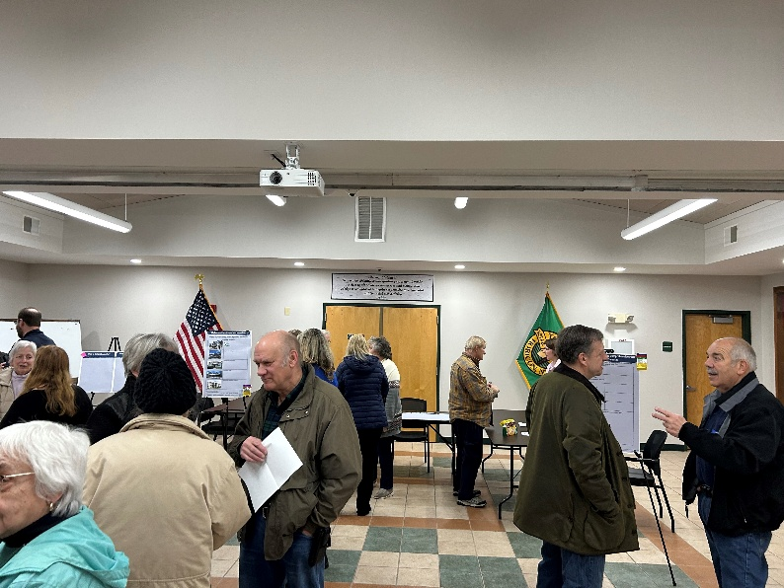
Public Workshop #1
Date: February 27, 2025 – Horicon Town Hall
Purpose: Open House & Visioning Workshop

Workshop Summary:
- 42 attendees, including community members, Town Board members, and representatives from the Comprehensive Plan Committee.
- Horicon is known for its tight-knit community, natural beauty, outdoor recreation, and peaceful rural setting
- Respondents would like to preserve the community’s rural nature while making it more family-friendly and affordable.
  - Balance tourism with local needs, focusing on outdoor recreation and the town’s rural beauty
- There is a significant need for improved housing options for locals, especially young families
- Many Horicon residents have family connections within the community
- Limited job opportunities, lack of affordable housing, and limited public amenities are barriers to living in Horicon
  - Limited services, such as childcare or convenient access to healthcare are problems that young families and older residents have
- Bike and pedestrian safety, short term rentals, and overdevelopment have been recent concerns for residents

Board Responses
What is Horicon known for?
- Community | - Vacationland
- Hospitable | - Nature
- Community | - Tourists
- Fun on the lake | - Outdoor activities
- Peace & quiet | - Rural beauty

What do you WANT Horicon to be known for?

- Friendly | - Happy
- History | - Family Oriented
- Affordable Housing and more young families | - Young families able to stay
- Historical past with museums- in both Brant Lake and Adirondack | - Both museum locations should be continued – Village and Adirondack location
- Outdoor tourism | - Nature and some tourism
- Rural beauty and nature | - Outdoor recreation
- Quality of life

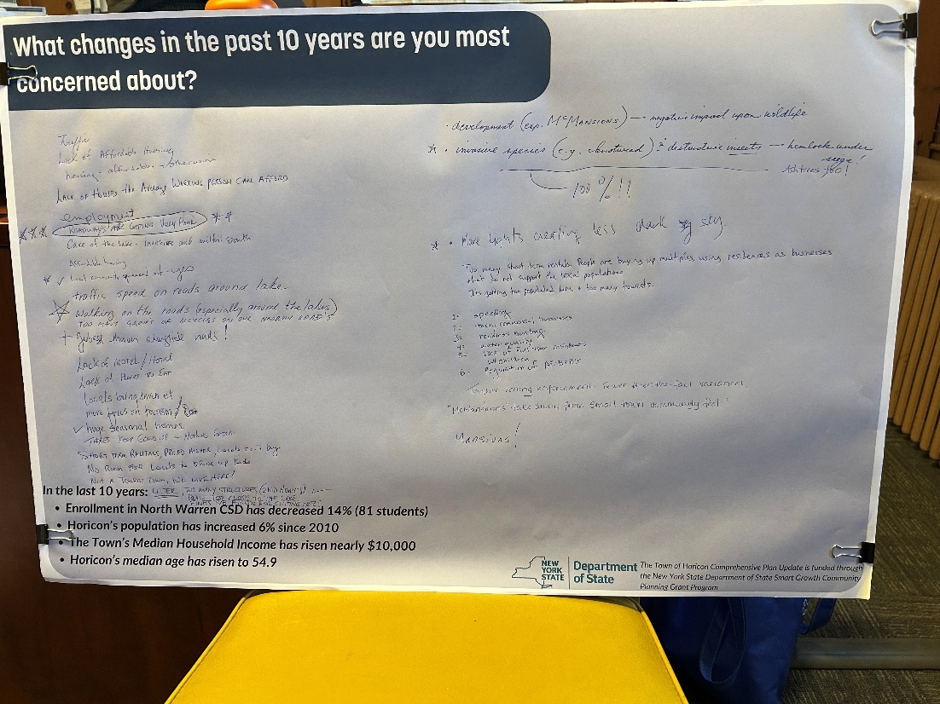
If you could design your perfect community from scratch, what would it include?

- Keeping the Boat Launch public for the locals (x3) | - More housing for locals | - Park for recreation, parking availability for events
- Having a ‘town center’ feel | - More housing | - Lake more accessible for all
- Mix of young working families & vacation/second home owners | - A town park on the Lake itself (x2) | - Keeping history alive in both Brant Lake and Adirondack
- A friendly walking village (x2) | - Stop the favoritism within the town | - Beach on Brant Lake for locals (x3)
- Housing that is affordable for young couples (x2) | - Playgrounds for children (x3) | - Small stores (x4)
- Opportunities for people to be a community | - Parking at boat launches for locals | - Something to attract young families
- More jobs (x2) | - Affordable taxes | - Affordable taxes, good school system
- Better town beach | - Bike and pedestrian lane around lake to attract the right persons | - Improve beach area with restrooms, community center (x2)
- Architectural restrictions on new buildings especially around Mill Pond (x2) | - We need another Daby’s | - Small local campground/campgrounds that focus on uniting families and sharing people the benefits of living rural
- More childcare | - Farmstands and people selling things/services | - Community garden (x2)

List 3 words that describe what Horicon should look like in 10 years:
- Friendly, Rural, Beautiful
- Vibrant, alive, active
- More local kids in school
- Safely walking roads (x3)
- Walking/biking paths (x3)
- Destination for outdoor recreation (x3)
- Cycling, hiking, outdoor recreational destination
- Bike friendly roads
- Clean, vibrant, small town feel
- Technology savvy government
- Schroon Lake focus/watershed plan
- Zoning enforcement
- Clean (e.g. Route 8), Unimpaired (Lake Waters), Integrated
- Clean, rural, peaceful
- Friendly and clean
Why do you live in Horicon?

- I was born here | - Family (x2) | - Family’s property (x2)
- Family live here | - Outdoor activities (x2) | - Lake
- Hiking | - Biking | - Skiing
- Peaceful (x2) | - Not a large population (x2) | - Fishing and lakes
- Born here, family foundation here | - Natural Beauty | - Quiet
- I chose to retire here because of the beauty and peacefulness | - Lakes & community | - Quiet and peaceful, safe
- Great place to raise our kids: great school, outdoor opportunities for recreational and otherwise, wholesome community environment | - I grew up here | - I have privacy

Why wouldn’t someone want to live in Horicon?
- Limited in restaurants, jobs (x2) | - Housing (x2) | - Traveling and work
- The price of a house and lack of housing | - It’s a bed community | - Too rural
- Proximity to shopping | - Limited work opportunities – especially year-round | - Housing for local young couples
- Poor healthcare | - Poor wages, no place to live | - Long commute for many amenities but many of us who live here like that!
- Phone/internet is bad (x2) | - Beautiful | - Lack of jobs
- Lack of work | - Lack of men

What changes in the past 10 years are you most concerned about?

- Traffic | - Lack of affordable housing | - Housing – affordable or otherwise
- Lack of houses the average working person can afford | - Employment | - Roadways are getting very poor – 5 stars
- Care of the lake and milfoil growth | - Affordable housing | - Local community squeezed out – “yes”, 2 stars
- Traffic speed on roads around the lake | - Walking on the roads (especially around the lakes ) – 1 star | - Too many groups of bicycles on our narrow roads
- Garbage thrown alongside roads | - Lack of motels/hotels | - Lack of places to eat
- Locals being driven out | - More focus on tourism | - Huge seasonal homes – 1 star
- Taxes keep going up + nothing extra | - Short term rentals, priced higher, locals cant buy | - No room for locals to bring up kids
- Not a tourist town, we live here! | - Litter, too many structures (2nd homes) built too close to the lake, fines s/b higher for cutting trees – 1 star | - Development (esp. McMansions), negative impact on wildlife
- Invasive species (eg knotweed) & destructive insects (hemlock woolly adelgid, ash trees too!) – “100%”, 1 star | - More lights creating less dark sky – 1 star | - Too many short term rentals. People are buying up multiples, using residences as businesses that do not support the local population
- Its getting too populated here + too many tourists | - Speeding | - Tacky commercial businesses
- Reckless boating | - Water quality | - Lack of full time residents w/ children
- Regulation of Airbnbs | - Tougher zoning enforcement. Fewer after the fact variances | - “McMansions” take away from the small town community feel!
- Mansions!

Help choose a title for the Comprehensive Plan!
- Horicon’s horizons: Guiding Growth, Preserving Heritage – 8
- Planning for Tomorrow: Horicon’s Comprehensive Vision – 4
- Shaping Horicon: A plan for the Future - 1
- Name it yourself!
  - Horicon Comprehensive Plan – 1
  - Horicon Rules
What types of housing are best for Horicon?
- Single Family Homes – 24
- Neighborhood Duplex – 1
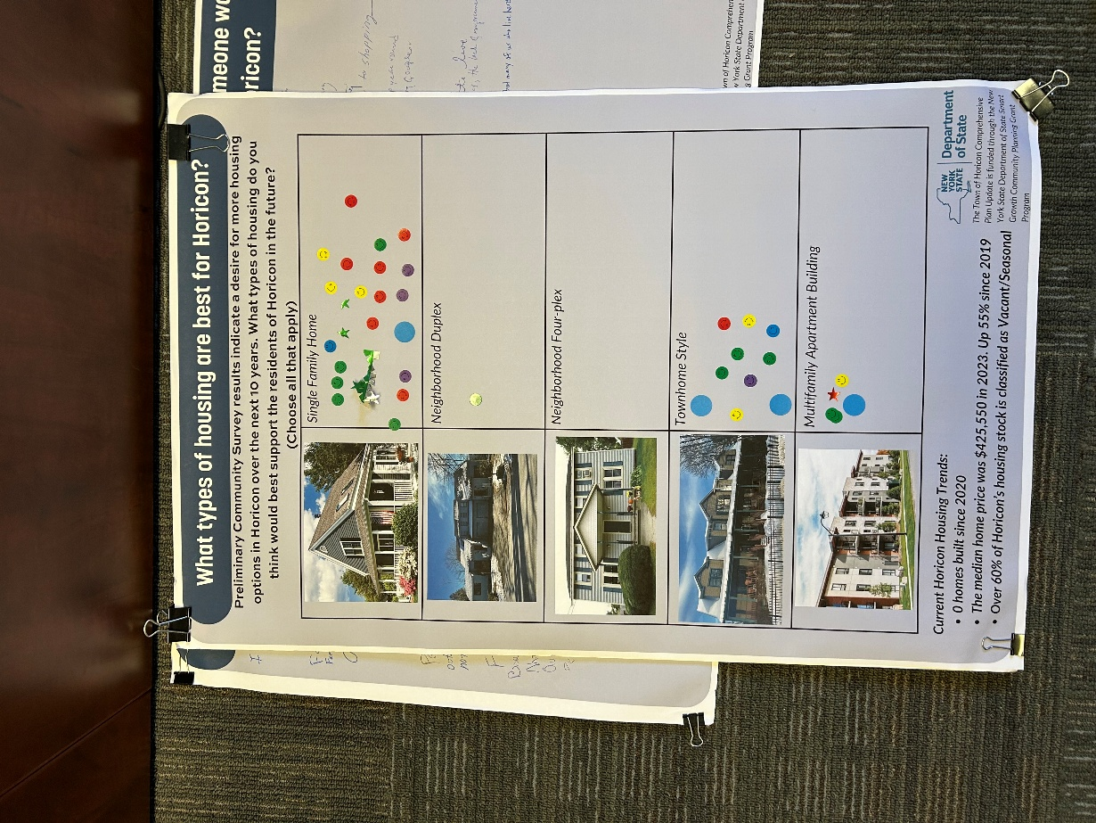
- Neighborhood Four-plex -0
- Townhome Style – 10
- Multifamily Apartment building -4
Miscellaneous Notes
- Development is okay if it is kept concentrated in certain areas (Brant Lake & Adirondack hamlets)
- Zoning changes are needed to ensure agricultural activities don’t adversely affect residents
- Regulation changes are needed to allow/ better accommodate for small businesses (ie farmstands, home businesses)
- Revitalize vacant/abandoned properties
- What are the barriers to staying in the community, post HS?
- Need: Better access to childcare for our young families
- Large need for Affordable and available housing
- Need to protect Horicon's important natural resources/aesthetics
- Preserve and enhance Horicon's small-town quality of life
- Help young families stay here/move here
- Areas for growth
  - Improved transportation services
  - Creation of community spaces or events, in addition to Food Truck Fridays
  - Desire for a restaurant in Town

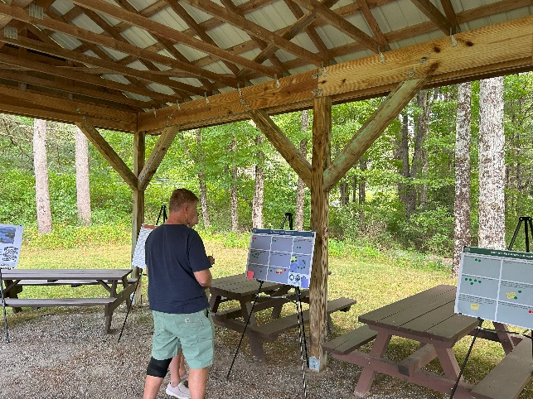
Public Workshop #2
Date: August 27, 2025 – Albert Monroe Park (Adirondack Park) Pavilion
Purpose: Goals and Strategies

Workshop Summary:
- Attendance -31
- Common themes include;
  - Importance of environmental protection
  - Need to further define zoning and follow up with enforcement measures
  - Desire to maintain the character of the Hamlet areas
    - Adjectives used to describe the community character include friendly, peaceful, and small-town.
    - Noted need for improvements in bike and pedestrian safety
  - Keep up with housing demands primarily through the rehabilitation and continued maintenance of existing residential homes
  - Objectives related to tourism may need reworking
Board Summaries
Vision Statement: The Town of Horicon is a vibrant and welcoming community where residents thrive, and future generations are inspired to put down roots and build their lives. Guided by a shared commitment to our heritage, community ties, opportunities, and sustainability, our town continues to grow while retaining its unique qualities. Our community is dedicated to:
 | Green | Red | Comments
Engaging Residents: Working with community members to ensure they feel appreciated, supported, and motivated to stay connected to our town. | 11
Quality, Affordable Housing: Increasing housing options that meet the needs of families, individuals of all ages, and seniors across various income levels. | 12
Supporting Local Businesses: Fostering entrepreneurship and local economic growth that embodies Horicon’s unique character. | 12
Environmental Stewardship: Protecting our environmental assets while nurturing a safe, welcoming, and interconnected community. | 21
Preserving our Heritage: Celebrating our past while actively shaping a prosperous future. | 15 | 1 | - Link the Concept and definition of “prosperity” with a healthy environment  - How to protect our community? Address enforcement – issues of existing + new laws. There is none
Attracting Young Families and Retaining Residents: Enhancing quality of life through excellent amenities, recreational opportunities, and a strong sense of community. | 10 | 1 | - Happy to travel to “amenities” & don’t need them next door – great community + rec opportunities
Accessible Transportation: Ensuring safe, dependable, and accessible transportation options that link residents to opportunities, services, and one another. | 5

Goal 1: Expand and Diversify Housing Options
Goal/ Objective | Green |  | Red | Comments
Goal 1: Expand and Diversify Housing Options | 4 |  | 6
1.1: Preserve and enhance existing rural neighborhoods by promoting the rehabilitation and maintenance of existing residential structures | 15
1.2: Promote a mix of quality housing options at price ranges that are accessible to all ages and incomes | 5
1.3: Create opportunities for lower-cost, affordable housing | 5
1.4: Continue to work collaboratively in order to balance short-term rental housing stock | 5
1.5: Identify locations suitable for new and inﬁll development for housing | 3 |  | 7 | - Define infill  - Concentrate new housing in a few areas, leaving open space
1.6: Improve retention of area employees by promoting affordable rentals for the local workforce | 5
Project Ideas & Comments
- Limit & enforce clear cutting of trees  - High fines for violators  - Stop hillside cuts! 25 acres is way too much |  | - Limit huge houses with expansive lawns i.e reduce suburbanization – retain the forested nature of the area  - Increase revenues by raising fees, for example a 3,000 ft2 house would have fees of $280 where in other towns $30it

Goal 2: Revitalize and Protect Hamlets as Community Hubs
Goal/ Objective | Green | Red | Comments
Goal 2: Revitalize and Protect Hamlets as Community Hubs | 5 |  | - Objectives are too vague – could mean so many things
2.1: Preserve the rural small-town character | 15
2.2: Build community image and identity. Preserve and enhance the distinctive identities of the Hamlets of Adirondack and Brant Lake through a combination of building and streetscape improvements | 6 | 2 | - Define streetscape improvements
2.3: Improve and enhance community facilities and services | 3
2.4: Improve and enhance the transportation infrastructure for the safety, convenience, and efficiency of drivers, cyclists, and pedestrians | 8 |  | - Just get rid of the trucks routing to VT
2.5: Improve the visual appeal and walkability of main streets and thoroughfares around the hamlets | 7 | 2 | - Put powerlines underground in the Brant Lake Hamlet
Project Ideas & Comments
- Water/Sewer system needed  - Reduce light pollution  - Draft legislation to address light pollution + enforce it | - Improve/ create better bikeways – need safety for riding  - Reduce the number of variances approved from 100% to 25%

Goal 3: Strengthen and Grow the Local Economy
Goal/ Objective | Green |  | Red | Comments
Goal 3: Strengthen and Grow the Local Economy | 4 |  |  | - Strengthening local economy emphasizing sustainable (green) business that provide and grow livelihoods and protect the integrity of the park which is the base of the economy
3.1: Strengthen and diversify the economic base of the Hamlets of Adirondack and Brant Lake. Encourage a mix of commercial, civic, and residential buildings within the two hamlets to provide a variety of necessary goods, services, and attractions for year-round and seasonal residents and tourists. Retain existing employment opportunities and attract new businesses | 10
3.2: Promote the Town’s recreational, cultural, and environmental resources to cultivate the tourism industry | 6 |  | 1 | - Maybe but also deserves quiet waters and a peaceful way of life – Close the boat launch  - This requires regulation, education & enforcement
3.3: Create employment opportunities by making the community more conducive to the establishment of businesses in designated areas | 4 |  | 2
3.4: Encourage remote working opportunities by determining gaps in broadband and cellular services and implementing solutions to address those gaps | 11 |  | 1
Project Ideas & Comments
- Automate & modernize Horicon government operations |  | - Pass local laws to allow residents who are not “electors” be employees and volunteers

Goal 4. Protect Natural Resources and Enhance Outdoor Recreational Assets
Goal/ Objective | Green |  | Red | Comments
Goal 4. Protect Natural Resources and Enhance Outdoor Recreational Assets | 11
4.1: Improve and maintain access to recreational areas, including the Pharaoh Lake Wilderness Area and Lily Pond | 4 |  |  | - Have DEC fix bridge on Pharaoh Lake Trail
4.2: Preserve the natural environment | 14
4.3: Continue to support water quality improvement efforts, including monitoring and prevention of aquatic and terrestrial invasive species | 14
4.4: Enhance stormwater and erosion management practices | 6 |  | 1
4.5: Improve facilities at Town Parks to better incorporate ADA/Universal Accessibility and to encourage younger families to more frequently visit and utilize them | 5
Project Ideas & Comments
- Vision to control light pollution  - Maintain environmental resources as is & guard against ridgeline development in order to preserve this valuable asset  - Add dark skies directive to Horicon zoning/light guidelines for outdoor lighting  - Town Code: Clarify ambiguous language, establish enforcement mechanisms for permit violations- current regs are inadequate, establish ridgeline development zones, enforce current regs better, adopt APA regulations by reference |  | - Obtain Beach area for locals on Brant Lake and Schroon Lake (Swimming)  - Modernize zoning code incorporating best practices and closing known gaps  - Develop a field enforcement process for zoning and APA codes  - What does “enhance” and “improve” mean? I support having primitive areas with limited access as much or more than areas with facilities

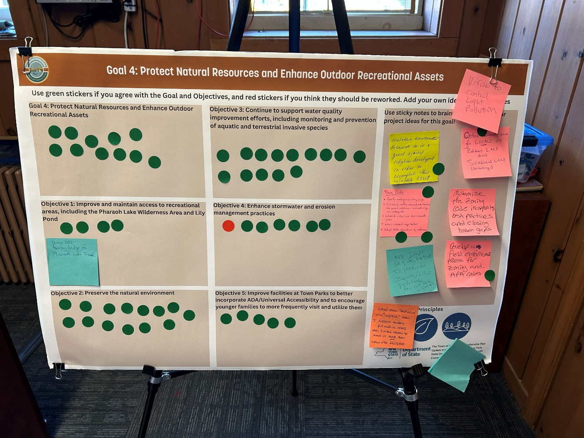
Goal 5: Promote Sustainable, Year-Round Tourism
Goal/ Objective | Green |  | Red | Comments
Goal 5: Promote Sustainable, Year-Round Tourism | 3 |  | 6 | - Rework this
5.1: Develop tourism strategies that balance economic growth with quality of life and natural resource stewardship | 9
5.2: Enhance the visitor experience through improving signage, a strong town identity, and investing in regional collaboration such as the ongoing Johnsburg, Chester, and Horicon branding strategy | 3 |  | 2
5.3: Promote Horicon’s diverse recreational opportunities across all seasons | 1
5.4: Establish a year-round calendar of events and programs to foster community engagement and attract off-peak tourism | 5 |  | 1
5.5: Leverage the community’s recreational assets to attract tourism businesses (lodging, services) | 1 |  | 9
Project Ideas & Comments
- Stop the fireworks! My horses hate them!  - Limit/ prohibit hill top development  - Consider the wildlife too – one idea would be to make it mandatory for realtors +sellers to provide guidance to homebuyers and business developers as to what is bad for the Park and bad for lake health. Fertilizers, blaet top, bright lights |  | - Objective #4 the calendar of events must be online and updated frequently, paper calendars should be available at Town businesses

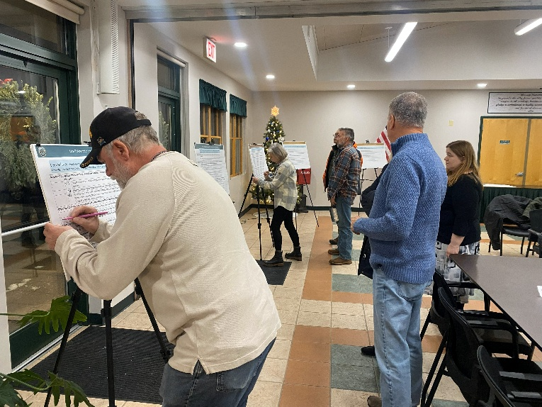
Public Workshop #3
Date: December 4th, 2025 – Horicon Town Hall
Purpose: Strategies & Land Use Workshop

Workshop Summary:
The Town of Horicon Comprehensive Plan Public Workshop was held at the Horicon Town Hall on December 4, 2025. The event took place from 5:00 – 7:00 pm and including a brief presentation of the process so far and questions, gaining feedback on identified strategies, and a future land use mapping exercise focused on the Hamlets of Adirondack and Brant Lake. A total of 16 attendees shared comments directly with LCLGRPB staff throughout the workshop
Board Summary
Workshop attendees were asked to place checkmarks or X’s on boards displaying the plan’s objectives and strategies. Responses to each strategy are below (checkmarks indicate support for that action, X’s indicate the respondents feel it needs to be re-worked).
Goal 1: Expand and Diversify Options
Strategies |  | Checks
S1.1 | Partner with county and regional housing programs to support the rehabilitation of existing homes for workforce housing and year-round residential uses | - 5
S1.2 | Establish a town-wide code compliance strategy that is enforceable, equitable, and efficient | - 1
S1.3 | Promote a mix of quality housing options at price ranges that are accessible to all ages, abilities, and income through land use policies and development decisions | - 3
S1.4 | Ensure local zoning and initiatives support the development of senior and accessible housing in centrally located areas with access to services and community activities | - 2
S1.5 | Identify and map parcels best suited for new and infill development for housing | - 3
S1.6 | Review and update Town fees, codes, and procedures to streamline the review and permitting process for residential development | - 3
S1.7 | Work with regional housing partners to implement a program to incentivize conversions of short-term rentals to year-round housing | X 1
S1.8 | Promote employee-assisted housing partnerships to help local workers live within the community | - 2 X 1

Goal 2: Revitalize and Protect Hamlets as Community Centers
Strategies |  | Checks
S2.1 | Codify design standards that reflect community character while balancing functionality, accessibility, and affordability | - 2 X 2
S2.2 | Develop a Hamlet Masterplan for Adirondack to ensure that any future development aligns with the community’s vision | - 5
S2.3 | Encourage reinvestment in underused or vacant buildings for housing or small businesses | - 4
S2.4 | Ensure local land use codes allow for mixed-use and small-scale business development | - 3
S2.5 | Support community spaces and facilities that enhance civic life and serve all residents | - 3
S2.6 | Plan and implement improvements to the Brant Lake Fire House | - 2
S2.7 | Conduct a feasibility study for the acquisition of property for a town beach on Brant Lake | - 5
S2.8 | Develop a plan for the upgrade of facilities at the public beaches in Adirondack and the Mill Pond, including evaluating ADA accessibility | - 4
S2.9 | Implement findings of the Brant Lake Feasibility Study | X 1
S2.10 | Develop a Gateway Masterplan for the Hamlets of Brant Lake and Adirondack that includes traffic calming measures that reduce vehicle speed | X 2
S2.11 | Work with NYSDOT and AGFTC to redesign and configure the intersection of Route 8 and Horicon Ave at the Mill Pond in Brant Lake | X1
S2.12 | Implement the Adirondack Hamlet Walkway initiative | - 1 X 1
S2.13

Goal 3: Strengthen and Grow the Local Economy
Strategies |  | Checks
S3.1 | Implement zoning regulations that encourage commercial uses in designated Hamlet areas | - 3
S3.2 | Promote the expansion of essential trades, service providers, and small manufacturers that support residents and regional employers | - 3
S3.3 | Ensure local regulations support business development while maintaining standards that are appropriate to the project scope | - 1
S3.4 | Formalize signage and parking for the Brant Lake Challenge | - 1 X 2
S3.5 | Connect recreational assets to Town Centers through signage, trails, sidewalks and other amenities | - 1 X 1

Goal 4: Support Local Business and Entrepreneurs
Strategies |  | Checks
S4.1 | Connect local businesses with the U.S. Small Business Administration’s Small Business Development Centers (SBDC) | - 2
S4.2 | Work with the Lake Champlain Lake George Regional Planning Board and Warren and Washington Counties IDA to connect businesses with low-interest loan opportunities and other technical assistance | - 4
S4.3 | Promote local products through a “Made in Horicon” initiative | - 3
S4.4 | Partner with local schools and nonprofits to introduce young residents to local arts, trades, and entrepreneurship pathways | - 5
S4.5 | Promote the establishment of a makers’ space or a central hub where local products can be sold | - 4
S4.6 | Identify underserved areas and work with service providers to expand service | - 7

Goal 5: Protect Natural Resources and Enhance Outdoor Recreational Assets
Strategies |  | Checks
S5.1 | Work with NYSDEC to implement Pharaoh Lake Trail access road and trail improvements | - 2
S5.2 | Conduct and implement the Mill Pond to Starbuckville Dam Feasibility Study | - 1
S5.3 | Work with Warren County Department of Public Works to reduce road salt usage around lakes and waterways | - 3
S5.4 | Continue to work with lake associations to support the AWI Boat Launch Stewards program | - 4
S5.5 | Conduct a Green Infrastructure Feasibility Study on Palisades Road, Brant Lake | X1
S5.6 | Work with Warren County and lake associations to distribute educational materials to property owners | - 1
S5.7 | Implement enhanced stormwater education and outreach to property owners and developers based on LCLGRPB’s MS4 Lite Campaign | - 1
S5.8 | Conduct an inventory and assessment of all town parks to identify ADA/UA gaps and plan for upgrades | X 1
S5.9 | Plan and develop community playgrounds in the Hamlets of Brant Lake and Adirondack | - 5
S5.10 | Design new recreational infrastructure with accessibility in mind | - 3
S5.11 | Work with the Warren County Planning Department to promote the available funding for homeowners for septic system replacement | - 2
S5.12 | Participate in a “Forest Pest Hunters” program to identify potential areas of hemlock woolly adelgid (HWA) infestations | - 3

Goal 6: Promote a Sustainable, Year-Round Recreation Economy
Strategies |  | Checks
S6.1 | Identify and support opportunities for local business growth and expansion that support the recreation and tourism economies in Horicon | - 3
S6.2 | Prepare an access management plan for Brant Lake Boat Launch upon the return of ownership and operational responsibility to the Town | - 1
S6.3 | Work with NYSDEC to update the Horicon Boat Launch UMP to include parking and traffic access controls | - 1 X 1
S6.4 | Consider the feasibility of establishing a permit-based system for Town boat launches | - 1
S6.5 | Improve physical access points to reduce erosion and disperse usage | --
S6.6 | Evaluate the recreational and social carrying capacities of Schroon Lake and Brant Lake | - 1
S6.7 | Develop a uniform wayfinding, informational, and interpretive signage plan for the Town | X 1
S6.8 | Collaborate with the Towns of Johnsburg and Chester to promote the region with coordinated marketing, tourism initiatives, and consistent signage | - 2
S6.9 | Invest in infrastructure that supports off-season recreation and full-time employment | - 3
S6.5 | Work with the North Warren Chamber of Commerce to ensure the community calendar is up to date and promoted to residents and visitors | - 2

Goal 7: Modernize and Align Zoning and Land Use Regulations
Strategies |  | Checks
S7.1 | Ensure land use and building regulations support a range of housing options to serve all ages, incomes, and abilities | - 3
S7.2 | Foster community participation in land use planning to ensure regulations align with the vision for the future | - 1
S7.3 | Identify areas in the APA Moderate Intensity and Low Intensity Land Use Areas that are eligible for the APA Community Housing Density Bonus Program for up to 120% AMI Income-restricted housing to increase the stock of workforce housing in Horicon | - 2
S7.4 | Establish a code compliance strategy that is enforceable, efficient, and equitable | --
S7.5 | Simplify local permitting for residential construction that is allowed by Town zoning code | - 2
S7.6 | Conduct a build-out analysis for Brant Lake and Adirondack to identify where new development could occur | - 2
S7.7 | Promote ridgeline development standards that safeguard environmentally sensitive areas while minimizing visual and broader community impacts | X 1
S7.8 | Strengthen tree preservation standards to minimize unnecessary tree removal and protect natural and scenic resources | - 2 X1
S7.9 | Provide guidance for, and encourage dark sky compliant lighting on new construction | - 1
S7.10 | Develop site plan review guidance for alternative energy facilities, like small-scale solar arrays and battery storage | - 10

What's on your mind? What's your big or small ideas, concerns, and wild projects?
- Work with North Warren School to create an apprenticeship program – working trades, entrepreneurship, finance, tourism
- Explore rent-to-own housing models
- New playground
- Host career nights
- Small nursing home/ daycare combo
- Horicon Town events newsletter/ calendar

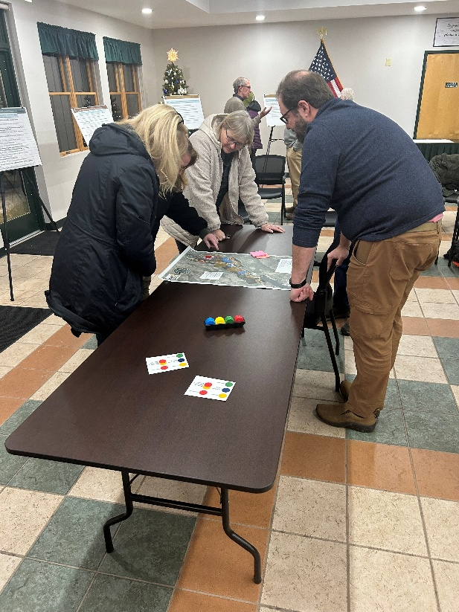
Land Use Mapping
Attendees were asked to review maps of the Hamlets of Adirondack and Brant Lake depicting their current land use. Using colored chips, attendees identified areas in which future land use changes should occur, such as more housing, commercial spaces, or open space:
- Housing – Yellow | - Multi-family housing – Blue​ | - Open Space – Green​
- Commercial – Red | - Mixed Use (housing and commercial) – Yellow and Red stacked.

Future Land Use in the Hamlet of Brant Lake
Future Land use in the Hamlet of Adirondack

In Adirondack, attendees envisioned new mixed-use development in the center of the Hamlet, around the Adirondack General Store. In Brant Lake, attendees envisioned new residential and multifamily housing in the mill pond area and along Route 8. Discussion also included the former landfill site, and what can be done with the large space in the Hamlet area.

Horicon Community Survey and Stakeholder Interviews Summary
Executive Summary
To support the development of the Town of Horicon's Comprehensive Plan, the project team conducted two key public outreach efforts. The first was a community survey conducted in the summer and fall of 2024, which served as the public’s initial introduction to the planning process. The survey offered valuable insight into a wide range of issues and opportunities shaping the future of the community.
During the Spring of 2025, stakeholder interviews were conducted with a wide range of individuals and organizations who were identified by the Comprehensive Plan Committee (CPC) as key representatives for the community. These stakeholders, including representatives from local and regional organizations, government agencies, and community members, offered valuable perspectives on both the town and the broader region, shaped by their unique roles and experiences.
Key Themes of Stakeholder Interviews
Staff from LCLGRPB conducted over fifteen interviews between March and April 2025, speaking with stakeholders both individually and in small groups. Conversations took place in person, by phone, and virtually via Zoom.
This document highlights the key themes, priorities, and needs that emerged from those discussions. These insights will help shape the direction of the comprehensive plan. While the timing of the interviews may have limited participation from seasonal business owners, seasonality itself was a consistent topic of concern. Future opportunities will be provided to ensure broader input from this group as the planning process continues.
Interview participants expressed the desire to see a usable document come out of the comprehensive planning process. This follow-through on the planning process will help to guide established and community-voiced projects to implementation.
Several recurring themes emerged from the stakeholder interviews, highlighting core challenges and opportunities facing the Town of Horicon (Figure 1). Among the most frequently discussed issues were the need for more affordable housing, enhanced transportation options, expanded community gathering spaces, and strategies for attracting a skilled workforce and retaining young residents.
Stakeholders repeatedly emphasized the importance of improving conditions for living, working, and recreating in Horicon. A common concern was the lack of reliable public transportation, particularly noted by community volunteers working with seniors and by school district staff. Interviewees underscored how better transportation could improve access to essential services such as healthcare, extracurricular activities, and food pantries, especially for school-aged children and older adults.
Housing was another critical issue. Many stakeholders expressed concern that young people, families, and long-time residents are finding it increasingly difficult to remain in Horicon due to the shortage of affordable, year-round housing options. From homes to rent or purchase to seasonal housing pressures, the lack of available inventory was widely viewed as a major barrier to community stability and growth.
The topic of housing affordability had already been a point of discussion within the community, and the comprehensive planning process has continued to build on that dialogue—through CPC meetings, the public workshop, and these stakeholder interviews. Participants strongly emphasized the need for the Town to prioritize housing solutions in the Comprehensive Plan and urged collaboration at the town, county, and state levels to address the issue through policies, regulations, and targeted projects.
Another recurring theme from the stakeholder interviews was the need for more community gathering spaces and organized activities. Interviewees emphasized the importance of having year-round, accessible spaces where residents can connect, build relationships, and foster a stronger sense of community.
Although not a central focus of the interviews, the need for improved cell service and high-speed internet was highlighted as a critical concern through the community survey and CPC meetings. Residents view reliable connectivity as essential for daily life, work, education, and public safety, making it a continued priority for the community.
Survey responses also pointed to additional challenges and opportunities, including the distance residents must travel to access basic goods and services, and a strong desire for better access to parks, trails, and recreational opportunities. Many respondents also expressed interest in expanding shopping and retail options within town limits.
The insights shared during stakeholder interviews and the broader public engagement process form a strong foundation for identifying projects and initiatives that will enhance the quality of life in Horicon. These perspectives will play a vital role in shaping a shared vision for the town’s future as reflected in the Comprehensive Plan.

Summary of Stakeholder Interviews by Topic

Young Families/Educators
The Town of Horicon is home to many families with children enrolled in the nearby North Warren Central School District. To better understand the perspectives of younger residents and those raising children in the area, young families and educators within the district were identified as key stakeholders. Their insights offer valuable context on the experiences and needs of youth and families in the community. According to the 2020 census, approximately 16% of Horicon’s population is under the age of 20. Public engagement efforts conducted in 2024 and early 2025 as part of the comprehensive plan process tended to skew toward older demographics. To address this imbalance, targeted interviews were conducted with young families and educators. A summary of the key themes and feedback from those interviews is provided below:
Reasons to live in Horicon:
  - I have family here
  - Small class sizes
  - North Warren Central School District offers enrollment in BOCES and ACC-accredited courses
  - There are school sports and elective offerings
- Nature/the outdoors
- Sense of community
Essential changes in the next 5 – 10 years:
- Housing: Lack of affordable housing for young families in the area
- Programming and support services for young people
- More robust public transportation
What do you hope to see come out of this Comprehensive Plan process?
- Find and implement more options for children to get involved in the community (i.e., a youth commission and a summer youth commission)
- Cost effective childcare/activities, especially in the summer, when there is a greater need
- Field trips with transportation
  - Transportation for late or early school extracurricular activities
  - Parents are deterred from seeking out those programs and activities for their children when having to provide their own transportation far from town
- Need for job experience and transition beyond high school for older students
Remote Workers
The Town of Horicon is home to a growing number of remote workers. Stakeholder interviews were conducted with residents identified for their experience working remotely, and their insights are summarized below.
Reasons to live in Horicon:
- Give back to the community where I grew up
- Family/friends
- Natural beauty and serenity
- Slowed-down pace of life
Horicon’s assets:
- Our small businesses
- Natural spaces
- The lake
- Seasonal attractions, including the winter
Essential changes in the next 5 – 10 years:
- Increased options/availability of internet
- Better job opportunities to earn a livable wage
- Community gathering space
- Housing needs to be a priority
What do you hope to see come out of this Comprehensive Plan process?
- Increase the involvement of young people in the community/in decision-making
  - New voices in the room
- Improve the affordability of staying in the area for young people/attracting people to come here
- Increase support services for those that are working here, working remotely, hybrid, or in-person
Town Employee and Community Services
The Town of Horicon operates an emergency food pantry on town property. The Town staff person who distributes food items, oversees all operations, and charts a plan for the future was identified as a community stakeholder. With an emergency food pantry designation by Warren County, community members are limited in their frequency of pick-ups, unless they are enrolled in the Commodities Program. The staff have noted that the food pantry has seen an uptick in visitors in recent months. Beyond giving out perishables and non-perishables alike, the food pantry can share information for other charities and how to sign up for food stamps and WIC and is a designated emergency shelter in partnership with the American Red Cross. The stakeholder interview with the Food Pantry Supervisor is summarized as follows:
Horicon’s needs:
- Population frequenting the food pantry includes senior citizens, who come for the Commodities Program (a once-a-month program with all types of vegetables, fresh and frozen)
- There is a need for the Commodities Program to cover more people - it is at capacity
- Need for more consistently available items, i.e., lately there has been substantially less meat
Essential changes in the next 5-10 years:
- The food pantry may have to resort to asking for more places for regular donations to meet the growing need within the community
- This location has always been designated by Warren County as an emergency food pantry and will remain one unless the county reverses that designation (emergency designation limits frequency of pick-ups for individuals)
What do you hope to see come out of this Comprehensive Plan process?
- With various factors increasing the need in the community, i.e., grocery prices, less availability from the regional food bank, etc., there needs to be proposed solutions to meet this growing need o Horicon’s elderly population is a part of that increasing need
Non-Profit and Community Organizations (Historical Society (HHS), The Helpers Fund, Trail Challenge, Library)
Organized groups that work to better the community and provide essential services were identified for having unique perspectives due to their charitable and educational work within the community. The stakeholder interviews with various members of those four non-profits/community organizations are summarized as follows:

Reasons to live in Horicon:
- Give back to the community where I grew up/where my kids grew up
- Sense of community
- Small-town feel
Horicon’s assets:
- Historical buildings, the aesthetic of well-maintained façades
- Availability of work/positions open in the summer
  - Influx of volunteers in the summer
Essential changes in the next 5 – 10 years:
- Addition of space for community connection
- Stewardship and care for the natural environment, protect the beauty of Horicon as use of trails, waterbodies, vista points increase
- Housing needs to be a priority
- Transportation accessible for seniors and people with disabilities
Challenges and changes unique to non-profits:
- Funding - the Town can support by way of Letters of Support for grant applications
- Community support and getting people engaged
What do you hope to see come out of this Comprehensive Plan process?
- Thoughtful decision making that benefits as many of our residents as possible
- Build capacity for community gathering: both in building/renovating a larger physical space and in volunteers and businesses organizing more events o
  - There needs to be space made available year-round
  - Space/opportunities for residents that identify as LGBT
- Housing that is affordable and right-sized for seniors
- Welcoming and sustained improvements to Horicon that go beyond the summer-month focus

Lake Associations
In the Town of Horicon, two bodies of water that have been popularized due to recreational access and residential property development have dedicated lake associations that work to protect these natural assets. Both the Brant Lake Association (BLA) and the East Shore Schroon Lake Association (ESSLA) have set goals and priorities for the future that overlap with community goals and priorities that help to inform the comprehensive plan. The stakeholder interview conducted with members of both lake associations and their insights into the community are summarized below:

Reasons to live in Horicon:
- Family ties
- Historical place
- Sense of community
- It’s beautiful here

Horicon’s assets:
- Lake associations have built capacity by increasing membership and engagement opportunities over the years
- Access to the lakes and surrounding land

Essential changes in the next 5 – 10 years:
- Address environmental concerns ο Dissolved oxygen levels of Brant Lake
  - Terrestrial and water-bound invasive species
- Boat-user friendly mapping on Schroon Lake to identify areas that are restricted/no access
- Town/County/BLA partnership to bring a portable boat wash station to the Brant Lake public boat launch
- Address potential overuse on the lakes and safety concerns at boat launches
- Continue to build engagement through lake-centered activities, such as the Boat Parade, Island Party, and live music

What do you hope to see come out of this Comprehensive Plan process?
- Tangible results that move other entities to recognize small positive changes that may be implemented
- Finding funding to keep up with current associations’ priorities and incorporate broader community goals

Local Businesses
The locally owned businesses in and around Horicon were identified as having unique perspectives on what it means to start and successfully operate a business. The stakeholder interview with Horicon businesses is summarized as follows:

Horicon’s assets:
- Our small businesses
- Natural spaces
- Brant Lake, Schroon Lake
- Seasonal attractions, including the winter
- Sense of community, although this has felt absent in recent years

Essential changes in the next 5 – 10 years:
- Construction of new homes
- Permitting at the Town and the APA level can be more efficient
- Housing needs to be a priority

What do you hope to see come out of this Comprehensive Plan process?
- A usable document that will be taken into consideration when making Town/community decisions
  - Follow-up with stakeholders
  - Follow-through on implementation
- Better define the local economy and re-examine how those assets can move forward. Do we need to bring back a ‘Main Street?’, and how can that happen?
- Install attractive signage to inform people traveling along The Northway (I-87) of what Brant Lake has to offer
- The younger generation has to be a part of the solution: o Make it affordable to stay, after graduation
  - Develop more trades program (in addition to what the NWCSD offers/BOCES)
  - Ensure reliable businesses have a pool of potential new business owners as the older generation retires/sells their business

Planning Board
The Town’s Planning Board meets monthly to review applications for subdivisions (major and minor), boundary line adjustments, conditional uses, and site plan review. The Planning Board provides a perspective of needs and development trends in the community, and how properties, especially prominent shoreline properties, are being used.
Planning Board decisions play a significant role in shaping both the function and appearance of a community. In Horicon, the volunteer Planning Board collaborates closely with the Zoning Administrator, who provides essential staff support. The summary below highlights key insights from an interview conducted with a current member of the Planning Board.
Horicon’s assets:
- Small-town feel
- Well-known, widely recognized
- Land use and development decisions primarily stay in Horicon with the Agency-approved Local Land Use Program (ALLUP) in place with the APA

Overlap with the current comprehensive plan:
- At present, the board does not refer to the comprehensive plan for decisions, but would like to do so in the future
Essential changes in the next 5-10 years:
- Improve understanding of how a decision is made and the individual project’s status after ZBA review, overall improve communication/coordination with the ZBA
- Housing stability/affordability needs to be a priority
What do you hope to see come out of this comprehensive plan process?
- Immediate and long-term solutions for current housing issues
- Continue community conversation and involvement beyond this comprehensive plan process
Zoning Board of Appeals
The Town of Horicon adopted a Zoning Law to help guide community development and retains a staff member to administer it. The Zoning Board of Appeals (ZBA) is a volunteer board responsible for reviewing requests for relief from the zoning ordinance. In cases of demonstrated hardship, the ZBA has the authority to grant variances, allowing applicants to deviate from the existing Zoning Law.
On April 22, 2025, before the regular ZBA meeting, staff from the LCLGRPB conducted a stakeholder interview with the full Board and the alternate member. This discussion was publicly noticed per open meeting requirements. ZBA meetings are open to the public, and community members are welcome to provide public comments on projects listed on the meeting agenda.
The topic of ongoing discussion within the ZBA and the broader community is whether and how to regulate travel trailers. Stakeholders continue to explore what such a regulation might entail and how it could be appropriately implemented. The stakeholder interview with the ZBA is summarized as follows:
Horicon’s assets:
- Small size
- Lack of vehicle traffic
  - Both size and traffic lend to ease of site visits for projects before the ZBA
- Sense of community
Overlap with the current Comprehensive Plan:
- Very few ZBA members were involved in the drafting of the 2010 document
- The ZBA does not currently reference the comprehensive plan when considering applications
Essential changes in the next 5 – 10 years:
- Housing to accommodate community needs and keep the character of existing neighborhoods
- Shoreline definitions and all interpretations need to be clear and consistent
- Enforcement
  - ZBA decisions are documented in the meeting minutes and read aloud to the applicant(s), but there is no other established method for following up on decisions

What do you hope to see come out of this Comprehensive Plan process?
- A document that can show community needs and changes that support keeping up with edits to the existing zoning law o The ZBA needs refined regulations and definitions for travel trailers (RV’s)
- A document that demonstrates the pride of residents for their community

Emergency Services
The Town of Horicon contracts with the Horicon Volunteer Fire Department (HVFD) to provide fire and rescue services. The Town of Horicon also leases the land that the community beach is on from the HVFD. The North Warren Emergency Squad (NWES) provides emergency medical services in the area. The stakeholder interviews with the HVFD Board of Directors, all current officers for the HVFD, and the NWES Captain are summarized as follows:

Horicon’s assets:
- Quiet community

Essential changes in the next 5-10 years:
- Needed transportation, especially for seniors
- Youth opportunities and outlets
- Community spaces for those opportunities and outlets, especially making better use of the Town Hall meeting room
- Affordable housing
- More grants to help get buildings in better shape and to help our business owners
- Improved cell coverage

Challenges and changes unique to the fire department:
- Volunteer recruitment and retention

Challenges and changes unique to the emergency squad:
- Ability to maintain a level of service and provide competitive wages to workforce
- Aging workforce, many employees have retired from larger departments elsewhere
What do you hope to see come out of this Comprehensive Plan process?
- Would like to see a plan for helping to take care of the buildings that we have o The old schoolhouse in Adirondack is currently in a state of disrepair and owned by the HVFD
- Radio towers/cell infrastructure upgrades to boost and improve current communications for responders and residents in need of assistance
- A plan for comprehensive coordination among the northern Warren County communities and County Emergency Management to improve mutual aid and other shared resources
- Follow-through on implementation

Community Survey Summary
The Horicon Community Survey was available to residents and visitors both online and in hardcopy from August 30, 2024, through March 12, 2025. Throughout this period, the survey was regularly promoted using the outreach methods listed below, and periodic updates were provided to the Comprehensive Plan Committee (CPC). Serving as the public’s first major touchpoint with the comprehensive planning process, the survey helped introduce the initiative and encouraged broad community participation in shaping Horicon’s future.
Promotion of the community survey:
- Postcards handed out at the final Food Truck Friday of the 2024 season
- Posters/flyers placed throughout the Town
- Link and information included on the dedicated comprehensive plan website
- Social media
- The Town of Horicon’s community table
- Easel and board displayed in Town foyer before and after Board meetings in November 2024, December 2024, January 2025, and February 2025
- Postcard mailing, as part of promotion for Public Workshop #1
- Selected email lists sent by LCLGRPB
- Word of mouth
Characteristics of survey respondents based on demographic questions answered:
- Full-time residents – 49.0%
- Seasonal residents - 48.2%
- Respondents 45 to 54 years of age - 9.9% (12% of the population)
- Respondents 55 to 64 years of age - 27.0% (20% of the population)
- Respondents 65+ years of age - 52.9% (17% of the population)
- Other age groups - 8.0% (49% of the population)
The responses to the survey indicate recognition that the area has changed recently and will continue to change, with many respondents preferring that the comprehensive plan address the following:
- Improve cell service/broadband access
- More affordable housing options
- More shopping and retail stores
- More community events and activities
- Improved access to parks, trails, and recreation
With 251 responses, the Horicon Community Survey provided valuable current concerns, future needs, and the perceived strengths and challenges within the community. As a foundational piece of public engagement, the survey served as both an introduction to the comprehensive planning process and a critical dataset for shaping the plan’s direction. Additional surveys may be conducted in the future to explore specific topics in greater depth.
Respondents identified the following as the most pressing issues currently facing Horicon:
- Inadequate broadband and cell service
- Distance from goods and services
- An aging population
- Affordability
- Lack of services for older adults
- Limited housing options
When asked why they chose to live in Horicon, participants cited access to recreation and open space, the town’s safety, its natural beauty and peacefulness, and a strong sense of home. These responses reflect a community that deeply values its rural character while recognizing key areas in need of investment and attention.
Looking ahead, survey participants prioritized the following changes over the next 5 to 10 years:
- Improved broadband and cell service
- More shopping and retail options
- Increased community events and activities
- Expanded affordable housing
Additionally, top concerns about Horicon’s future growth included the potential for rising taxes, reduced affordability, and negative impacts on air and water quality.
To tailor the survey to different audiences, respondents were first asked whether they were residents or visitors. Visitors (7 responses) primarily traveled to Horicon to visit family, most often participated in water-related activities, and reported few difficulties accessing needed services during their stay.
The resident survey (Questions 2–9) captured demographic information, such as residency status (year-round or seasonal), age, and household income. Questions 10–17 gathered qualitative responses on reasons for living in Horicon, concerns about change, hopes for the future, and perceptions of the town’s current condition. These responses offer deeper insight into the lived experience of Horicon residents.
The major themes revealed through the community survey closely align with topics raised throughout the broader planning process. During a SWOT analysis conducted by the CPC and LCLGRPB staff, recurring concerns included preserving natural assets, addressing affordability, and expanding broadband and cellular coverage. The alignment between survey responses and ongoing stakeholder feedback reinforces these priorities as key components to be addressed in the Comprehensive Plan.

Questions and Responses from the Community Survey
Question 10: What do you like the most about living in Horicon?
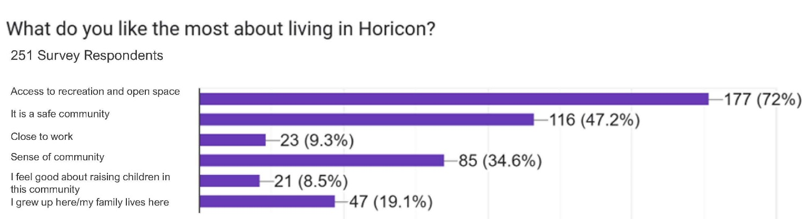
Other responses (2%) included individualized answers that touched on the beauty and ruralness of Horicon.
Question 11: How satisfied are you with living in Horicon?
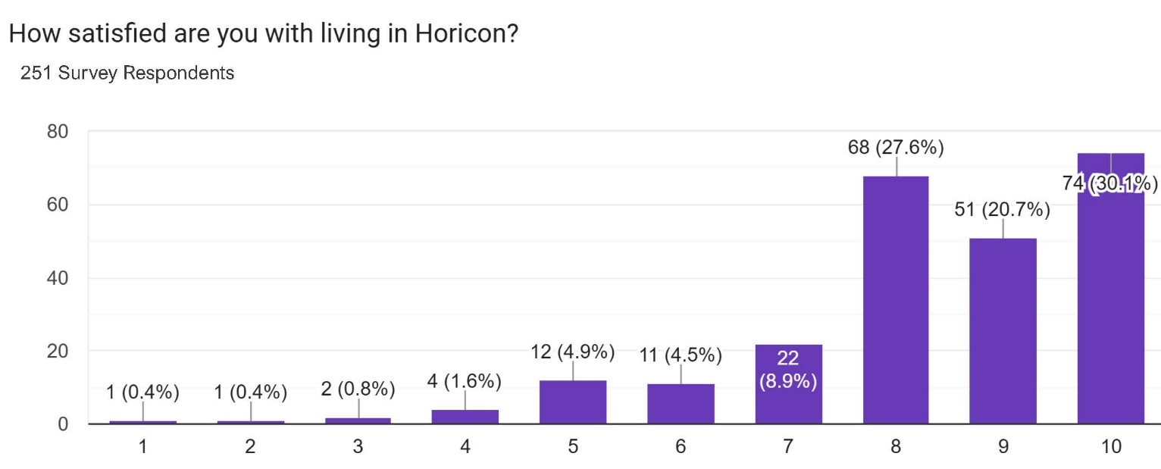

Question 12: How well does Horicon meet your expectations as a great place to live?
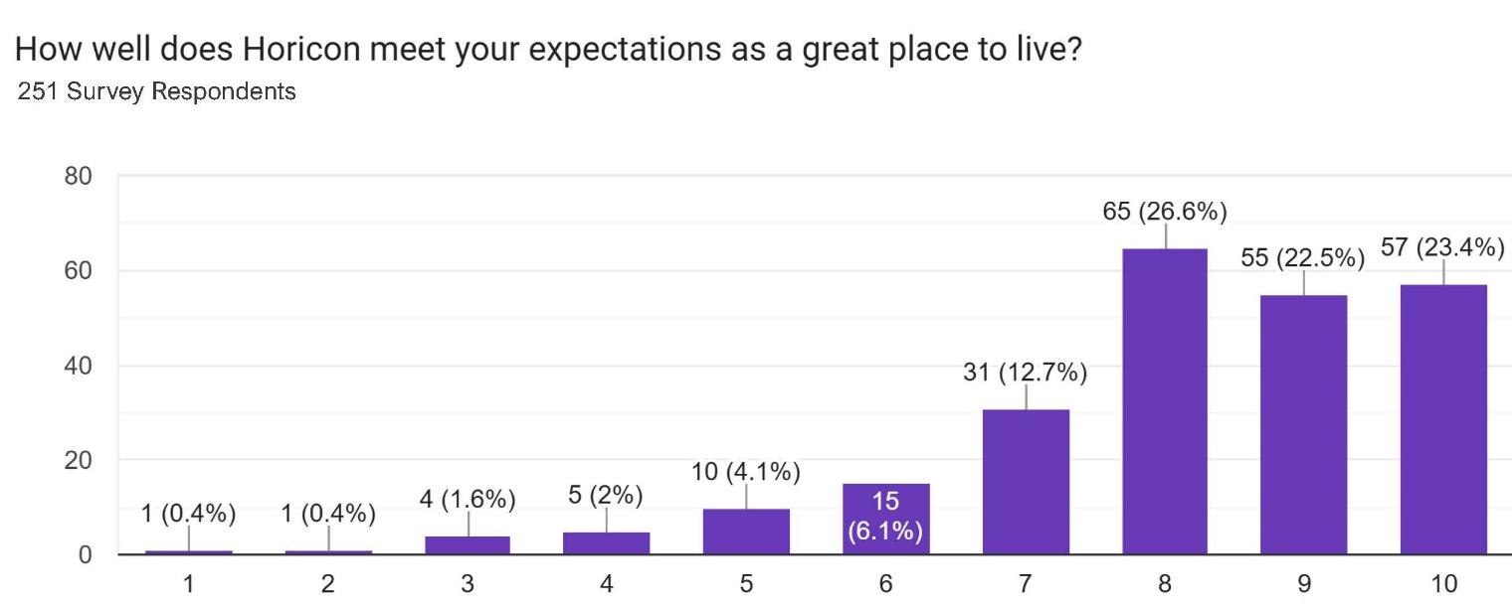
Question 13: What are current issues facing Horicon?
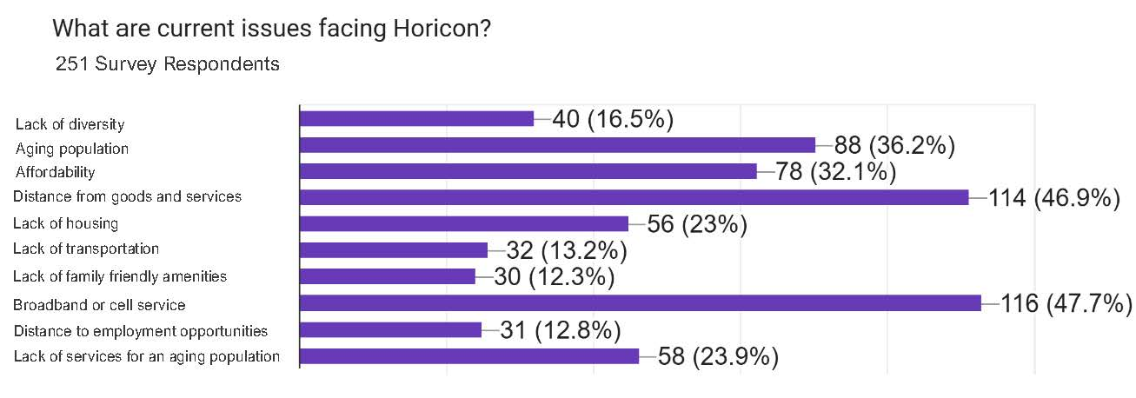
Question 14: What are your biggest concerns as Horicon grows and changes?
(Listed in order of frequency of answer)
- Increased taxes
- People can’t afford to live here
- Impacts on air/water quality
- Lack of workforce as the population ages into retirement
- Too many people
- Loss/change in community identity
- Increased regulation
- Too crowded
- Decreased access to open space
- Lack of diversity

Question 15: What are the most essential changes you would like to see in Horicon in the next 5-10 years? (Listed in order of frequency of answer)
- Improved cell service and broadband access
- More shopping and retail stores
- More community/events and activities
- More affordable housing options
- Improved access to parks, trails, and recreation
- More school-aged children
- More family-friendly amenities
- Increased transportation options
- More community spaces
- Increased population

Question 16: What makes Horicon special?
  - Sense of Community
  - Clean
  - The Adirondacks
  - The sense of belonging to a community
  - Safe
  - Small population
  - Enjoying the Lake and Mountains
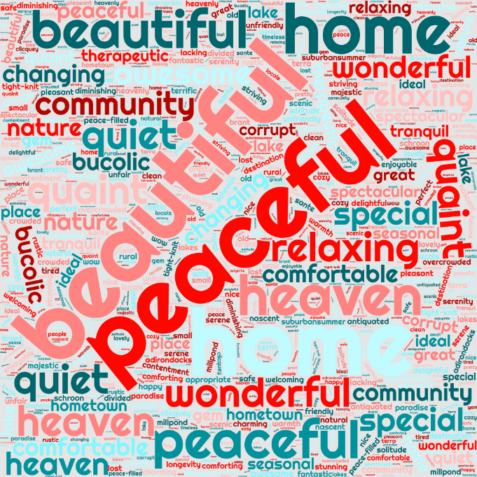
Question 17: Describe Horicon in one word:

