Appendix B
Town of Horicon Community Profile
Horicon’s Horizons Comprehensive Plan
This document was prepared with funding provided by the New York State Department of State Environmental Protection Fund.

Contents
_Toc212641857
Introduction 2
Map 1. Regional Context Map 3
2010 Comprehensive Plan 4
Historic, Cultural, and Scenic Resources 4
Map 2. Existing Parks and Open Space 8
Waterfront Resources and Public Access 9
Demographics and Regional Trends 10
Economic Indicators 14
Local and Regional Economic Characteristics 15
Land Use and Smart Growth Focus Areas 18
Agricultural and Forest Lands, Use, and Districts 19
Map 3. Land Use 20
Map 4. Adirondack Park Agency Land Use Classifications 21
Map 5. Existing Land Uses in Adirondack and Brant Lake Hamlets 22
Zoning and Other Local Development Controls 23
Map 6. Town of Horicon Zoning Map 26
Map 7. Town of Horicon Zoning within the Hamlets of Adirondack and Brant Lake 27
Infrastructure 28
Natural Resources 30
Map 8. Natural Resources 33
Map 9. Topography 34
Rare Plants, Animals, and Important Habitats 35
Extreme weather events, Flooding, Erosion Hazards, and Local Resiliency 35
Community Services 37
Parks and Public Spaces 37
Fiscal Resources 38
Grant History 39

Introduction
The Town of Horicon is in the northern part of Warren County, New York, within the Adirondack Park. It is bordered by the Schroon River to the west, the Town of Hague to the east, and the Town of Schroon in Essex County to the north. Known for its vast forested landscapes and abundant water resources, Horicon offers easy access to premier outdoor recreation areas such as the Pharaoh Lake Wilderness Area and the Lake George Wild Forest. The town boasts scenic water-based recreation on both Brant Lake and Schroon Lake, and is a short drive from Gore Mountain, a popular year-round recreational hub in neighboring Johnsburg. With convenient access via the I-87 Northway, Horicon is a popular destination for visitors and second-home owners exploring the Lake George and the Adirondack region.
The Horicon area was first settled in the late 1700s by a single landowner and officially incorporated as the Town of Bartonville in 1838. Like much of the region, its early hamlets were centered around logging and industries that harnessed the resources of the dense wilderness. Early settlers constructed dams, such as the Mill Pond, built sawmills, and used the Schroon River to transport logs downstream to larger milling operations in Glens Falls.
By the mid-1800s, several hamlets had emerged across the town, each with its own school. Among the most prominent were Adirondack, Bartonville, South Horicon, and Hayesburg. Both South Horicon and Adirondack had a tannery, with the South Horicon tannery earning distinction as the largest in New York State. Tanning and leathermaking were vital industries, drawing on the area’s abundant hemlock trees for their tannin-rich bark. In addition to industry, small-scale subsistence farming contributed to the local economy.
By the early 1900s, tourism had begun to eclipse traditional industries, largely due to improved access facilitated by nearby railroads. This economic shift transformed the community, as hotels and summer camps sprang up around Brant Lake, catering largely to affluent families from urban areas. Residents found new roles as hunting and fishing guides, and the economy increasingly oriented itself around seasonal visitors. Over time, many of the early hotels and businesses faded, and tourism in Horicon evolved into a model centered on second-home ownership, a pattern that continues to define the area today.

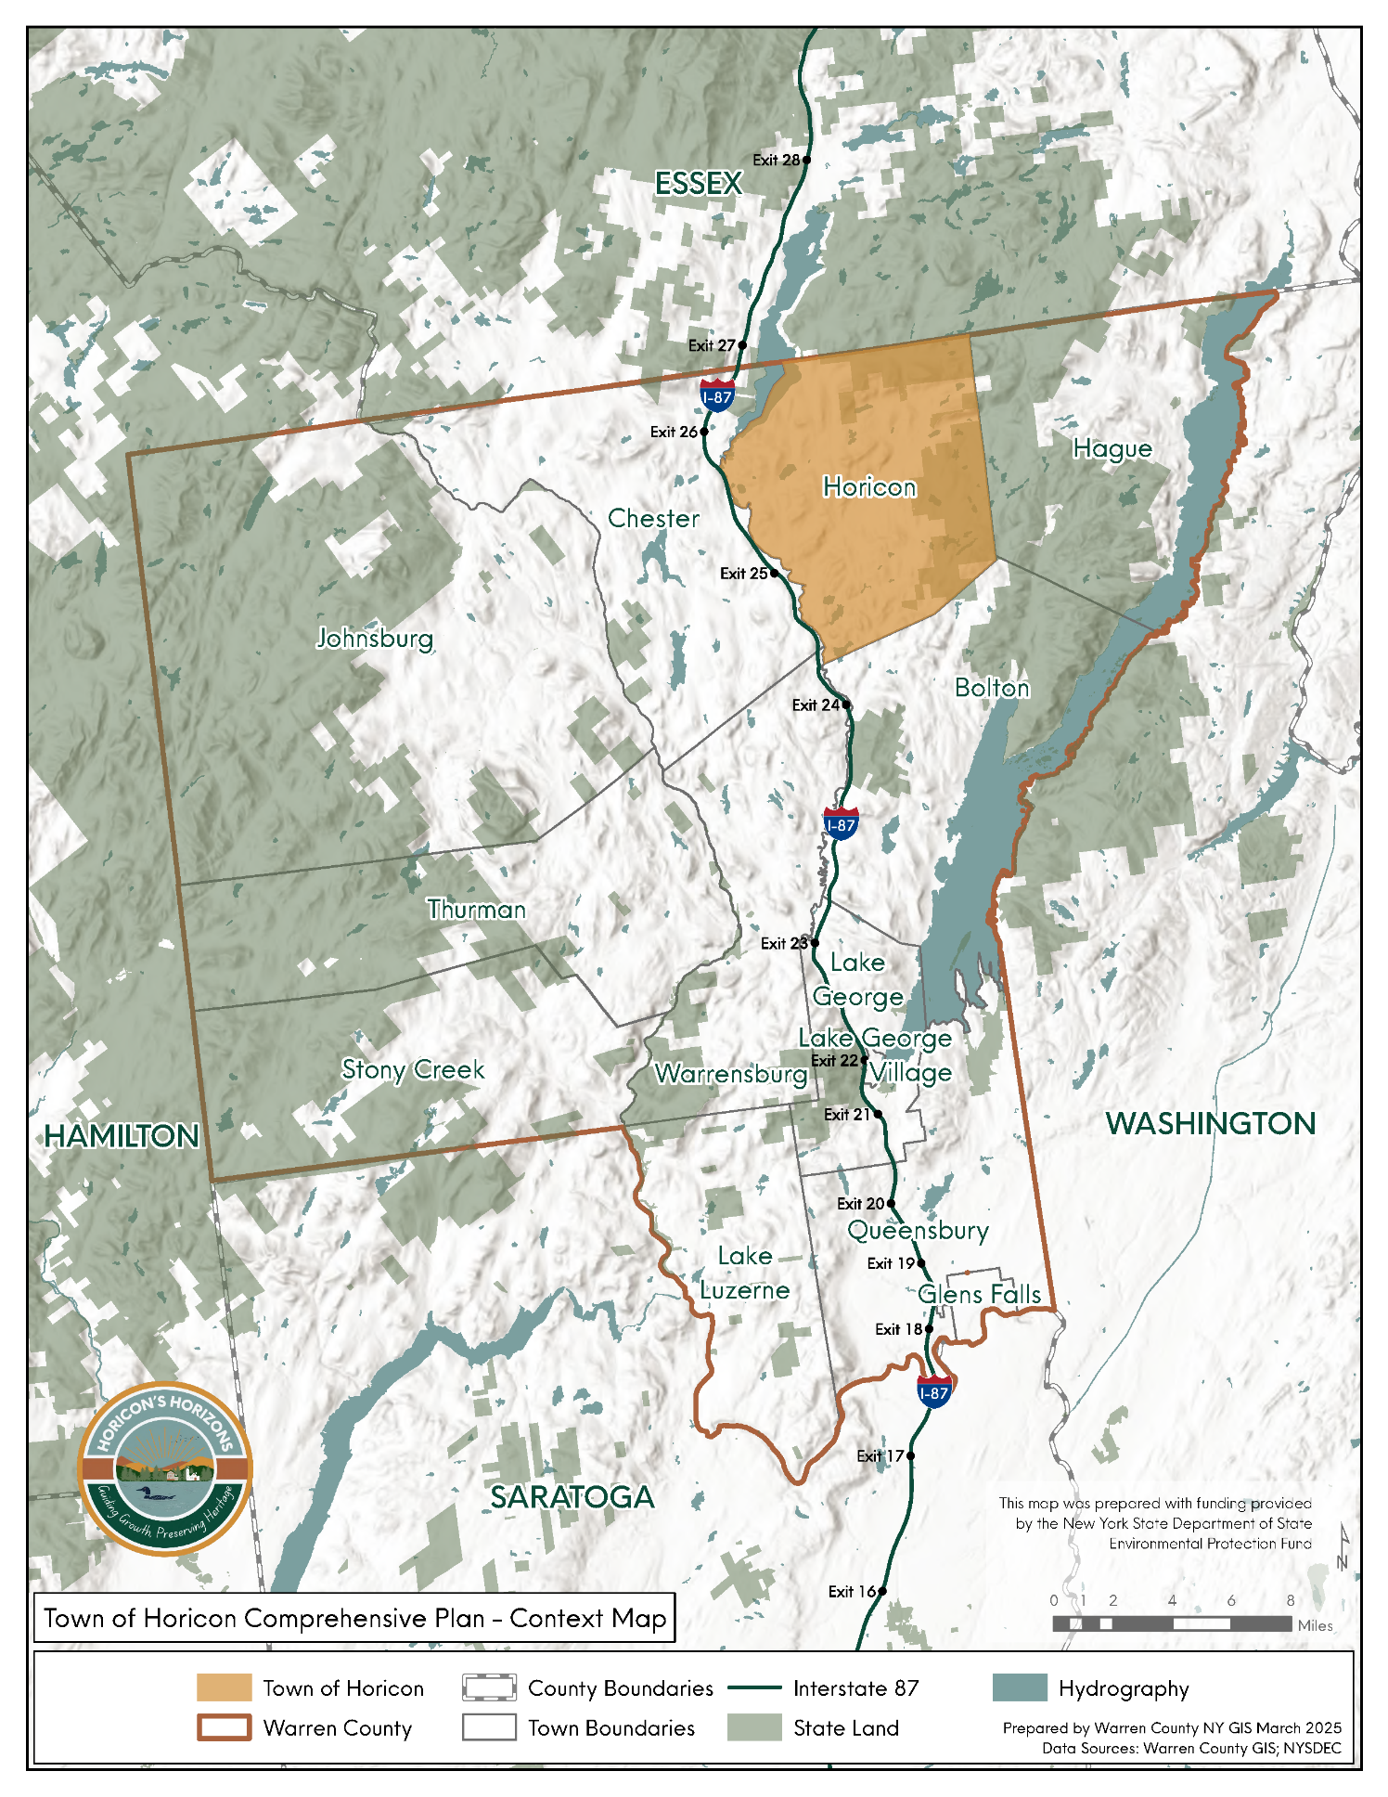

Map 1. Regional Context Map

2010 Comprehensive Plan
The 2010 Comprehensive Plan for the Town of Horicon was prepared by the SUNY Plattsburgh Environmental Science Department with guidance from a comprehensive plan steering committee. Public input was gathered through an extensive community survey and other public workshops. Additionally, select town residents were gathered for focus group interviews.
The plan identifies four foundational goals, including preservation of rural character, preserving the natural environment, creating opportunities for lower-income, affordable housing, and creating employment opportunities by making the community more conducive to the establishment of businesses in designated areas. These goals were used to guide the direction and recommendations of the plan.

Historic, Cultural, and Scenic Resources

Historic Resources
A community’s history and cultural identity are often its most defining traits. They not only tell the story of the past but also offer insight into its values and priorities. Although the Town of Horicon has few listings on the National Register of Historic Places, it boasts a rich heritage that residents deeply value.
The Town’s only National Register building is the Heintzelman Library, a historic stone and wood building on the shores of the Mill Pond, which was established through the philanthropic efforts of Mrs. Emily Heintzelman, who donated books and funds to create a public library for the community. The building was built in 1907. This structure served as the Town’s library from 1907-2001. Today it functions as the office of the Town Historian and houses the Adirondack Book Collection.
Cultural resources in the Town that reflect the values and importance of the history of Horicon include the following:
Horicon Historical Society: The Horicon Historical Society is dedicated to the preservation and promotion of the town’s history. It operates two museums in the Town:
Town of Horicon Museum (Brant Lake Museum): This museum is housed in a restored 19th-century farmhouse. It provides insights into Adirondack pioneer life. The museum features artifacts such as antique clothing, furniture, china, quilts, old photographs, horse-drawn farm equipment, tools, and boats. The museum is located at 6696 State Route 8 in Brant Lake.

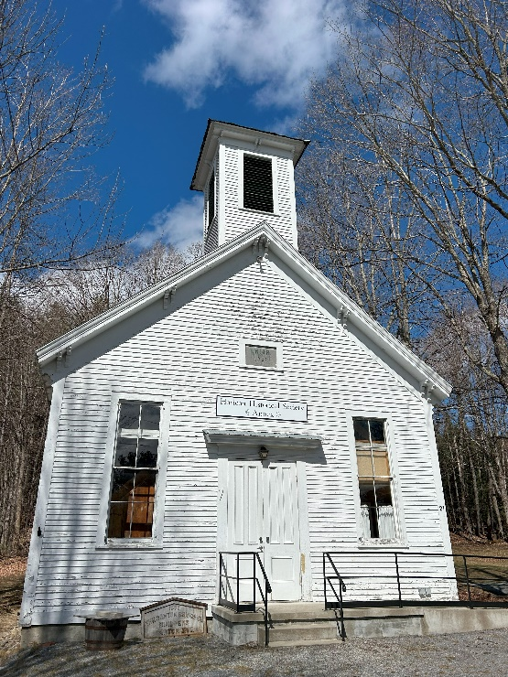
Adirondack 1881 Annex: The annex, located at 21 Church Street in the Hamlet of Adirondack, complements the main museum by offering additional exhibits related to the town’s history. The annex is housed in a historic building that once functioned as the Adirondack Schoolhouse. Constructed in 1881, this schoolhouse was one of several in the area. The building has been preserved and repurposed to house a small museum that complements the Town of Horicon Museum in Brant Lake and illustrates the daily life of the Horicon area in the late 19th and early 20th century.
Horicon Community Center: The Community Center serves as a hub for local events, meetings, and community activities. The Town offices, Horicon Free Library, and the local food pantry are all located within this building.
Due to its central location, meeting space, and services that it provides, the community center plays a vital role in fostering community engagement and providing essential services to the residents of the Town of Horicon.
Photo 1: Adirondack 1881 Annex, LCLGRPB

Scenic Resources
Scenic resources, such as mountains, lakes, forests, rivers, and open landscapes, offer a wide range of benefits to communities, including environmental, social, and economic advantages that enhance quality of life, support economic development, and foster a strong sense of place.
Mill Pond: The Mill Pond is one of the most recognizable and cherished bodies of water in the Town of Horicon. Originally formed by a series of dams on the creek flowing from Brant Lake, the pond once powered the saw and grist mills that gave it its name. While the mills have long since disappeared, the Mill Pond has evolved into a peaceful retreat for visitors and residents alike. Today, its small public beach welcomes swimmers throughout the summer, and its calm waters attract anglers, kayakers, and those seeking a quiet place to enjoy the natural beauty of Horicon.
Brant Lake: Brant Lake is an approximately 1,376-acre lake that is completely within the Town of Horicon and is the largest lake entirely within Warren County. It is about 5 miles long, with a maximum depth of approximately 65 ft. This lake is renowned for its natural beauty and rich history. Historically, Brant Lake has been a popular destination for fishing and hunting enthusiasts. The lake’s serene waters are ideal for boating, fishing, and kayaking. Located approximately one mile northeast of the hamlet of Brant Lake is the DEC Brant Lake Public Boat Launch and parking area. The Brant Lake community is thoroughly engaged in the area, and the Brant Lake Association (BLA) also plays a pivotal role in the lake’s health and promoting community involvement.
Schroon Lake: Schroon Lake is a 4,107-acre lake that spans Warren and Essex counties. While most of the lake lies within the Towns of Schroon and Chester, a small portion of the southern end of the lake falls within the boundaries of the Town of Horicon. Key access points to the lake include the Horicon Boat Launch, Eagle Point Campground, and a small swimming area off Church Road in the hamlet of Adirondack.
Schroon River: The Schroon River is a 68-mile-long tributary of the Hudson River that winds its way through the Adirondack landscape, forming the western boundary of the Town of Horicon. Originating in the central Adirondacks, the river flows southward through forests, wetlands, and small hamlets before joining the Hudson River near Warrensburg. Within Horicon, the Schroon River is both a scenic and recreational asset, offering opportunities for fishing, kayaking, and canoeing along its calm stretches and gentle rapids. Its banks support a variety of wildlife and provide picturesque views that highlight the town’s natural beauty. The river also plays an important role in defining Horicon’s character, shaping local ecology, influencing settlement patterns, and offering a tranquil setting that attracts residents and visitors alike.
Pharoah Lake Wilderness and Lake George Wild Forest: The Pharaoh Lake Wilderness Area occupies the northeastern corner of the Town of Horicon, encompassing roughly 4,186 acres within town boundaries. This area is part of a larger 46,483-acre wilderness complex known for its pristine lakes, extensive trail network, and opportunities for backcountry recreation. Nearby, approximately 7,094 acres of the 71,133-acre Lake George Wild Forest also lie within Horicon, further contributing to the town’s remarkable access to public lands. Together, these vast, undeveloped tracts of state-owned property form an integral part of the Adirondack Park’s protected landscape. They feature an array of ponds, mountains, streams, and forests that support diverse wildlife and offer year-round recreation, including hiking, paddling, and camping in the summer and snowshoeing and cross-country skiing in the winter. The presence of these lands within Horicon not only preserves the area’s natural character but also enhances its appeal as a destination for outdoor enthusiasts seeking an authentic Adirondack experience.
Smart Growth Analysis of Historic, Cultural, and Scenic Resources: The Town of Horicon’s historic, cultural, and scenic assets align well with Smart Growth principles. While the town faces challenges such as its expansive geography and seasonal population shifts, there are significant opportunities to build on its strengths, many of which will be addressed through the comprehensive plan’s goals and recommendations.
Historic and cultural resources are concentrated in the hamlets of Brant Lake and Adirondack, where most community services are located. These areas contain a rich collection of scenic and historic sites within close proximity; however, they currently lack adequate pedestrian infrastructure and designated bicycle routes. Enhancing walkability through connected walking loops, improved signage, and accessibility upgrades would better link these resources and enrich the visitor and resident experience.
Scenic resources such as Mill Pond, Brant Lake, Schroon Lake, and the surrounding wilderness lands are central to Horicon’s identity and economy. Preserving these natural landscapes while maintaining the town’s small-scale character is a key component of the community’s long-term vision. Horicon’s sense of place is also deeply rooted in its history, museums, and lakeside heritage. Establishing formal design guidelines for the hamlet areas could help protect and enhance this distinct character, fostering attractive, vibrant centers that reflect Horicon’s historic and visual identity.
Finally, expanding year-round tourism opportunities would strengthen the local economy, support small businesses, encourage greater community engagement across all seasons, and has the potential to increase year-round residents.

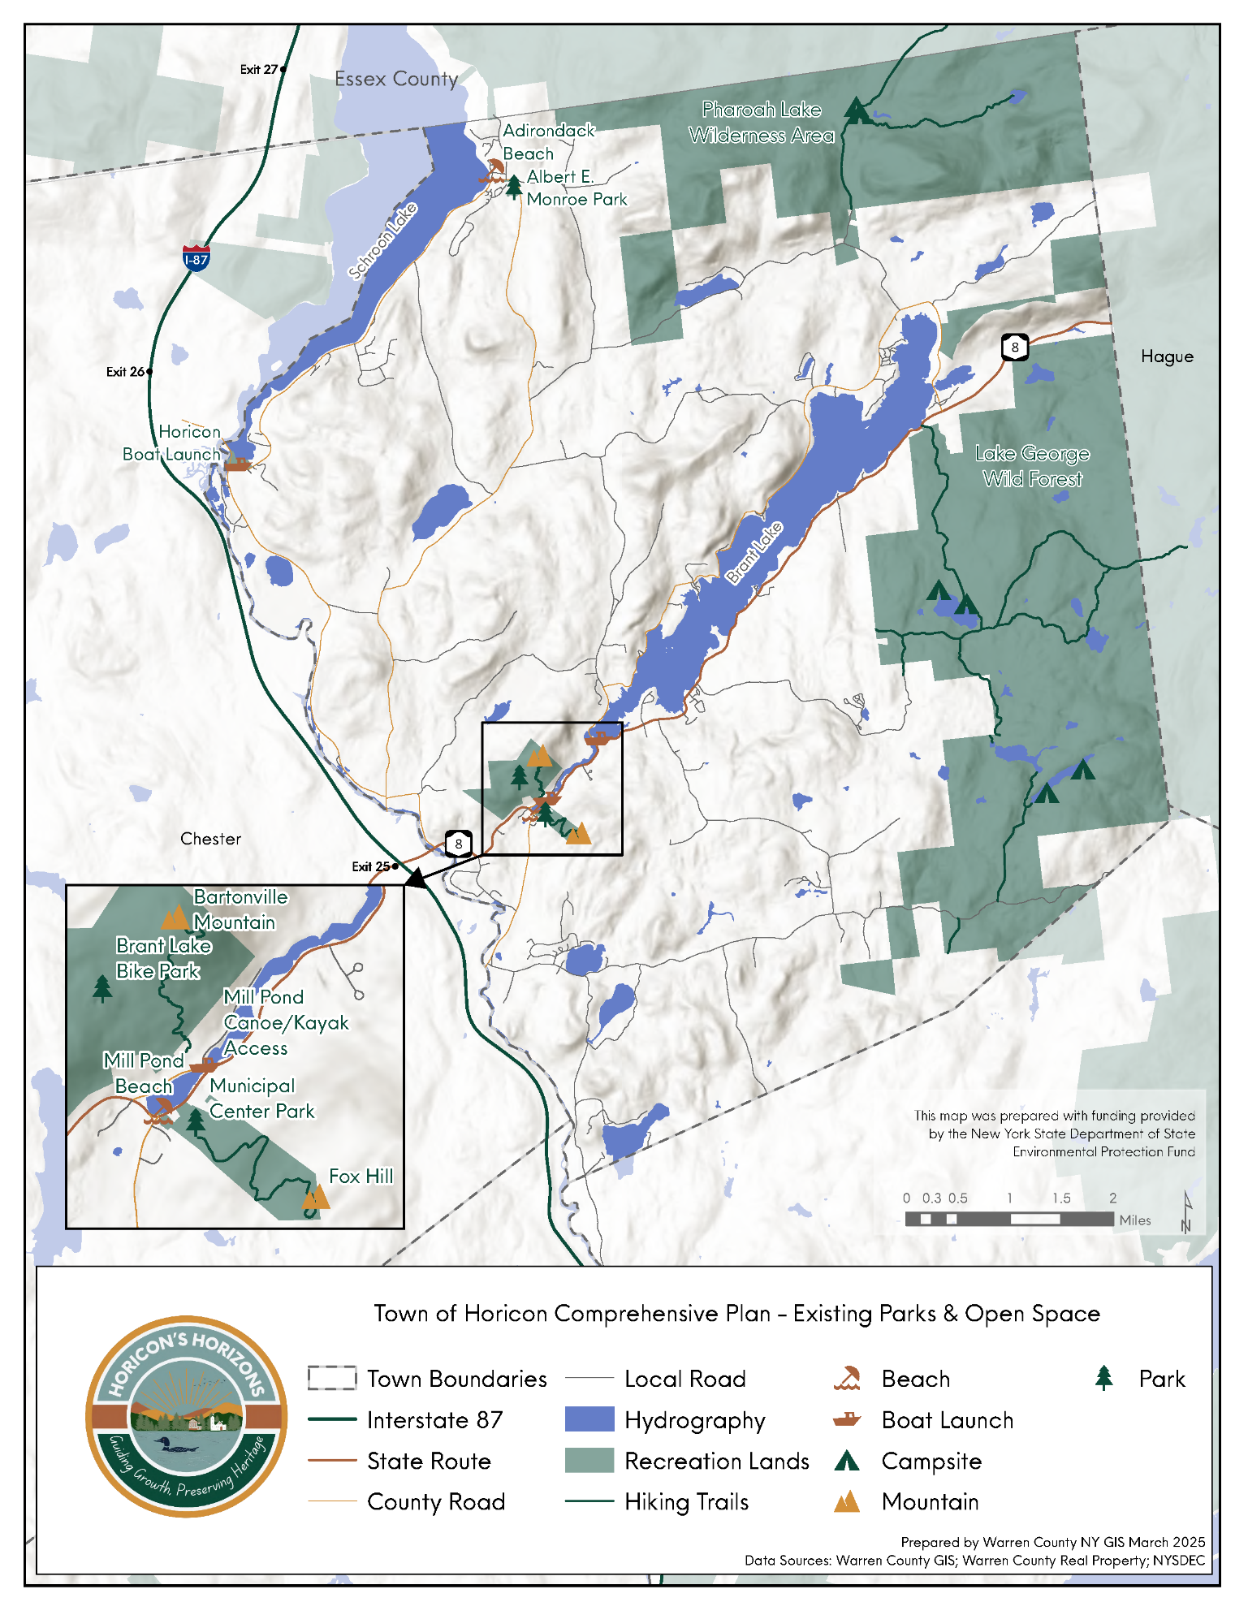

Map 2. Existing Parks and Open Space

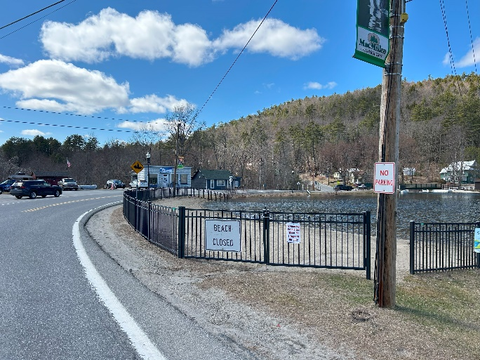
Waterfront Resources and Public Access
The Town of Horicon is defined by its abundant water resources, including two major lakes, Schroon Lake and Brant Lake, as well as several smaller but notable ponds and lakes. Among these are Sherman Lake, Mill Pond, Lily Pond, Island Pond, Valentine Pond, and Round Pond, each contributing to the town’s natural beauty and recreational opportunities.
Sherman Lake, located in the southwest corner of town, is a privately owned lake with no public access. Mill Pond, situated in the Hamlet of Brant Lake, offers a scenic in-town setting with a small public beach and calm waters ideal for kayaking and fishing. Lily Pond, Island Pond, and Round Pond are more secluded, offering quiet escapes for those seeking hiking, paddling, or fishing experiences in a tranquil Adirondack setting.
Photo 2: Brant Lake Public Beach, LCLGRPB
The Town of Horicon provides a variety of public access points to its lakes and rivers, allowing residents and visitors to enjoy the town’s waterfront amenities:
Town of Horicon Public Beach (Schroon Lake): Located on Church Street in the Hamlet of Adirondack, this public beach features a sandy shoreline and a designated swimming area. Parking is available on the corner of Church Street and Red Wing Road.
Brant Lake Public Beach: Situated along Mill Pond off NY-8 in Brant Lake, this beach offers a small swimming and sunbathing area for residents and visitors.
Horicon Boat Launch (Schroon Lake): Located along County Route 62 just north of Pottersville, this is the largest public boat launch on Schroon Lake. It features a hard-surface ramp and parking for approximately 45 cars and trailers. This site is heavily used in the summer months with parking often overflowing onto the road.
Brant Lake Canoe/Kayak Access: Located on the Mill Pond in Brant Lake, this site provides easy launching for canoes and kayaks, offering paddlers and anglers direct access to Brant Lake.
Brant Lake Public Boat Launch: This facility provides access to Brant Lake with a hard-surface ramp suitable for various types of watercrafts.
The Schroon River is another vital natural and recreational resource within the Town of Horicon, forming much of the town’s western boundary. The river supports boating and fishing opportunities and is well-known for its populations of rainbow, brown, and brook trout. Public access points along the river allow for each entry, regular fish stocking by Warren County in partnership with NYSDEC enhances its appeal to anglers and outdoor enthusiasts.
Horicon’s extensive inventory of lakes, ponds, and rivers strongly supports Smart Growth principles by reinforcing the community’s natural character, directing recreation toward established hamlet areas, and protecting sensitive environmental resources. Public access points on Brant Lake, Schroon Lake, and Mill Pond concentrate activity where infrastructure already exists, strengthening the vitality of the Hamlet of Brant Lake while reducing development pressure on more remote natural areas such as Lily Pond, Island Pond, and Round Pond. These water resources enhance walkability and multimodal access by providing recreation opportunities near population centers and existing trail networks. Their protection also aligns with Smart Growth goals to preserve open space, safeguard clean water, and maintain the scenic qualities that define Horicon’s sense of place. Together, these assets support a balanced approach to growth—one that promotes recreation-oriented economic development while conserving the environmental features central to the Town’s identity.

Demographics and Regional Trends

Population
According to the 2020 U.S. Census, the Town of Horicon has a population of 1,471, making it the fourth smallest town in Warren County. Only Hague, Stony Creek, and Thurman have a smaller population. Between 2000 and 2023, Horicon's population remained relatively stable, declining by only 2%. Between the 2010 and 2020 Censuses, Horicon was the only municipality in Warren County outside of the urban center to have an increase in population, seeing a 6% growth, while neighboring communities of Chester and Hague saw declines of 8% or greater. (Figure 1). Schroon, a neighboring town in Essex County, experienced a 6.8% population increase during the same period. Overall, Warren County's population grew by 4% between 2000 and 2020.
Although Horicon is one of the smallest towns in Warren County, it has maintained a stable population over the past two decades, declining only 2% between 2000 and 2023. Population growth and stability indicate that Horicon is more successful than surrounding rural towns in retaining and attracting residents, potentially due to its high quality of life, natural amenities, or housing characteristics. Horicon’s growth mirrors similar increases in nearby communities like Schroon in Essex County, indicating that certain Adirondack towns may be experiencing renewed residential interest. Overall, Horicon’s stability and recent growth—outpacing the county's long-term trend—suggest a community with rising desirability and consistent service demands that support long-range planning.

Figure 1 Population change of neighboring communities 1970-2020. Source: US Census Bureau

Aging population
In 2020, Warren County was the fifth oldest county in New York State with a median age of 47.5. Horicon is the third oldest municipality in the county, with a median age of 56.9. The neighboring towns of Chester and Johnsburg are slightly younger, with a median age of 52.4 and 52. In 2023, approximately 32.8% of the Town was aged 65 or older, which is an increase of approximately 10% from 2010. While the nation is aging, this demographic trend is especially pronounced in Warren County and the Town of Horicon. In 2023, Horicon’s median age of 54.9 was almost a decade and a half older than the nation (39.2) and state (40.2).
The implications of this aging structure show that Horicon is experiencing a combination of aging in place among long-term residents and possible out-migration of younger adults who are seeking employment, housing, or educational opportunities. This demographic imbalance has shown, and may continue to show, challenges in the availability of workforce, long-term economic prospects, and the sustainability of municipal services. The age shift will also require the provision of age-related services such as healthcare access, emergency response capacity, supportive transportation, and age-friendly housing options.

Table 1: Population Change by Age 2000-2020
Population | 2000 | 2010 | 2020 | Change 2000-2020 | Change in Number
Under 5 years | 40 | 58 | 46 | 13% | 6
5 to 14 years | 195 | 107 | 136 | -43.4% | -59
15 to 24 years | 147 | 144 | 103 | -17.6% | -22
25 to 34 years | 123 | 124 | 125 | 2.4% | 3
35 to 44 years | 220 | 150 | 126 | -37.5% | -60
45 to 54 years | 241 | 213 | 160 | 13.9% | 39
55 to 64 years | 232 | 238 | 280 | 12.8% | 34
65 to 74 years | 172 | 216 | 266 | 2.3% | 4
75 to 84 years | 88 | 109 | 176 | -66.0% | -35
85 years and over | 21 | 30 | 53 | 60.4% | 32

Table 1 shows changes in population by age cohort between 2000 and 2020. Between 2010 and 2020, the Town of Horicon experienced a net in-migration of approximately 95 residents ages 55 to 74, alongside a net out-migration of about 23 residents ages 15 to 34. In-migration refers to people moving into Horicon from elsewhere in the United States, while out-migration refers to residents leaving the Town to live elsewhere in the U.S.
Although Horicon continued to lose younger residents during this period, the pace of out-migration slowed compared to the previous decade, when approximately 74 residents ages 15 to 34 left the Town. More recent data suggests a shift in this trend. According to the 2023 American Community Survey (ACS), Horicon saw a net gain of approximately 85 residents ages 15 to 35 between 2020 and 2023. Anecdotal evidence further supports this change, indicating that more young people are choosing to remain in the area after high school or return after college.

School Enrollment
In 1973, the North Warren Central School District was established, consolidating the schools of Horicon, Chester, and Pottersville into a single district for the 1974 school year. This consolidation aimed to centralize educational resources and services for the three communities. Before this merger, each town managed its own separate school facilities. The aging population in these communities, combined with the decrease in young families, has impacted the school district, with enrollment declining by 193 students since 2000, representing a decline of 24% (Figure 2). The decline in school enrollment reflects broader demographic changes. The community is aging with fewer young families, which affects schools, local services, economic vitality, and planning priorities.
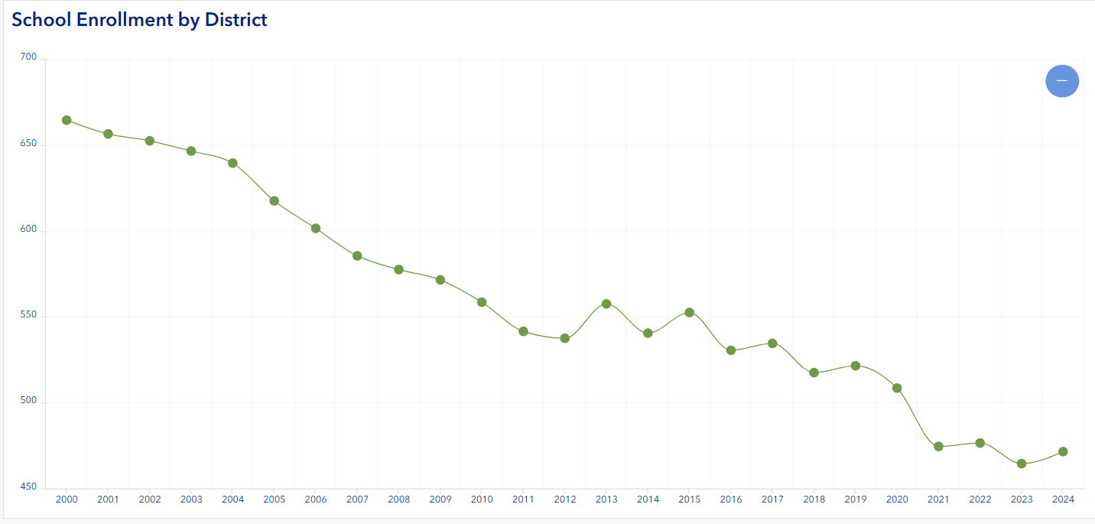
Figure 2: North Warren Central School District Enrollment 2000-2024. Source: New York State Department of Education. https://warren-county-giswarrencountyny.hub.arcgis.com/apps/290c5909c0cd4b5e965c9a925ada5c64/explore

Educational Attainment
A significant portion of the residents of Horicon are at least high school graduates (91.5%), which is similar to the whole of Warren County (91.9%). Almost a quarter of Horicon residents have received a bachelor's degree or higher (24.8%).

Race and Ethnicity
The Town of Horicon has limited racial and ethnic diversity. According to the 2020 Census, approximately 94% of residents identify as White. Other races and ethnic groups represented in the community include Hispanic or Latino (1.56%), Black or African American (0.41%), Asian (0.54%), and American Indian or Alaska Native (0.07%). These demographics closely reflect those of Warren County overall.
Demographic Challenges and Opportunities
The Town of Horicon faces demographic challenges that require thoughtful planning. While the population has remained stable, it is aging, and the town would benefit from attracting younger residents to ensure long-term vibrancy.
The compact hamlets of Brant Lake and Adirondack present a valuable opportunity to promote age-inclusive, environmentally sensitive, and community-focused development. Addressing the needs of an aging population while also creating conditions that appeal to younger generations will be essential.
Expanding housing options, services, and support for small businesses can help meet the needs of residents across all age groups. At the same time, enhancing pedestrian infrastructure will improve mobility for older adults and make the community more attractive to younger families seeking an active, connected lifestyle.
Horicon’s demographic trends are shaped by a range of factors, but they also present an opportunity to support aging in place while cultivating a welcoming environment for new residents and visitors. The goals and recommendations of this plan will seek to respond to these dynamics and guide the town towards a more inclusive and resilient future.

Economic Indicators

Household Size
The most recent Census ACS data shows Horicon with an average household size of 2.0 persons per household. Warren County has an average of 2.1-1.2 persons per household, and New York State as a whole has 2.5 persons per household, which is larger than both the County and Town. Smaller household sizes often reflect that a community has an older population, a higher share of single-person households, or the presence of seasonal or second homes, which are very common in the region.

Median Household Income
The median household income (MHI) represents the midpoint at which half of all households earn more and half earn less. It is a key indicator of a community’s economic health, often correlating with factors such as home values, educational attainment, and employment stability. Lower median incomes may signal a greater need for affordable housing and expanded job opportunities.
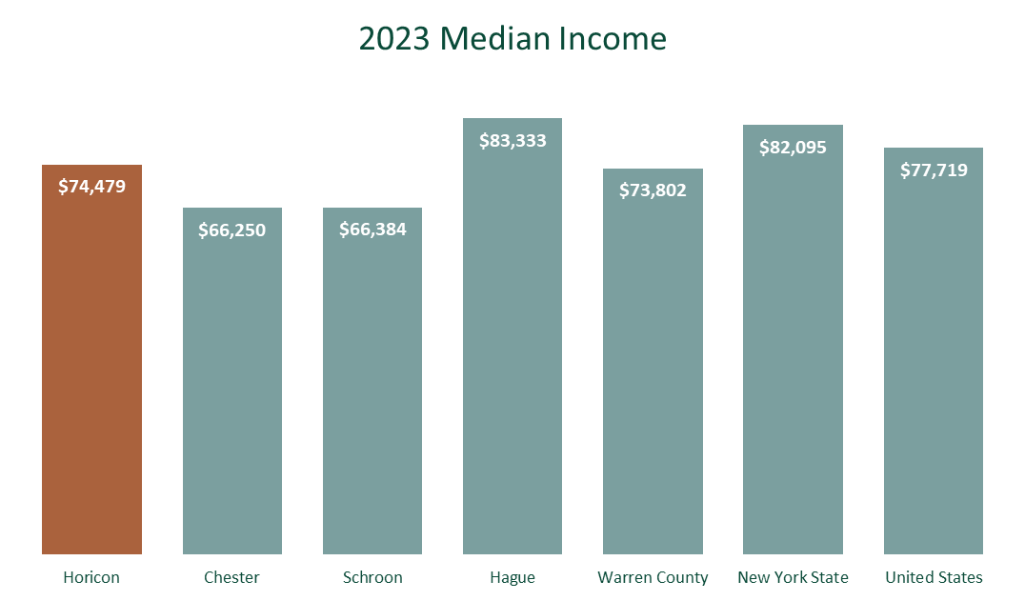
In 2023, the Town of Horicon had an MHI of $74,479 (ACS 5-year Estimate, 2023), slightly higher than the Warren County MHI of $73,802. According to the Warren County Housing Needs Assessment, the MHI for seniors in Horicon is higher than the countywide figure. While Horicon’s MHI is below the New York State and U.S. medians, it remains higher than the neighboring communities of Chester and Schroon (Figure 3).
Figure 3: Selected regional communities, Warren County, and U.S. MHI, 2023. Source: American Communities Survey.

Poverty

Horicon has a relatively low overall poverty rate of 5.3 percent, significantly below Warren County’s rate of 9.1 percent. Poverty rates help illustrate a community’s economic stability, access to jobs and housing opportunities, and need for services. Horicon’s relatively low rate is likely influenced by the high number of retirees in the community and also suggests a generally stable economic environment. However, the picture is more nuanced for younger residents. Among those under age 18, poverty levels are more comparable to the County, with 8 percent in Horicon and 10 percent countywide. This indicates that some families with children may face greater financial strain, highlighting the importance of affordable housing, access to childcare, and opportunities for economic mobility, all of which are challenges that have been identified by the community.

Local and Regional Economic Characteristics

Unemployment Rates and Trends
The unemployment rate in Warren County has been relatively low in recent years, reflecting a tight and resilient labor market. In 2024-2025, unemployment generally hovered between 3.2 and 3.4 percent (not seasonally adjusted), well below the county’s long-term average of roughly 6 percent and lower than typical U.S. rates. Federal Reserve Economic Data (FRED) trends show a sharp decline from a peak of about 8 percent in 2020 to approximately 3.5 percent by 2023-2024, indicating that the county has largely recovered from pandemic-related job losses and continues to demonstrate strong economic stability.
Small communities such as Horicon, however, experience additional dynamics that aren’t always reflected in countywide averages. Seasonal employment patterns and a mix of full-time and part-time work, especially in the tourism, hospitality, and recreation sectors, can create fluctuations in workforce stability and household income. These conditions shape local planning needs related to workforce development, housing affordability, and economic diversification.

Major Employers and Industries
The top industries for workers in the Town of Horicon are Educational Services, and health care and social assistance (16.8%), followed by Retail (14.9%), and Public Administration (14.8%) (Table 2). Major Town and Regional employers include the Town of Horicon and North Warren Central School District. Workers in Horicon are primarily in private industry (65%), followed by government employees (27%) and self-employment (8%) (Figure 4).
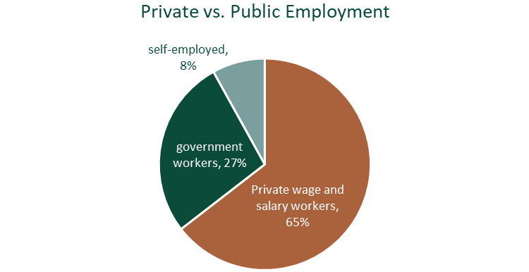
Figure 4: Public versus Private employment In the Town of Horicon
Table 2: Industry for the Civilian Employed Population 16 Years and Over (2023 ACS)
Educational services, and health care and social assistance | 16.8%
Retail trade | 14.9%
Public administration | 14.8%
Construction | 11.2%
Arts, entertainment, and recreation, and accommodation and food services | 9.3%
Finance and insurance, and real estate and rental and leasing | 7.3%
Agriculture, forestry, fishing and hunting, and mining | 6.3%
Professional, scientific, and management, and administrative and waste management services | 5.0%
Other services, except public administration | 4.7%
Manufacturing | 4.2%

Sales Tax
The minimum combined sales tax rate for Warren County is 7%. This is the total of state and county sales tax rates. The New York State sales tax rate is currently 4% and the Warren County sales tax rate is 3%. Warren County is one of three counties in New York with a sales tax rate of 7%, the lowest rate in the state. Sales tax is distributed among municipalities based on assessed value. In 2018, Horicon received $557,059 in sales tax distribution from Warren County.

Property Tax Rates
Property taxes are determined by multiplying the tax rate by the property value per thousand dollars (Table 3). Property tax rates are a key economic indicator because they reflect both a community’s fiscal capacity, and the cost of living and doing business. Higher rates reflect a limited tax base, requiring property owners to carry a larger share of the cost for local services, while lower rates usually indicate a broader or more diverse tax base. Property taxes affect housing affordability and business and development decisions. Overall, tax rates signal how well a community can fund services while remaining affordable and economically competitive.
Table 3: Tax Rates Town of Horicon 2020 – 2025
Source: Warren County Real Property Tax Service Agency
 | 2020 | 2021 | 2022 | 2023 | 2024 | 2025
County | $3.986 | $3.920 | $3.899 | $3.578 | $3.351 | $3.707
Town | $0.880 | $0.906 | $0.936 | $0.512 | $0.466 | $0.421
Fire Pro | $0.382 | $0.380 | $0.381 | $0.333 | $0.388 | $0.411
Schroon Lk Park | $0.034 | $0.033 | $0.033 | $0.241 | $0.030 | $0.027
New EMS (2023) | N/A | N/A | N/A | $0.029 | $0.250 | $0.282

Economic Trends

Housing Characteristics
The town had approximately 1,900 housing units, of which 760 (40%) were occupied by year-round residents, and 1,011 (53%) were seasonal (ACS 5-year Estimates, 2023). This is much higher than the county average of 15% seasonal housing units, but falls between Horicon’s immediate neighbors of Chester, with 37% of seasonal units, and Hague, with 67% seasonal units. The percentage of year-round units has increased slightly over the past 13 years, with approximately 40% of units in 2023 being occupied by year-round residents, compared to about 37% in 2010. Approximately 86% of year-round units are owner-occupied, with 14% renter-occupied.
Approximately 18% of households are considered mortgage-burdened, paying more than 30% of their household income on a mortgage, while nearly 58% of renter households are rent-burdened. About 8% of year-round householders have moved into their homes since 2021, while approximately 18% moved to the Town prior to 1990.
The US Census shows that most homes in Horicon are single-family homes (1,702), followed by mobile homes (198). Approximately 19% of Horicon’s housing stock was built before 1940. The town’s largest increase in housing was in the 1960s and 1980s, with nearly 300 housing units built in each of those decades. In contrast, only 103 homes were reportedly constructed between 2010 and 2023. According to local building permit data, 66 building permits have been issued for single-family units between 2019 and 2024, as well as 10 permits for manufactured homes (Figure 5). 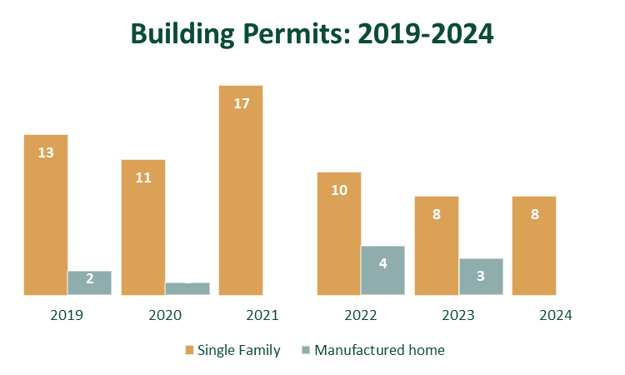
Figure 5: Building Permits issued in the Town of Horicon (2019 - 2024).

Land Use and Smart Growth Focus Areas
Land use
Land use in the Town of Horicon is shaped by multiple layers of regulation, including local ordinances, Adirondack Park Agency (APA) standards, and NYSDEC Unit Management Plans (UMP). These frameworks overlap across different parts of the town, influencing how land can be developed, conserved, and used for recreation.
Public recreation lands account for more than one-third (37.7%) of Horicon’s total land area, including portions of the Lake George Wild Forest and the Pharaoh Lake Wilderness. Publicly owned forests, open spaces, and parklands make up the town’s largest land-use category. Within the hamlet areas, local parks, ballfields, and other recreation areas contribute an additional 3.9% of land area and are classified as Recreation & Entertainment.
Vacant land is also a major land-use category, representing 29.2% of the town. These areas included forested lots without primary structures, hunting lands, underwater parcels, rural properties, and lands used for public utilities. Residential uses make up nearly 27% of the Town’s land area (Map 3. Town of Horicon Land Use Map).
Within the Brant Lake Hamlet, land use is a mix of residential, commercial, and community services with large tracts of vacant land on the perimeter that could provide opportunity for future compatible uses. The Hamlet of Adirondack is primarily residential with pockets of commercial use in the southern portion of the hamlet (Map 5. Hamlets of Adirondack and Brant Lake Land Use Maps).
Smart Growth Focus Areas
The Town of Horicon has two hamlet areas: Adirondack is located in the northern part of the town, and the hamlet of Brant Lake, located in the center of the town at the southern end of Brant Lake. Both hamlets are APA-designated Hamlet Areas and are targeted for growth and development due to several factors that are unique to the Adirondack Park. These hamlet areas are ideal and suitable as focus areas for smart growth, many of which have clusters of residential that could support pedestrian infrastructure and place-based community building. The Hamlet of Adirondack and the Hamlet of Brant Lake are primarily residential, though both hamlets have a small mix of commercial uses. Sidewalks are not present in most areas of the hamlets with no designated bike lanes, often making safety an issue for pedestrians and bicyclists.

Agricultural and Forest Lands, Use, and Districts
The land cover in Horicon is 91% forested, with no large-scale or industrial agricultural operations, although a number of small subsistence farming operations exist. This number is much higher compared with 53% land cover of forested land across New York State. State-owned forest lands within the town are managed by the New York State Department of Environmental Conservation (NYSDEC) under a Unit Management Plan (UMP). These plans evaluate the natural and physical resources of state-owned land, guide public use and recreation opportunities, and ensure that activities align with the assigned land classifications while also considering environmental sustainability. The Town of Horicon reaches into three state land units: Pharaoh Lake Wilderness Area, Lake George Wild Forest Area, and First Brother Primitive Area, all of which are covered under their respective UMPs, and shown in Map 4.

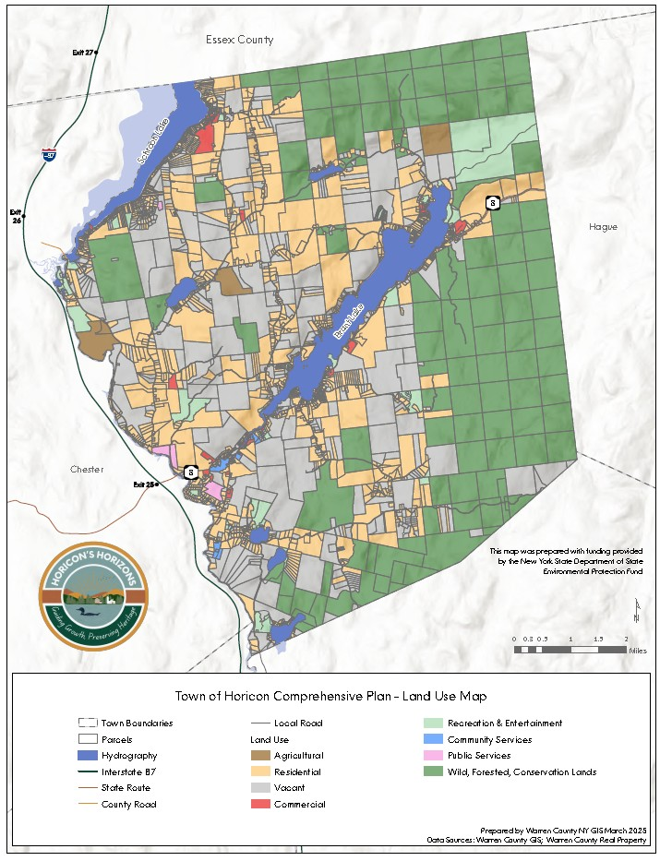

Map 3. Land Use
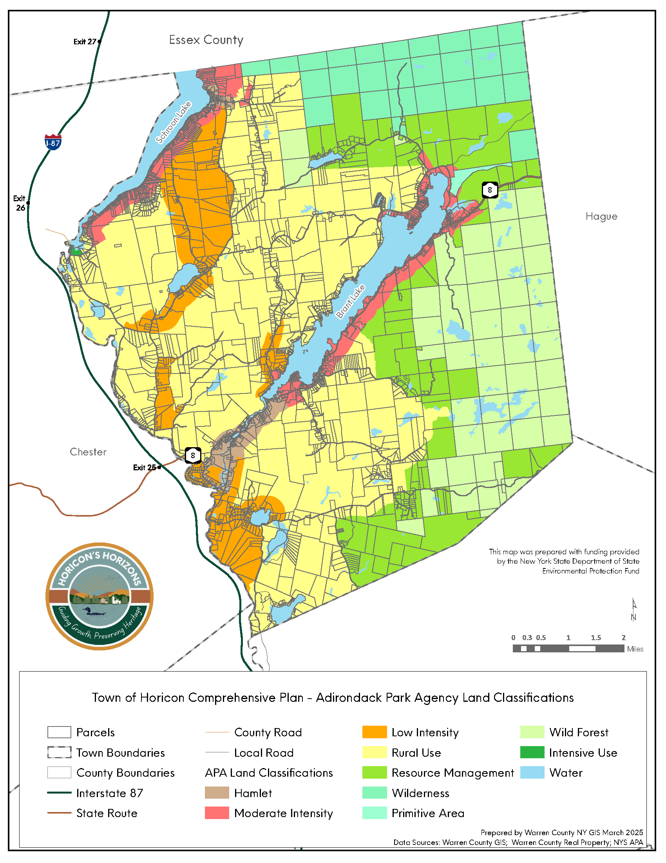

Map 4. Adirondack Park Agency Land Use Classifications
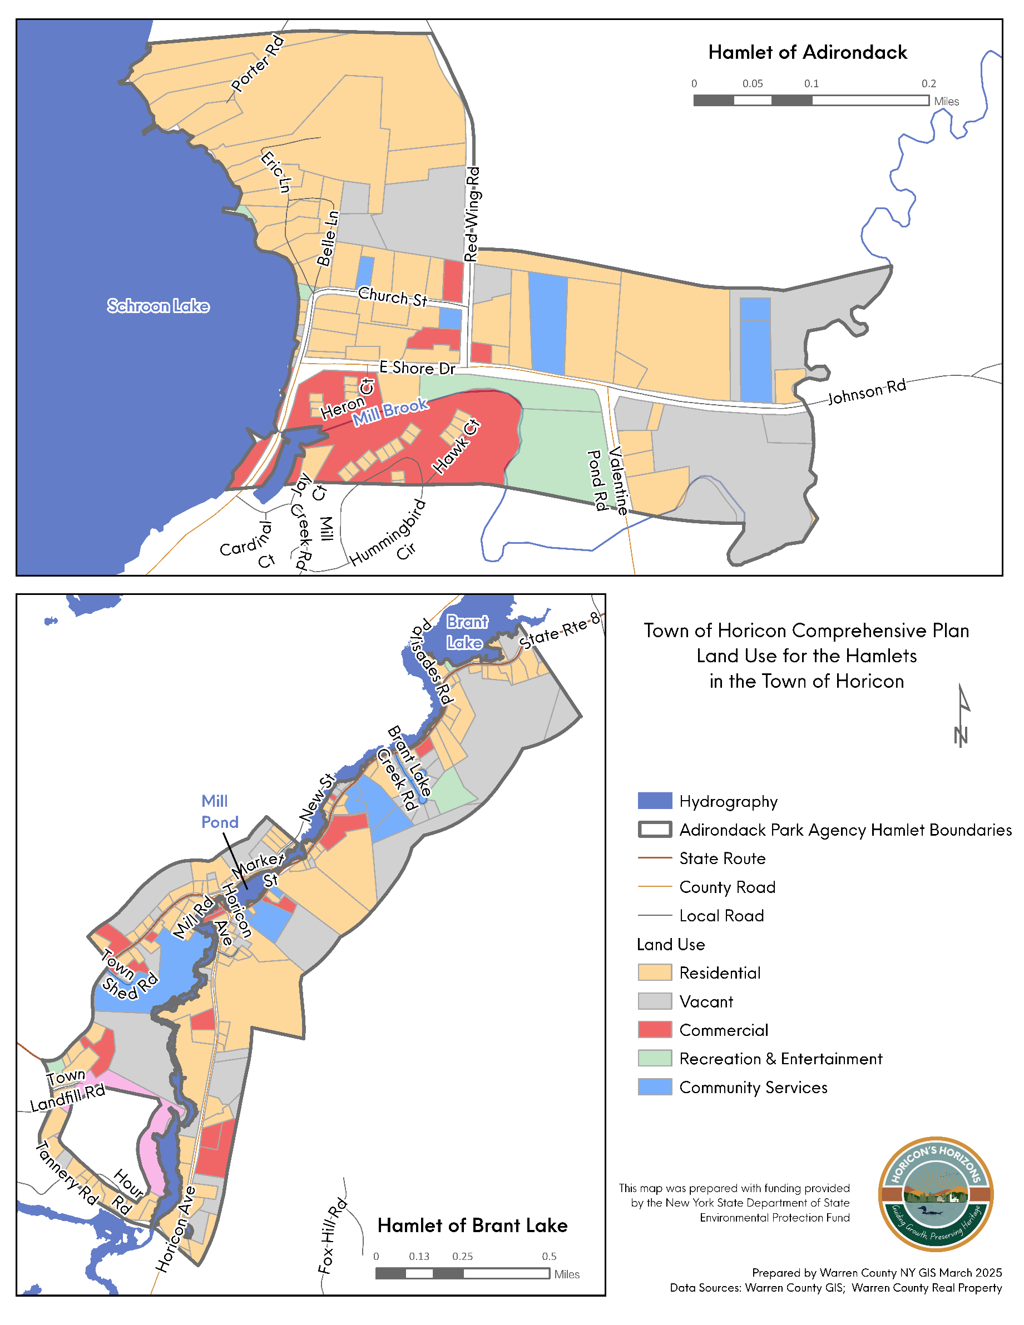

Map 5. Hamlets of Adirondack and Brant Lake Land Use Maps

Zoning and Other Local Development Controls
The Town of Horicon is located within the Adirondack Park. Due to this designation, the Town is subject to Adirondack Park Agency (APA) land controls as well as any locally adopted land use ordinances. Portions of the New York State Park Land within the Town is also subject to a Unit Master Plan (UMP), a plan that is developed by the NYSDEC to manage the properties.
The APA is an independent, executive state agency responsible for developing long-range Park policy in a forum that balances statewide concerns and interests of local governments in the Adirondack Park. Created by New York State law in 1971, the APA regulates development on private land with the Adirondack Park. APA also administers the Adirondack Park Agency Act, the Adirondack Park Agency Rules and Regulations, the freshwater Wetlands Act, and the Wild, Scenic, and Recreational Rivers System Act.
The APA Act §810 defines different land uses and development as class A or class B regional projects based on their location, use, intensity, and other characteristics. Class A regional projects would include higher-intensity or regionally significant development such as a large subdivision near Schroon Lake, a resort hotel, or marina expansion, or a commercial or recreational facility located near a travel corridor like NYS Route 9 that would affect traffic, natural resources, or regional tourism patterns. Class B regional projects include more moderate development that still warrants APA oversight such as smaller residential subdivisions, moderate expansions of campgrounds or seasonal lodging, or commercial uses within hamlet areas that exceed local thresholds but have a more limited regional effect. Together, these classifications help ensure that growth in Horicon, particularly near sensitive waterfronts is scaled and reviewed appropriately to balance economic development with environmental protection.
Local land use programs under the APA Act: Local governments with the Adirondack Park may develop their local land use program known as an Agency-approved Local Land Use Program (ALLUP), which if approved by the APA may transfer some permitting authority from the APA to the local government’s jurisdiction. If a municipality has an APA ALLUP, review jurisdiction over class B regional projects, and variances from shoreline restrictions are transferred to the local governments. Class A regional projects require the Agency to apply certain considerations of the standards and requirements of the local land use program in its review.
Horicon ALLUP: The Town of Horicon has adopted an ALLUP and has two APA-Designated Hamlet Areas. The Hamlets of Brant Lake and Adirondack. Within the Adirondack Park, the Hamlet Areas are the growth and service centers where development is encouraged. There are very few development restrictions from the APA within the Hamlet areas.
Horicon Zoning consists of seven zoning districts and two overlay districts. Most of the town’s land area is classified as Land Conservation, with areas of residential located in hamlets, and along the lakeshore of many of the town’s lakes (Table 4, Map 6).
Note: The Town of Horicon’s Zoning Regulations should be consulted for the descriptions, vision, allowable uses, intent, and densities for each district.
Table 4: Town of Horicon Zoning Districts and District Intent
Zoning District | Purpose and Intent/Vision
Residential 1 | The vision for this district is to maintain the scenic residential environment, and promote and protect the residential character and physical environment of lakeshore areas, while providing for tourism and resort-oriented businesses consistent with traditional land uses found along the town’s lakeshores
Residential 1A | This district is envisioned as lower density residential neighborhoods that provide  affordable rural building lots
Residential 2 | The district includes the purposes and intent of Residential 1 and Residential 1A, but with rural residential and home-based commercial developments
Commercial/Residential (Mixed Use) | Serve as focal points and growth centers for neighborhoods
Land Conservation | There are three main intentions:  (a) Promote and protect the open space  character of the environment, (b) Allow for recreation, agriculture, forestry and other  open space uses of land, and (c) Allow for low density rural residential development  and home-based businesses
Recreational River District | This district is envisioned as mixed use rural residential areas that prioritize maintaining open lands, public use of the river, and riverfront
Industrial | Opportunity for development of forest and ag lands, commercial sand and gravel extraction, mineral extraction, public utility expansion, and hunting and fishing specific structures
Adirondack Hamlet Design Review Overlay | Continue to build on community public amenities, such as the Town Park and Recreation Facilities
Millpond Overlay | Preservation of scenic qualities of selected travel corridors

Planning Board: The powers of the Planning Board include review and approval of Site Plans, and the issuance of Conditional Use Permits. Additionally, the Planning Board provides advisory opinions on the Town Board on proposed amendments to Zoning Law and any matter related to planning and zoning.
Zoning Board of Appeals: The Zoning Board of Appeals (ZBA) rules on appeals to decisions made by the Zoning Enforcement Officer and requests for variances to the zoning law.
Subdivision Review: The Planning Board can grant subdivision approvals. Subdivision of land is what drives growth and development in a community. When zoning and subdivision controls are separate, they can ensure well-ordered development. An important feature of subdivision control is that it attempts to ensure that when development does occur, it will be accompanied by adequate services and facilities.
Short Term Rental Law: In March 2025, the Town Board of Horicon adopted a Local Law Regulating Short-Term Rental Units in the Town of Horicon. The purpose and intent of the Local Law is to establish the means to secure the health, safety, and welfare of property owners, residents, and the public regarding the operation of Short-Term Rental businesses. The law requires short-term rental hosts to obtain a revocable permit and restricts the number of permits for short-term rentals to a maximum of 135, which is approximately 7.5% of all dwelling units in the town.
Zoning Analysis
The Comprehensive Plan is intended to serve as a foundational guide for zoning regulations in the State of New York. During this process, the Comprehensive Plan Committee and planning team will conduct a review of the existing land uses, potential future land uses, and the Land Use Ordinance to identify any potential conflicts and make recommendations for future changes or further analysis.
The planning process will also consider the frequency and nature of variance requests, the types of cases presented to the Zoning Board of Appeals, and the clarity and relevance of existing definitions, use categories, and bulk requirements. This evaluation will help ensure that the zoning regulations align with the current and future needs of the community.
Zoning and Smart Growth
The hamlets of Brant Lake and Adirondack are designated APA Hamlet Areas suitable from mixed-use development, combining residential and some commercial uses. Redevelopment is focused in the APA Hamlet Areas where infrastructure exists, and Site Plan review prioritizes compatible infill development and revitalization. The Hamlet areas are compact, service-centered, and appropriate for growth.

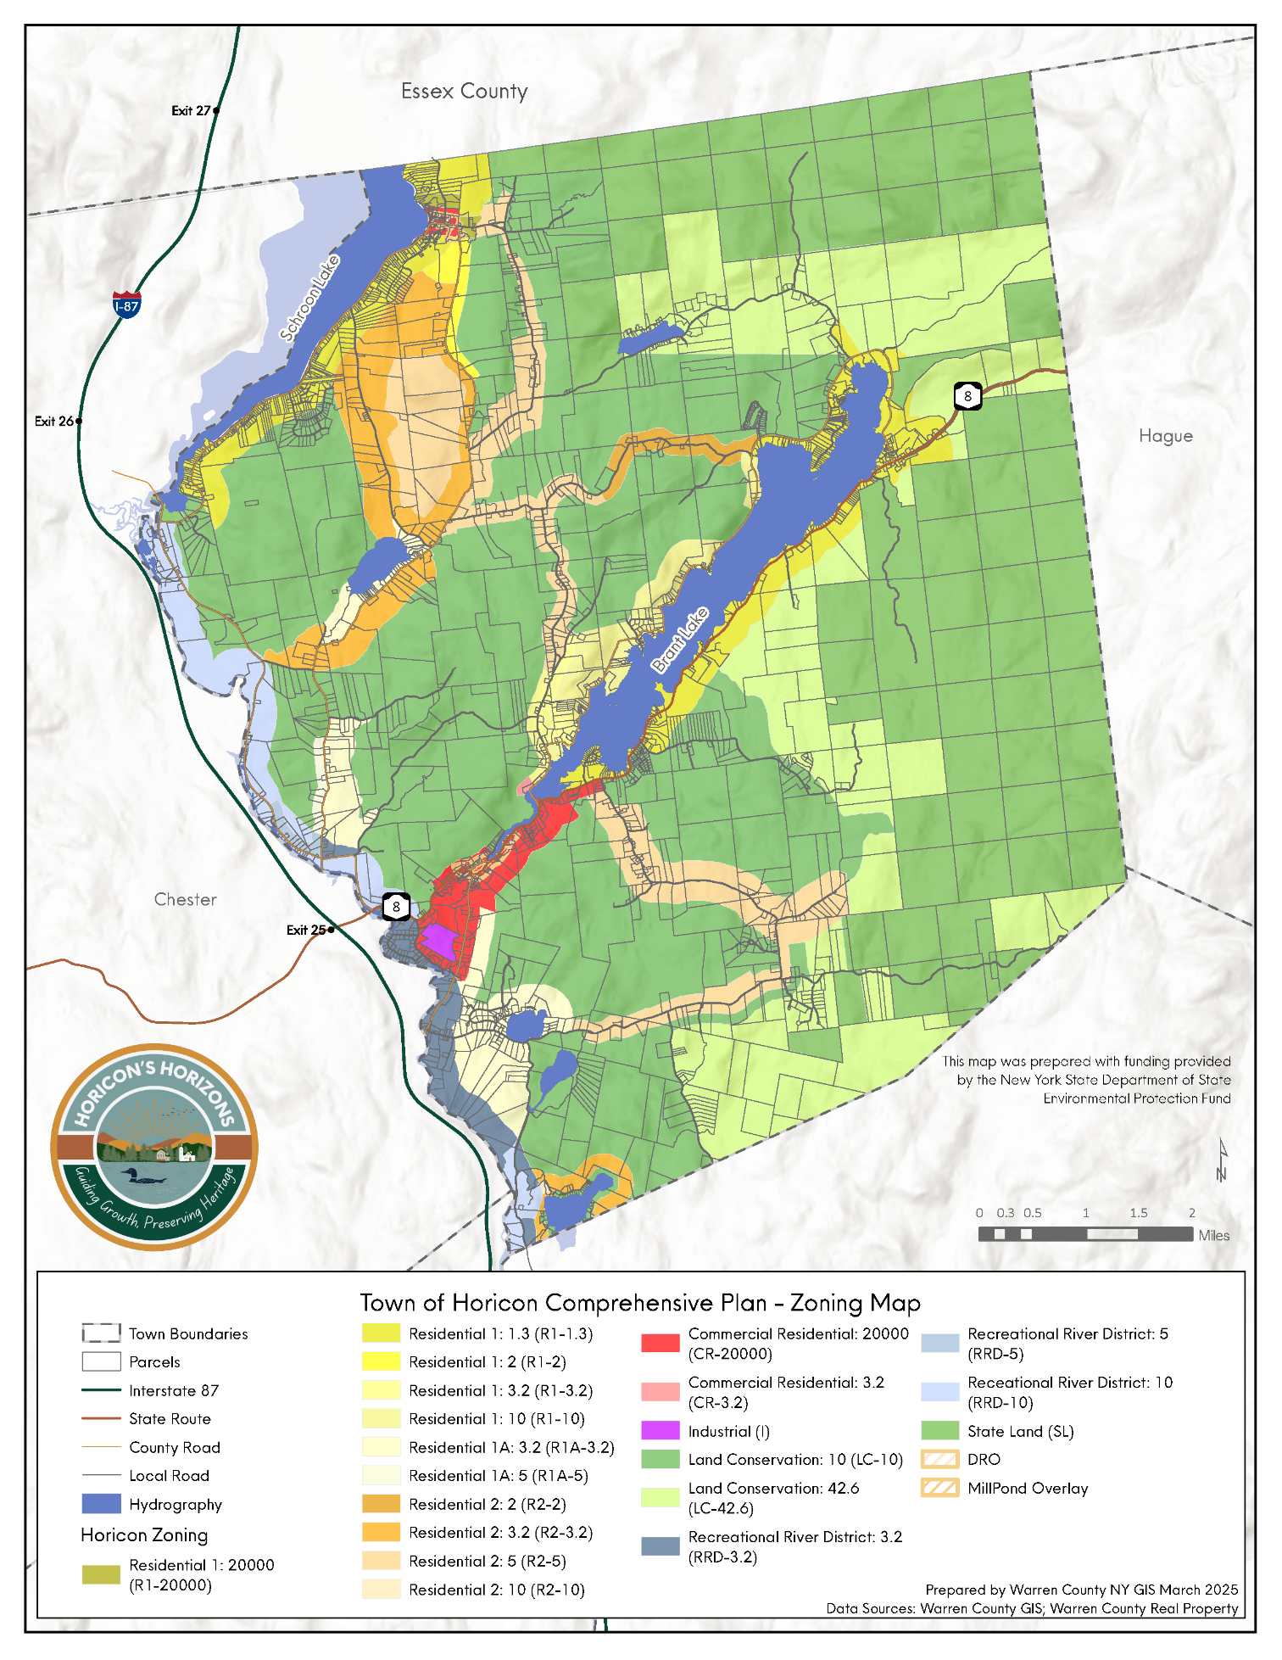

Map 6. Town of Horicon Zoning Map
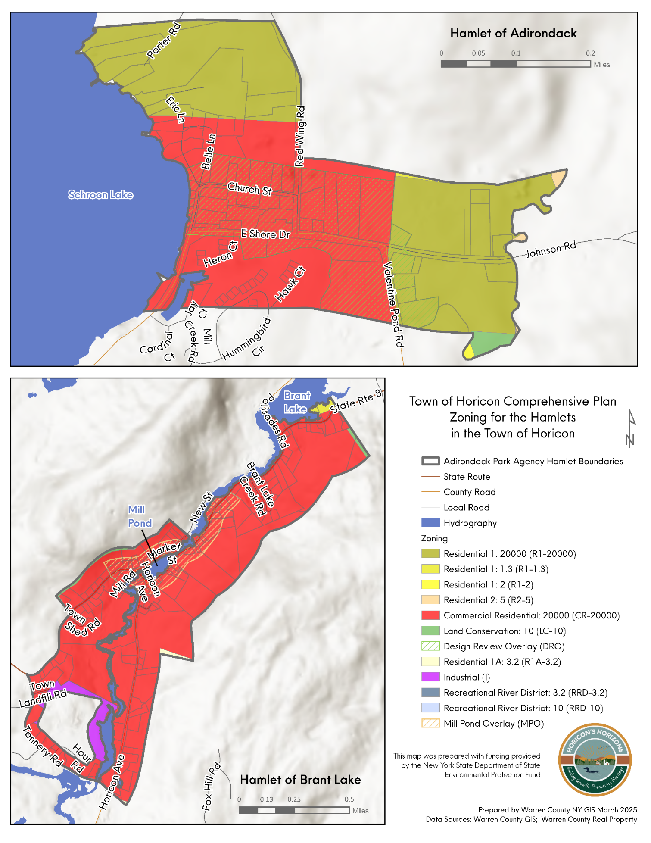

Map 7. Town of Horicon Zoning within the Hamlets of Adirondack and Brant Lake

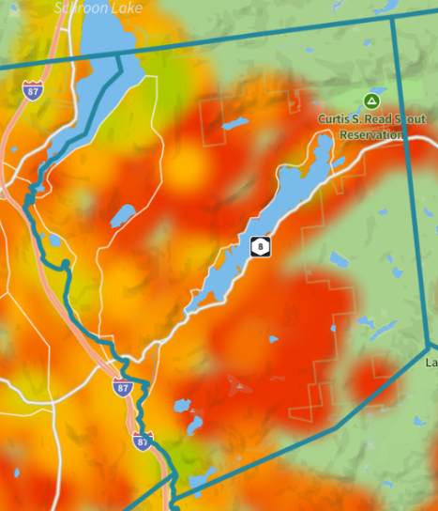
Infrastructure
Water supply and wastewater disposal is provided either by individual on-site systems or by private community septic systems. There are no town water supply or sewage collection and treatment system.

Cellular Infrastructure
Figure 6 illustrates the 4G and 5G signal strength for wireless providers across the region, using a color-coded scale where red represents no signal (-120 dBm), orange indicates poor signal (-106 dBm), and yellow denotes fair coverage (-95 dBm). Green shades represent stronger connectivity, with good (-81 dBm) and excellent (-40 dBm) signals appearing in limited areas.
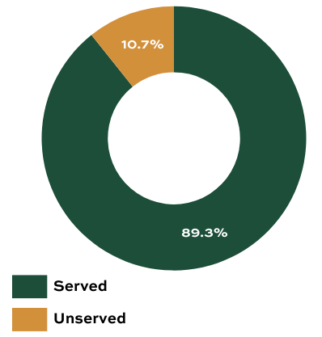
According to the map, much of Horicon experiences weak or nonexistent wireless coverage. Large portions of the town are categorized as having poor or no signal, particularly in more rural and forested areas. This limited connectivity can present challenges for residents, businesses, and visitors, especially in terms of accessing essential communication services, emergency response, and modern digital infrastructure needs.
Figure 6: Signal Strength in the Town of Horicon Source: Ookla Speedtest Data

Broadband Connections
The New York State Broadband Map evaluates the availability, reliability, and affordability of high-speed internet across communities statewide. In Horicon, approximately 89% of homes have internet access, while 11% are classified as unserved (Figure 7), lacking a fixed wireless or wired internet connection, or having connected speeds below 25 Mbps. Connection and service fees can be deemed a hurdle to future broadband connection. High costs for broadband create a situation where residents are classified as served but have not chosen to connect due to the high price.
Figure 7: Broadband coverage in the Town of Horicon. https://mapmybroadband.dps.ny.gov/explore?address=Horicon,%20New%20York
Challenges and Opportunities
The Town of Horicon has identified broadband and cellular connectivity as a critical issue affecting public safety, workforce development, and economic growth. Gaps in reliable internet and cell service pose challenges for emergency response, remote work, business operations, and access to essential services. There are opportunities for the Town to participate in regional and statewide initiatives working towards broadband improvements and enhancing cellular coverage in rural communities.
Transportation Systems
The Town of Horicon relies primarily on personal vehicles, as there is no public transportation currently available. Located near the I-87 Highway (Adirondack Northway), the town has three main transportation corridors: County Route 15, along Schroon Lake; State Route 8; and County Route 26, both of which run along the shores of Brant Lake and provide direct access to I-87. Among these, State Route 8 is the most frequently traveled, with an Average Annual Daily Traffic of 2,030 in 2023 (source: Department of Transportation Traffic Data Viewer- https://www.dot.ny.gov/tdv )
With the growing adoption of electric vehicles (EVs), the demand for charging stations is expected to increase. As of 2023, the Town of Horicon has no public EV charging stations, with only one private Direct Current fast charging station located near the Mill Pond area of Brant Lake. Countywide, Warren County has expanded its charging infrastructure significantly, increasing the number of available stations from 9 in 2017 to 214 in 2023. With the increase in electric cars on the road, it would be beneficial for the Town to consider EV stations in high traffic areas.
Commuting: On average, residents of Horicon spend 23 minutes commuting to work, which is similar to Warren County with an average travel time of 22.9 minutes. Over 81% of workers over the age of 16 report commuting alone, 4.9% carpool, and 10% work from home.
Bicycle and Pedestrian Mobility: Bicycle and pedestrian mobility are limited throughout the community, with sidewalks absent from the more densely populated hamlets of Adirondack and Brant Lake. Additionally, there are no dedicated bike lanes or shared lane markings, "sharrows", on popular cycling routes such as County Route 15 and State Route 8. Overall, the National Walkability Index lists the Town of Horicon as Least Walkable, where almost all errands require a car. This is partly due to a general lack of commercial businesses, including grocery stores, pharmacies, or doctor’s offices.
Transportation and Smart Growth: Although Horicon’s transportation system is largely vehicle oriented, these conditions present opportunities to apply Smart Growth principles in a rural context by focusing investment within existing corridors and hamlet centers rather than encouraging new sprawl. Strategic placement of EV charging stations in high-traffic areas such as State Route 8 or near I-87 access points, or within Brant Lake and Adirondack could support changing travel patterns, reduce emissions, and enhance the Town’s attractiveness to residents and visitors. Similarly, incremental bicycle and pedestrian improvements could improve safety support tourism and recreation, and enable short local trips without a car. Together, these targeted investments would strengthen existing community centers, expand transportation choice, improve public health, and advance sustainability goals while maintaining Horicon’s rural character.

Natural Resources
Several key surface waters exist in the Town of Horicon which provide valuable environmental and economic resources such as Schroon Lake, Brant Lake, and the Schroon River. Other surface waters include:
- Beaver Pond | - Burnt Pond
- Crystal Lake | - Mill Brook
- Sherman Lake | - Streeter Pond
- Valentine Pond | - Lily Pond
- Island Pond | - Round Pond  - Long Pond

Most waterbodies in Horicon are part of the Upper Hudson River Watershed, which ultimately drains into the Hudson River. However, waterbodies in the southeastern portion of the town, including Island Pond, Long Pond, and Round Pond, belong to the Lake Champlain Watershed. These waterbodies flow into Lake George and eventually drain to Lake Champlain and finally into the Saint Lawrence River.
The NYSDEC Division of Water monitors and assesses New York State’s waterbodies, assigning them letter grades (AA, A, B, or C) to establish water quality and stream management standards. Class AA and A waters meet the highest standards for water supply, swimming, and fishing, Class B waters are regulated to standards for swimming and fishing, and Class C waters are regulated to standards suitable for fishing. In Horicon, most major waterbodies are classified with an A rating. However, certain uses of Schroon Lake and Brant Lake are impaired by pollutants such as mercury, phosphorus, arsenic, dissolved oxygen, and iron. A summary of NYSDEC assessed waterbodies can be found in Table 5.
Table 5: Assessed Waterbodies in Horicon
Source: NYSDEC
Waterbody | Classification | Use Assessment – Use Category
Brant Lake | AA-Special | Impaired – Fishing, Source of Water Supply
Schroon Lake | A | Impaired – Fishing, Secondary Contact Recreation, Primary Contact Recreation, Source of Water Supply
Lily Pond (Minor Lake Tribs to Brant Lake Watershed) | AA- Special | Impaired – Fishing
Spuytenduivel Brook | AA- Special | Stressed – Fishing

Shoreline development is concentrated along Brant Lake and Schroon Lake, which consists of both residential and commercial uses in the hamlets of Brant Lake and Adirondack. Sherman Lake also has concentrated residential development, while other waterbodies maintain more open space and have limited developed use. The Town of Horicon regulates shoreline development in accordance with APA regulations. This is due to development increasing the risk of pollutants carried by stormwater runoff and lawn fertilizer, which can degrade water quality, promote the growth of aquatic invasive species, and increase the likelihood of harmful algal blooms.
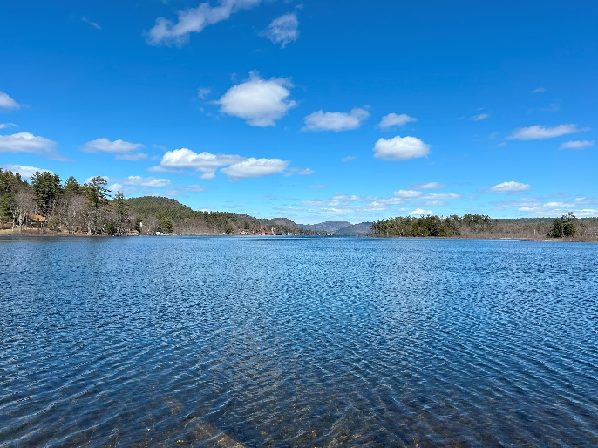
Smart Growth principles support Horicon’s shoreline regulations by encouraging compact, well-sited development and conservation of sensitive natural resources, which in turn reduces impervious surfaces and limits stormwater runoff into lakes and streams. By directing growth toward existing hamlet areas and away from shorelines, Smart Growth helps minimize nutrient loading from fertilizers, septic systems, and roadways that can degrade water quality, contribute to aquatic invasive species, and increase the risk of harmful algal blooms. Complementary practices—such as preserving natural shoreline buffers, promoting low-impact development techniques, and encouraging redevelopment over new shoreline disturbances will reinforce APA regulations while protecting lake ecosystems, sustaining recreational value, and supporting long-term environmental resilience.
Schroon Lake and Brant Lake have significant populations of aquatic invasive species, including Eurasian Milfoil and Curly Leaf Pondweed, which impact their water quality. Efforts to manage these invasives include education campaigns, outreach initiatives, and direct interventions supported by local lake associations and Towns. In 2023, Brant Lake successfully underwent treatment with an aquatic herbicide to control the spread of Eurasian Milfoil.
Photo 3: Brant Lake, LCLGRPB
Volunteer organizations, such as the Brant Lake Association and the East Schroon Lake Association, play a vital role in protecting and improving the water quality of their respective lakes through education and outreach, and other conservation initiatives.
Wetlands: Within the Adirondack Park, wetlands are the responsibility of the Adirondack Park Agency. Under the APA Act and the NYS Freshwater Wetland Act, almost all land uses, such as draining, dredging, placing fill, structures, and subdivisions in, or involving wetlands require an APA permit. APA-regulated wetlands are dispersed throughout the town and generally follow stream corridors.

Topography
Much of the Town can be characterized as having hilly and mountainous terrain. The average elevation is about 1,105 feet above sea level, ranging from a low of about 715 feet in the Schroon River valley in the south, to a high point of little over 2000 feet at the summit of Park Mountain in the north of the town. Among the higher mountains and hills include Park Mountain, Number Eight Mountain, Second Brother Mountain, Little Stevens Mountain, Sutter Mountain, First Brother Mountain, Prickly Ash Mountain, Fox Mill, Pollyann Mountain, Amasa Mountain, Phoebes Knob, Sand Beach Mountain, Bartonville Mountain, Grasshopper Hill, Buck Mountain Baldwin Mountain, Pine Mountain, and Hawk Hill.
The elevation of the Town affects the layout of site improvements, stormwater drainage, and the suitability of land that can be developed. Low-lying areas can be prone to flooding, and understanding the absolute elevation as well as elevation change across a site can provide insight into the potential for the existence of floodplains, wetlands, and other sensitive environmental features. Disturbance of areas with steep slopes is regulated under the Town’s Comprehensive Zoning Law and Subdivision Regulations.

Geology and Soils
The bedrock in Horicon consists of various types of metamorphic rock, formed through the heat and pressure acting on igneous or sedimentary rock foundations. The Adirondack rocks, found in this region, are among the oldest in the United States.
Surficial geology, which refers to the material near the Earth's surface, primarily consists of glacial till in most areas of Horicon. This till was deposited as a sheet during the glacier's retreat and generally forms a thin layer of clay or clay-loam material with low porosity. However, the thickness and porosity of this layer can vary significantly across different locations.
Horicon's geologic features are notable for their influence on the location and types of development possible within the area. Additionally, the town's geology affects the availability and distribution of groundwater deposits, which is particularly critical since the entire town lacks access to public water services.
The Town of Horicon’s soils are primarily forest-dominated soils. They are acidic, course textured, and typical of coniferous or mixed forests. They have low fertility and are not typically ideal for agriculture. Additionally, soils in Horicon are shaped by glacial till and glacial deposits. This leads to variable soil depth, and poor drainage in some areas.
Smart Growth principles encourage directing growth toward areas with more suitable soils and existing development patterns, reducing the need for extensive land disturbance and costly infrastructure. By emphasizing compact development, conservation of forested lands, and redevelopment within established hamlets, the Town can protect groundwater resources, minimize erosion and stormwater runoff, and avoid development in areas where geological and soil limitations increase environmental and public health risks, all while preserving Horicon’s natural landscape and rural character.

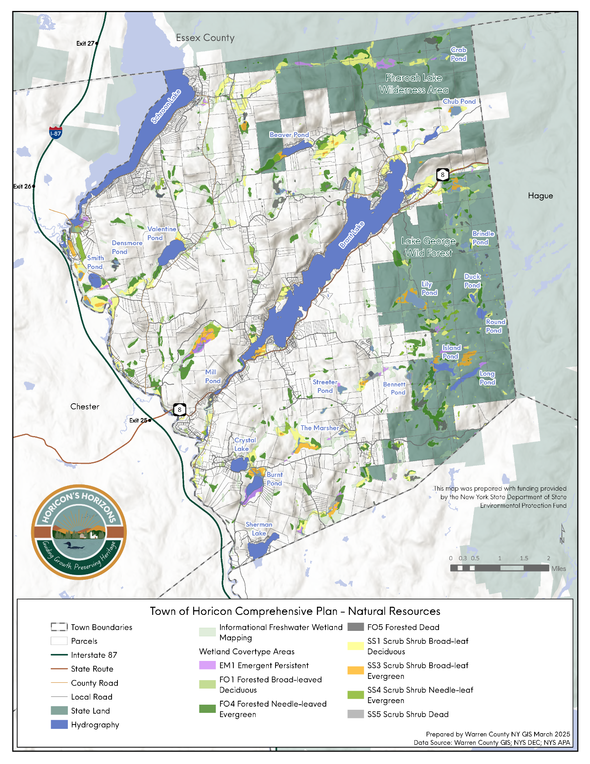

Map 8. Natural Resources
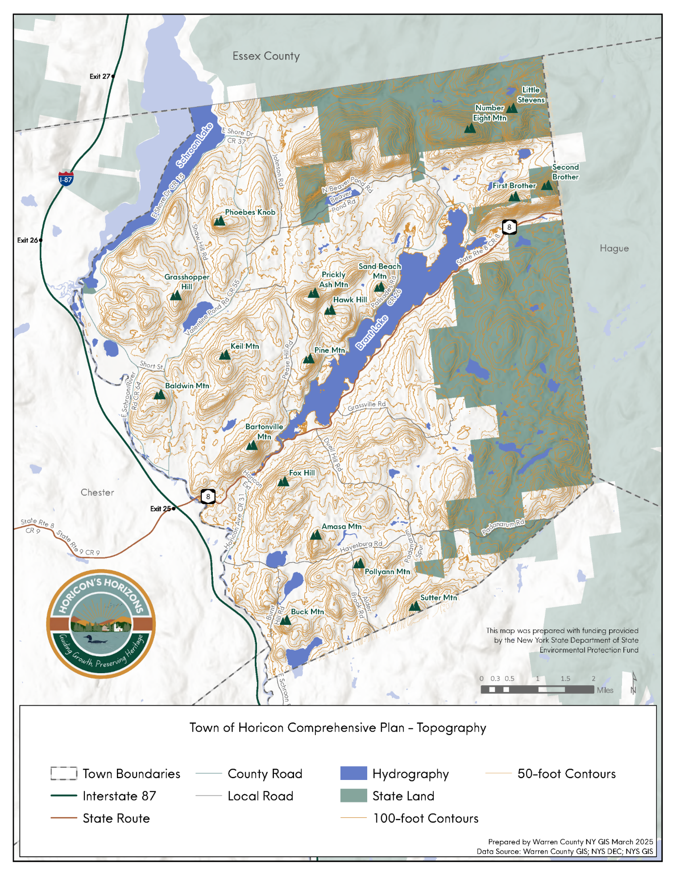

Map 9. Topography

Rare Plants, Animals, and Important Habitats
Within the Town of Horicon, one historically present mammal is classified as a species of special concern. Additionally, four species of threatened flowering plants have been confirmed or are considered possibly present. The Town also features two upland natural communities, four freshwater nontidal wetlands, and one river or stream. Rare plants, animals, and important habitats in Horicon are summarized in Table 6.
Table 6: Rare Plants, Animals, and Important Habitats by Location
Source: NYSDEC
Animals: Mammals
New England Cotton Tail | Historically Confirmed | Special Concern
Plant: Flowering Plants
Alternate-Flowered Water Milfoil | Historically Confirmed | Threatened
Clustered Sege | Possible but not Confirmed | Threatened
Pink Shinleaf | Recently Confirmed | Threatened
Red Pondweed | Historically Confirmed | Threatened
Natural Community: Uplands
Maple-Basswood Rich Mesic Forest | Recently Confirmed
Spruce-Fir Rocky Summit | Recently Confirmed
Natural Community: Freshwater Nontidal Wetlands
Inland Pond Fen | Recently Confirmed
Northern White Ceder Swamp | Recently Confirmed
Sedge Meadow | Recently Confirmed
Shrub Swamp | Recently Confirmed
Natural Community: Rivers and Streams
Mash Headwater Stream | Recently Confirmed

Items in the above chart labeled “Recently Confirmed” are those that have been observed and verified within the last 30 years. Items labeled “Historically Confirmed” have been observed more than 30 years ago.

Extreme weather events, Flooding, Erosion Hazards, and Local Resiliency
In 2023, Warren County undertook and adopted an update to its Countywide Hazard Mitigation Plan. This plan includes specific environmental and natural hazards that have affected the Town of Horicon in the past and prioritizes hazard mitigation actions for the future. The Town of Horicon representatives highlighted one significant event as having adverse impacts on Town operations, the Halloween Storm of 2019, which caused flooding. Table 7 summarizes Horicon’s self-ranking of their community's risk and vulnerability when faced with hazard events:
Table 7: Horicon Risk and Vulnerability Assessment
Hazard | Risk
Extreme Temperature | Medium
Flood | Low
Severe Storm | High
Severe Winter Storm | High
Wildfire | Low
Dam Failure | Medium
Identified issues and vulnerabilities for Horicon within the Warren County Hazard Mitigation Plan include:
- Limited Town-wide emergency notification system
- Aging infrastructure, primarily culverts
- Lack of Town specific emergency planning
- Lack of water level control systems for Brant Lake
Climate Change
Like many rural communities, the Town of Horicon faces growing challenges associated with a changing climate. Climate change is considered a threat multiplier, intensifying existing issues and introducing new ones. Its impacts can include loss of life, property damage, strain on infrastructure, environmental degradation, and a decline in the overall quality of life within the community. Warren County is currently certified Bronze in the New York State Climate Smart Communities Program and is also designated as a New York State Clean Energy Community. These programs support local governments in adapting to climate change by providing grants and technical assistance for specific mitigation and resilience actions. However, as of 2025 the Town of Horicon is not an active participant in either program.
Temperature: Average temperatures in New York State are projected to rise by 5 to 11°F, resulting in more frequent heating days, which are periods of extreme heat. This poses serious health risks for Horicon’s aging population, including an increased risk of heat stroke, respiratory issues, and cardiovascular complications. Prolonged heat events can also place additional stress on local emergency services. To address this, in 2024, the Warren County Office of Emergency Services has established a network of eight Cooling Centers, offering safer conditions during extreme heat. While none of these cooling centers are located in the Town of Horicon, the County does publish a list of cooling centers for the public to access if needed. Additionally, warmer temperatures have also contributed to a rise in tick populations, increasing the prevalence of Lyme disease in the region. Warren County now averages 151.8 cases per 100,000 residents, significantly higher than the New York State average of 54.1.
Environmental Impacts
Invasive Species: Due to warming temperatures, parts of the Adirondack region have become more susceptible to the spread of terrestrial and aquatic invasive species. Two of the most pressing concerns are the spread of the Hemlock Woolly Adelgid (HWA) and Beech Leaf Disease (BLD). The spread of either can have detrimental and cascading effects on Horicon’s forests as well as other environmental impacts. Both HWA and BLD have been found in Warren County, as close as the Lake George area. Currently, Warren County is working with the NYSDEC to contain infestations of both.
Severe Storms: Climate change is also increasing the frequency and severity of storm events, with regional precipitation expected to rise by more than 10%, much of it in the form of short, intense rainfall events. These events can cause flooding in low-lying areas near waterbodies and damage critical infrastructure such as roads, bridges, and culverts, underscoring the need for resilient planning and investment.

Community Services
Emergency Medical Services: The North Warren Emergency Squad is a 501(c)(3) non-profit organization that provides paramedic and emergency services to the Towns of Horicon and Chester. The Squad is partially funded through a special tax district in both towns but relies heavily on donations and patient billing. In 2021, they responded to over 700 EMS calls and had a total of 22 staff members.
Volunteer Fire Department: The Town of Horicon is served by a single volunteer fire department, the Horicon Volunteer Fire Department, which operates a main station on the Mill Pond in Brant Lake and a substation in the hamlet of Adirondack.

Parks and Public Spaces
Trails and Campsites: There are several foot trails located on state forest preserve lands, as well as several state funded snowmobile trails. Many snowmobile trails are located within the Lake George Wild Forest area, and others run through a combination of public and private lands as well as lightly traveled roads within the Town. Some of the hiking trails available to the public include Fox Hill trail, a 1.6-mile round trip trail located behind the Town of Horicon Municipal Center, Lily pond and Round pond trails, which is 5.2 miles round trip, as well as the Crab pond trail, which is 5.6 miles round trip. Bartonville Mountain in Brant Lake has a 0.7-mile trail, and there are several trailheads located in the Town including Sucker Brook trailhead, Pharoah Road trailhead, Padanarum Road trailhead, among others. Additionally, there are DEC campsites located on Long Pond, Island Pond, Lily Pond, Round Pond, as well as campsites in the Pharoah Lake Wilderness.
Town Beaches: The Town of Horicon operates two beaches. There is currently a small beach on Schroon Lake in the hamlet of Adirondack, and the second beach is located on Mill Pond on the Brant Lake outlet.
Boat Launches: There are three public boat launches in the Town of Horicon. Two are on Brant Lake, and one is on Schroon Lake. These boat launches are described further in the Waterfront Resources section of the plan and identified on the parks and open space map (Map 2).
Parks and Playgrounds: The town maintains two little league fields, one in Brant Lake located behind the Town Hall, and a second in the hamlet of Adirondack. The Brant Lake recreation area has a playground, and the facility in Adirondack includes tennis courts. Additionally, there is a 207-acre bike park with 6 miles of mountain bike trails located in Brant Lake, on Market Street.
Summer Camps: The Adirondacks have a rich history as a summer camp destination. For generations, the beautiful lakes of the region have catered to the youth of the time. Horicon is no different. Two specific summer camps that are in the town include:
- Point O’Pines is a girl’s summer camp located on a peninsula in Brant Lake. The location mixes the natural beauty of Brant Lake with a peaceful seclusion of the Adirondack. It has been offering recreational opportunities, and activities that boost confidence, independence, and harness lifelong friendships since 1957.
- Brant Lake Camp is a boy’s summer camp that has been around since 1916. For generations, this camp has offered a mix of activities such as sports, arts, adventure, and leadership development.
Fiscal Resources
In November of 2024 the Town adopted the budget for Fiscal Year 2025. The Town Supervisor is the Chief Fiscal Officer and the Chief Executive Officer, and the Town Board acts as the executive and legislative branch. The Town Board is responsible for adopting the annual budget of $4,148,787.05.
The 2025 adopted budget is consistent with previous’ years budgets for the Town of Horicon. The Town’s general fund revenues are generated from property tax, bed tax, redistribution from collected county taxes, fees and permits, the sale of cemetery lots, service fees, collected interest, and fines. State and federal aid are also an annual revenue source for the Town. Special Districts of Horicon Ambulance, Fire Protection District, Schroon Lake Park District, and the highway fund are also responsible for budget revenue. A summary of the fiscal budget by fund is included in Table 8 below:
Table 8: Horicon Budget Summary
Fund | Appropriations | Estimated Revenue | Unexpected Fund Balance | Amount to be Raised by Tax
General Fund | $ 1,602,952.22 | $ 1,586,184.00 | $ 16,768.22 | $ 0.00
Highway Fund | $ 1,959,896.83 | $ 1,392,594.00 | $ 217,900.83 | $ 349,402.00
Horicon Ambulance | $ 235,996.00 | $ 0.00 | $ 0.00 | $ 235,996.00
Fire Protection District | $ 344,306.00 | $ 0.00 | $ 0.00 | $ 344,306.00
Schroon Lake Park District | $ 5,636.00 | $ 0.00 | $ 0.00 | $ 5,636.00
GRAND TOTAL | $ 4,148,787.05 | $ 2,978,778.00 | $ 234,669.05 | $ 935,340.00

The Office of the New York State Comptroller maintains the Fiscal Stress Monitoring System, which acts as an early warning tool used by the State and local governments to provide feedback to local leaders, State officials, and taxpayers about fiscal stress conditions to help them prioritize the needs of their community. According to the latest self-assessment submitted by the Town of Horicon in 2023, the fiscal stress score was 3.3, resulting in No Designation. According to the system, Horicon has remained in a healthy fiscal position since 2021.

Grant History
In the past five years, the town has received a total of $504,750 across 17 different grants. The preservation and restoration of historic sites, protection of water quality, and ensuring the recreation economy thrives are all priorities for the town as evidenced in the successful grant applications to funding entities such as the New York State Dormitory Authority and Adirondack Architectural Heritage (AARCH). The Town of Horicon’s grant funds help to inform and implement town priorities. This Comprehensive Plan will help to identify potential projects and new funding courses that will allow the Town to secure additional funding and move forward in a resilient manner.

