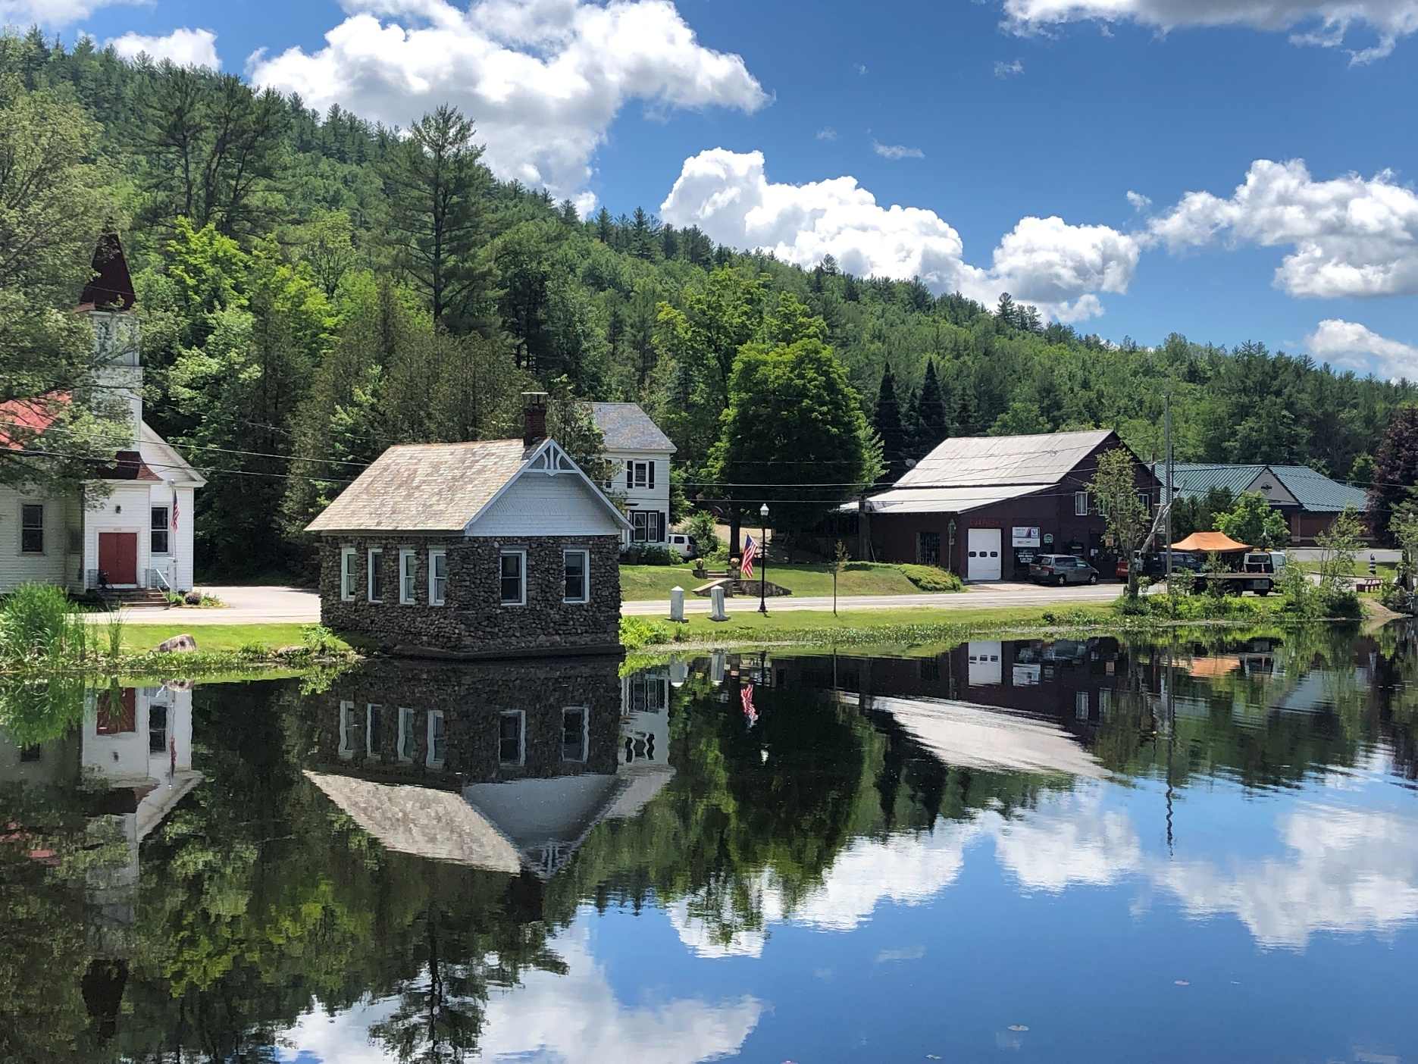
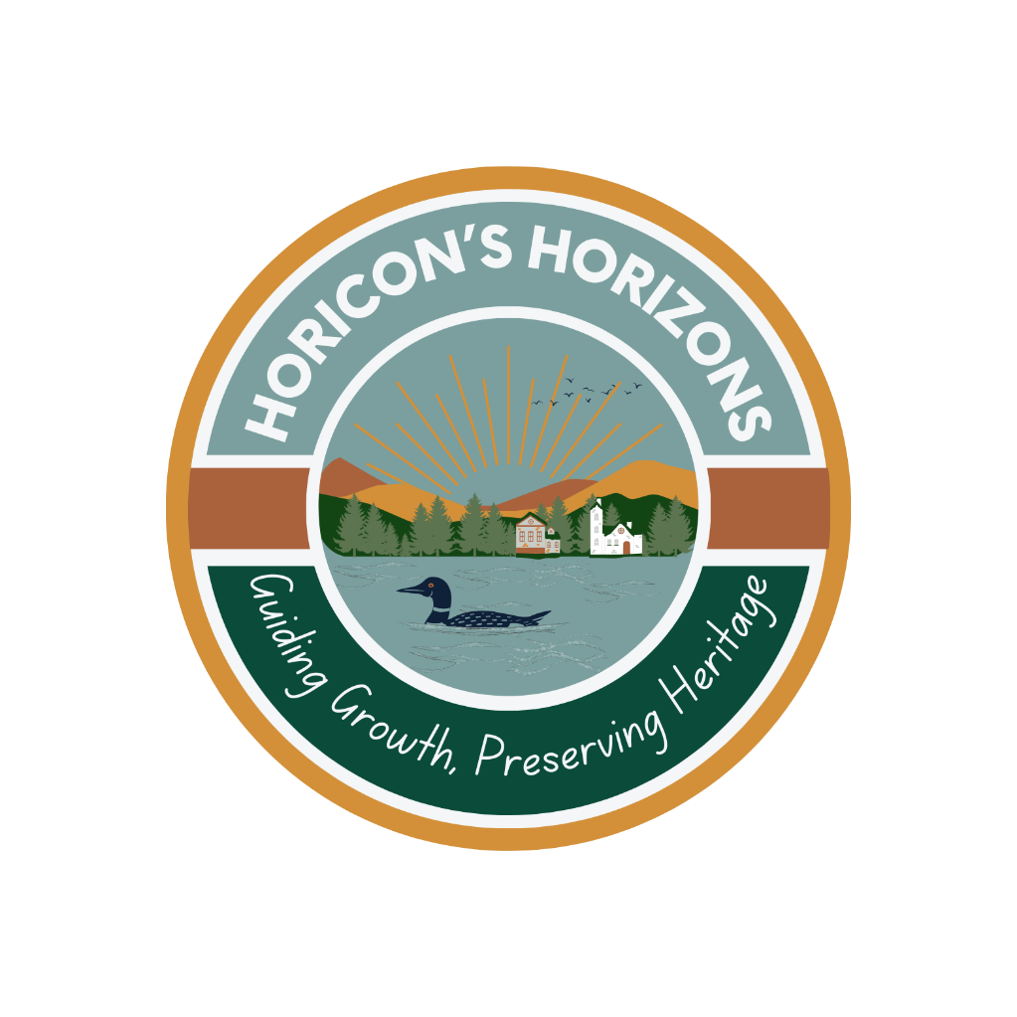
Horicon’s Horizons

A Comprehensive Plan for the Town of Horicon
DRAFT
December 2025

HORICON’S
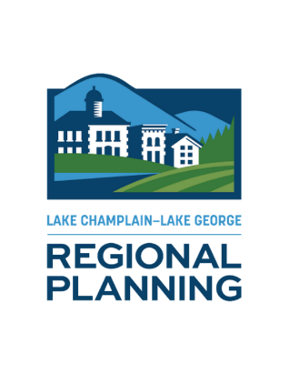
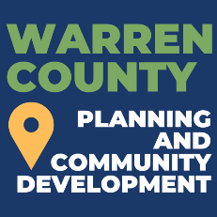
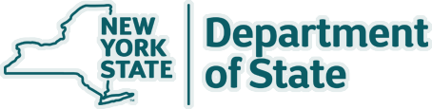
A Smart Growth Comprehensive Plan for the Town of Horicon
HORIZONS
March 2026
ACKNOWLEDGEMENTS
A special thank you to the Town of Horicon Comprehensive Plan Committee:
Supervisor Wayne Butler | Colleen Murtagh
Kayla Carlozzi | Frank Murtagh
Drew Cappabianca | Casey Palmer
Jeanne Clement | Becky Ross
John Dunn | Curt Smith
Cheryl Ericson | James Ventura
Brandon Himoff
Craig Leggett
Carol Molino
Steve Mullins
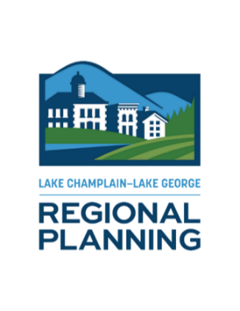
and former Supervisor Mike Geraci

Project Team:
Lake Champlain Lake George Regional Planning Board
Warren County Planning Department

Funding:
This Comprehensive Plan was prepared with funding provided by the New York State Department of State Environmental Protection Fund.

Table of Contents
Executive Summary 1
Section 1. Introduction 3
1.1 Regional Context and Community Background 8
1.2 The Planning Process 10
1.3 Local and Regional Plans 11
1.4 Community Engagement and Findings 12
1.5 Highlights from the Town of Horicon Community Profile 14
Section 2. Vision, Goals, and Objectives 43
2.1 Smart Growth Principles 44
2.2 Goals, Objectives, and Strategies 46
Section 3. Future Land Use 70
Section 4. Implementation Strategy 71
4.1 Implementation Matrix 73
4.2 Funding and Technical Assistance Resources 92
Acronyms Used 92
Appendices 101

Index of Maps
Map 1. Regional Context Map 9
Map 2. Land Use Map 26
Map 3. Hamlets of Adirondack and Brant Lake Land Use Maps 27
Map 4. APA Land Use Map 29
Map 5. Town of Horicon Zoning Map 33
Map 6. Hamlets of Adirondack and Brant Lake Zoning Map 34
Map 7. Historic and Cultural Resources Map 38
Map 8. Parks and Open Space Map 42

Executive Summary
Horicon’s future depends on balancing the contributions and needs of both seasonal and year-round residents. The Comprehensive Plan embraces this balance, aligning housing, employment, services, and stewardship to ensure Horicon remains vibrant, resilient, and welcoming in every season
In Horicon, like many Adirondack communities, population levels fluctuate with the seasons, creating a rhythm that is both a strength and a challenge. Seasonal and full-time residents may differ in their daily needs and expectations, but all share a deep affection for the Town. The goals and objectives of Horicon’s Horizons recognize these differences not as competing interests, but as complementary elements of a resilient and interconnected community.
Seasonal residents play an important role in supporting the Town’s financial health. Through property taxes and local spending, they help fund municipal services, infrastructure, and environmental stewardship that benefit the entire community. Full-time residents, in turn, are the steady heartbeat of Horicon. They rely on affordable housing, dependable local employment, and year-round services like schools, emergency response, healthcare, and everyday amenities. These residents staff local businesses, volunteer for fire and rescue services, serve on boards, and maintain civic life during the quiet months.
Balancing the varying needs of the community requires planning and open dialogue. Through extensive public engagement and community discussion, the Town of Horicon Comprehensive Plan has established goals and strategies that respond to the interests, needs, and challenges of both seasonal and year-round community members. Recommendations such as encouraging a mix of housing options help ensure that teachers, tradespeople, service workers, and young families can continue to live in the community they support, and strategies that strengthen year-round employment, protect natural resources, maintain recreational assets, and manage peak-season pressures, helping preserve the qualities that draw people to Horicon in every season.

A successful balance recognizes that seasonal and full-time residents are partners in shaping the Town of Horicon’s future. Guided by a shared long-term vision, the Town can address the interests of seasonal residents while ensuring that year-round residents have the housing, jobs, and services they need to thrive. In this way, Horicon becomes not just a place people visit or live, but a community that works for everyone, year-round.

Section 1. Introduction

In 2022, the Town of Horicon secured a grant from the New York State Department of State (NYSDOS) to update its Comprehensive Plan, originally adopted in 2010. This update incorporates Smart Growth Principles into the planning process, reflects extensive community input, and is shaped by the shared priorities of both year-round and seasonal residents, whose combined contributions form the foundation of Horicon’s community life.

Today, Horicon faces several interrelated challenges, including an aging population, limited housing availability and affordability, and gaps in locally available goods and services. At the same time, the Town is well-positioned to build on significant opportunities, including its abundant natural and recreational resources, strong sense of community, and enduring appeal as a place to live, work, and visit. The Comprehensive Plan addresses the challenges and opportunities facing the Town of Horicon, providing a clear framework to guide future decision-making and ensure the Town remains vibrant and resilient throughout every season.

Future Vision

The future vision for the Town of Horicon was developed through a comprehensive, long-range planning process grounded in substantial public outreach and guided by a locally supported Comprehensive Planning Committee (CPC). Representing a broad cross-section of the community, the CPC helped ensure that diverse perspectives and local priorities shaped the planning effort.

This vision presents an aspirational picture of what the Town of Horicon hopes to become over the next 10 years. Rooted in community values and collective input, it reflects both what makes Horicon unique today and the community’s shared ambitions for the future.
The vision statement serves as the foundation of this planning document, informing the goals and objectives that follow. Together, they provide a clear framework to guide decision-making and help the Town move toward a vibrant, resilient, and sustainable future.

Town of Horicon Vision Statement:

The Town of Horicon is a vibrant and welcoming four-season community where all residents contribute to a place where people thrive, and future generations are inspired to put down roots and build their lives. Guided by a shared commitment to our heritage, community ties, opportunities, and sustainability, our town continues to grow while retaining its unique qualities. Our community is dedicated to:

- Engaging Residents: Ensure that all residents have a strong voice in decisions shaping the Town’s future, while fostering an inclusive community where all members feel valued, supported, and connected.
- Quality, Affordable Housing: Expand diverse, attainable housing options for families, individuals, and seniors of all income levels and abilities.
- Supporting Local Businesses: Promote entrepreneurship, skilled trades, and local economic growth that sustains year-round employment and strengthens Horicon’s unique character.
- Environmental Stewardship: Protect natural resources while nurturing a safe, welcoming, and interconnected community.
- Preserving our Heritage: Celebrate the Town’s history while actively shaping a prosperous future driven by innovation, small business, and resident participation.
- Attracting Young Families and Retaining Residents: Enhance quality of life through housing, excellent amenities, supportive services, recreational opportunities, and a strong sense of community.
- Reliable Infrastructure and Accessible Transportation: Maintain safe, dependable roads, telecommunications, and transportation networks that link residents to opportunities, services, and one another.

To achieve the community’s vision, the following goals were developed around the issues of housing, hamlet centers and community hubs, economic stability, natural resources and recreation, and land use and development. Each area represents a priority for the Town and reflects the values and needs expressed by community members throughout the planning process.

Housing
- Expand and Diversify Housing Options
1.1 Preserve and enhance existing residential neighborhoods by promoting the rehabilitation and maintenance of existing residential structures
1.2 Create opportunities for lower-cost, affordable housing
1.3 Continue to work collaboratively to balance short-term rental housing stock and the need for affordable year-round housing opportunities
1.4 Improve retention of area employees by promoting affordable long-term rentals for the local workforce
Hamlet Centers and Community Hubs
- Revitalize and Protect Hamlets as Community Hubs
2.1 Retain our rural small-town character
2.2 Preserve and enhance the distinctive identities of the Hamlets of Adirondack and Brant Lake through a combination of building and streetscape improvements that maintain the rural community character
2.3 Improve and enhance community facilities and services
2.4 Improve transportation infrastructure to enhance the safety, convenience, and efficiency of drivers, cyclists, and pedestrians
2.5 Improve the visual appeal, safety, and walkability of main streets and thoroughfares throughout Horicon
Economic Stability
- Strengthen and Grow the Local Economy
3.1 Strengthen and diversify the economic base of the Hamlets of Adirondack and Brant Lake by encouraging a mix of commercial, civic, and residential uses
3.2 Retain existing employment opportunities and attract new businesses
3.3 Promote the Town’s recreational, cultural, and environmental resources to foster the local economy
- Support Local Businesses and Entrepreneurs
4.1 Support the Town’s local and home-based businesses with technical assistance
4.2 Promote the establishment of cottage industries that highlight the area’s culture, history, and natural resources
4.3 Encourage remote working opportunities and digital business growth by closing gaps in broadband and cellular services
Natural Resources and Recreation
- Protect Natural Resources and Enhance Outdoor Recreational Assets
5.1 Coordinate with NYSDEC land managers to better align state management and maintenance practices with local needs
5.2 Improve and maintain access to recreational areas
5.3 Continue to support water quality improvement efforts including monitoring and prevention of aquatic invasive species and emerging water quality threats
5.4 Enhance stormwater and erosion management practices
5.5 Improve facilities at town parks to better incorporate ADA/Universal Accessibility and provide inclusive, family-friendly amenities that serve all residents and users
5.6 Develop a septic inspection program that combines incentives and educational initiatives to safeguard community health and safety and protect the Town’s waterways
5.7 Collaborate with the Lake George Hemlock Coalition and Warren County Soil and Water Conservation District to share information and resources about emerging terrestrial invasive species
- Promote a Sustainable, Year-Round Recreation Economy
6.1 Develop tourism strategies that balance economic growth with quality of life and natural resource stewardship
6.2 Manage and enhance public access to waterways, including Brant Lake, Schroon Lake, and the Schroon River, by developing access management plans and improving physical access points
6.3 Enhance the visitor and resident experience by improving signage, strengthening town identity, collaborating regionally, and connecting hamlets and neighborhoods to recreation areas with trails and paths
6.4 Promote Horicon’s diverse recreational opportunities across all seasons
6.5 Expand the Town’s online, year-round calendar of events and programs to foster community engagement and attract off-peak tourism
Land Use and Development
- Modernize and Align Zoning and Land Use Regulations
7.1 Update zoning and land use policies to reflect Horicon’s evolving community needs while preserving its small-town character
7.2 Encourage appropriate and sustainable growth through clear, predictable, and streamlined regulations
7.3 Promote mixed-use and infill development within the Hamlets of Adirondack and Brant Lake to strengthen their role as vibrant community centers
7.4 Protect natural resources and scenic beauty by integrating conservation practices into land use decisions

1.1 Regional Context and Community Background
The Town of Horicon is in the northern part of Warren County, New York, within the Adirondack Park and is bordered by the Schroon River to the west, the Town of Hague to the east, and the Town of Schroon in Essex County to the north (Map 1. Regional Context Map). Known for its vast forest landscapes and abundant water resources, Horicon offers easy access to premier outdoor recreation areas such as the Pharaoh Lake Wilderness Area and the Lake George Wild Forest. The town boasts scenic water-based recreation on Brant Lake, Schroon Lake, and the Schroon River, and is a short drive from Gore Mountain, a popular year-round recreational hub in neighboring Johnsburg. With convenient access via the I-87 Adirondack Northway, Horicon is a quaint community and a popular destination for visitors and second-home owners.
The Horicon area was first settled in the late 1700s by a single landowner and was officially incorporated as the Town of Bartonville in 1838. Like much of the region, its early hamlets were centered around logging and industries that harnessed the resources of the dense wilderness. Early settlers constructed dams, such as the Mill Pond, built sawmills, and used the Schroon River to transport logs downstream to larger milling operations in Glens Falls.
By the mid-1800s, several hamlets had emerged across the town, each with its own school. Among the most prominent were Adirondack, Bartonville, South Horicon, and Hayesburg. Both South Horicon and Adirondack had a tannery, with the South Horicon tannery earning distinction as the largest in New York State at the time. Tanning and leathermaking were vital industries, drawing on the area’s abundant hemlock trees for their tannin-rich bark. In addition to industry, small-scale subsistence farming contributed to the local economy.
By the early 1900s, tourism had begun to eclipse traditional industries, largely due to improved access facilitated by nearby railroads. This economic shift transformed the community, as hotels and summer camps sprang up around Brant Lake, catering to affluent families from urban areas. Residents found new roles as hunting and fishing guides, and the economy increasingly oriented itself around seasonal visitors. Over time, many of the early hotels and businesses faded, and tourism in Horicon evolved into a model centered on second-home ownership, a pattern that continues to define the area today.

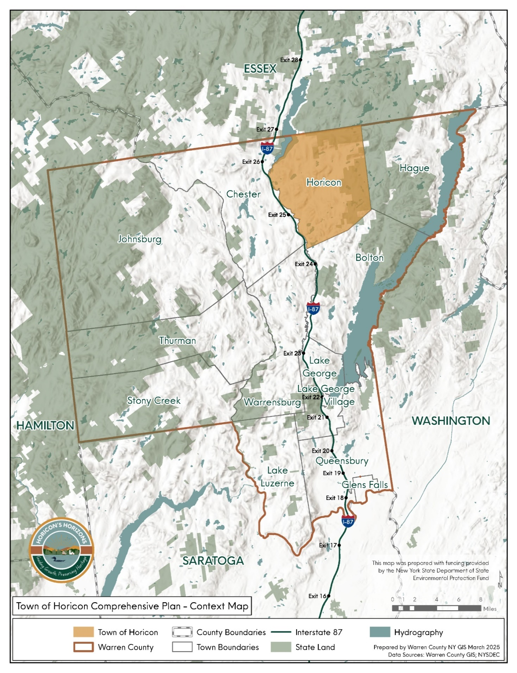
Map 1. Regional Context Map

1.2 The Planning Process
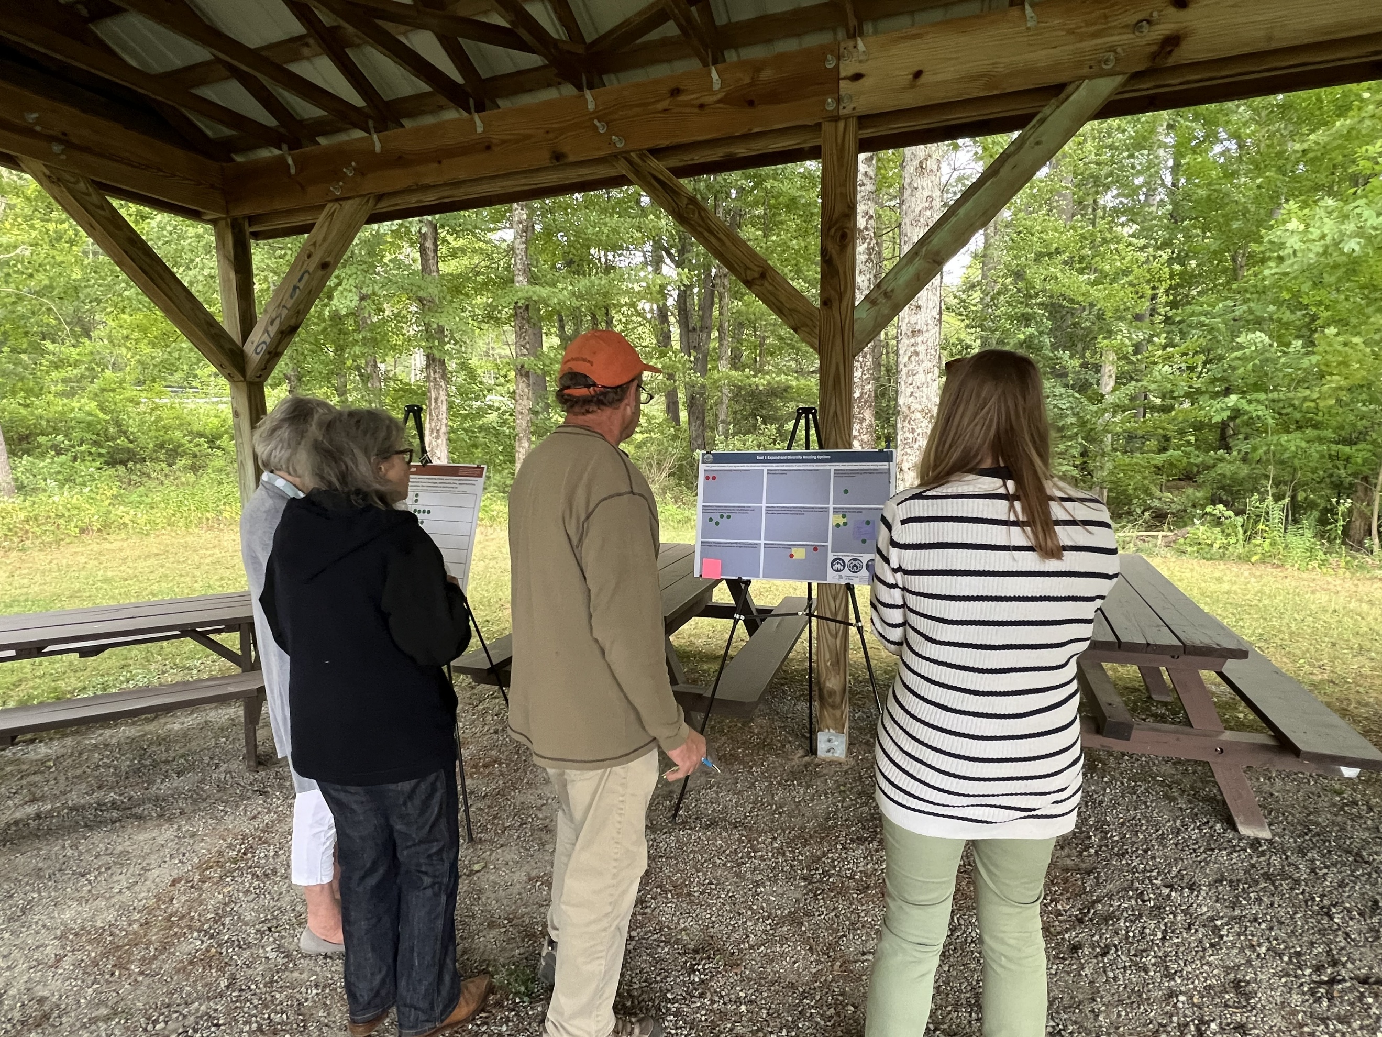
The comprehensive plan process began in the summer of 2024 with the appointment of a Comprehensive Plan Committee (CPC), established by the Town Board to guide the development of the plan. The CPC brought together a diverse group of individuals whose local knowledge, experience, and perspectives helped shape the planning process. Members of the CPC include representatives from the Town Board, Planning and Zoning Boards, Town staff, the Town Historian, local business owners, and residents with recreational and environmental interests.
Photo 1: August 2025 public workshop at Albert E Monroe Park in Adirondack.

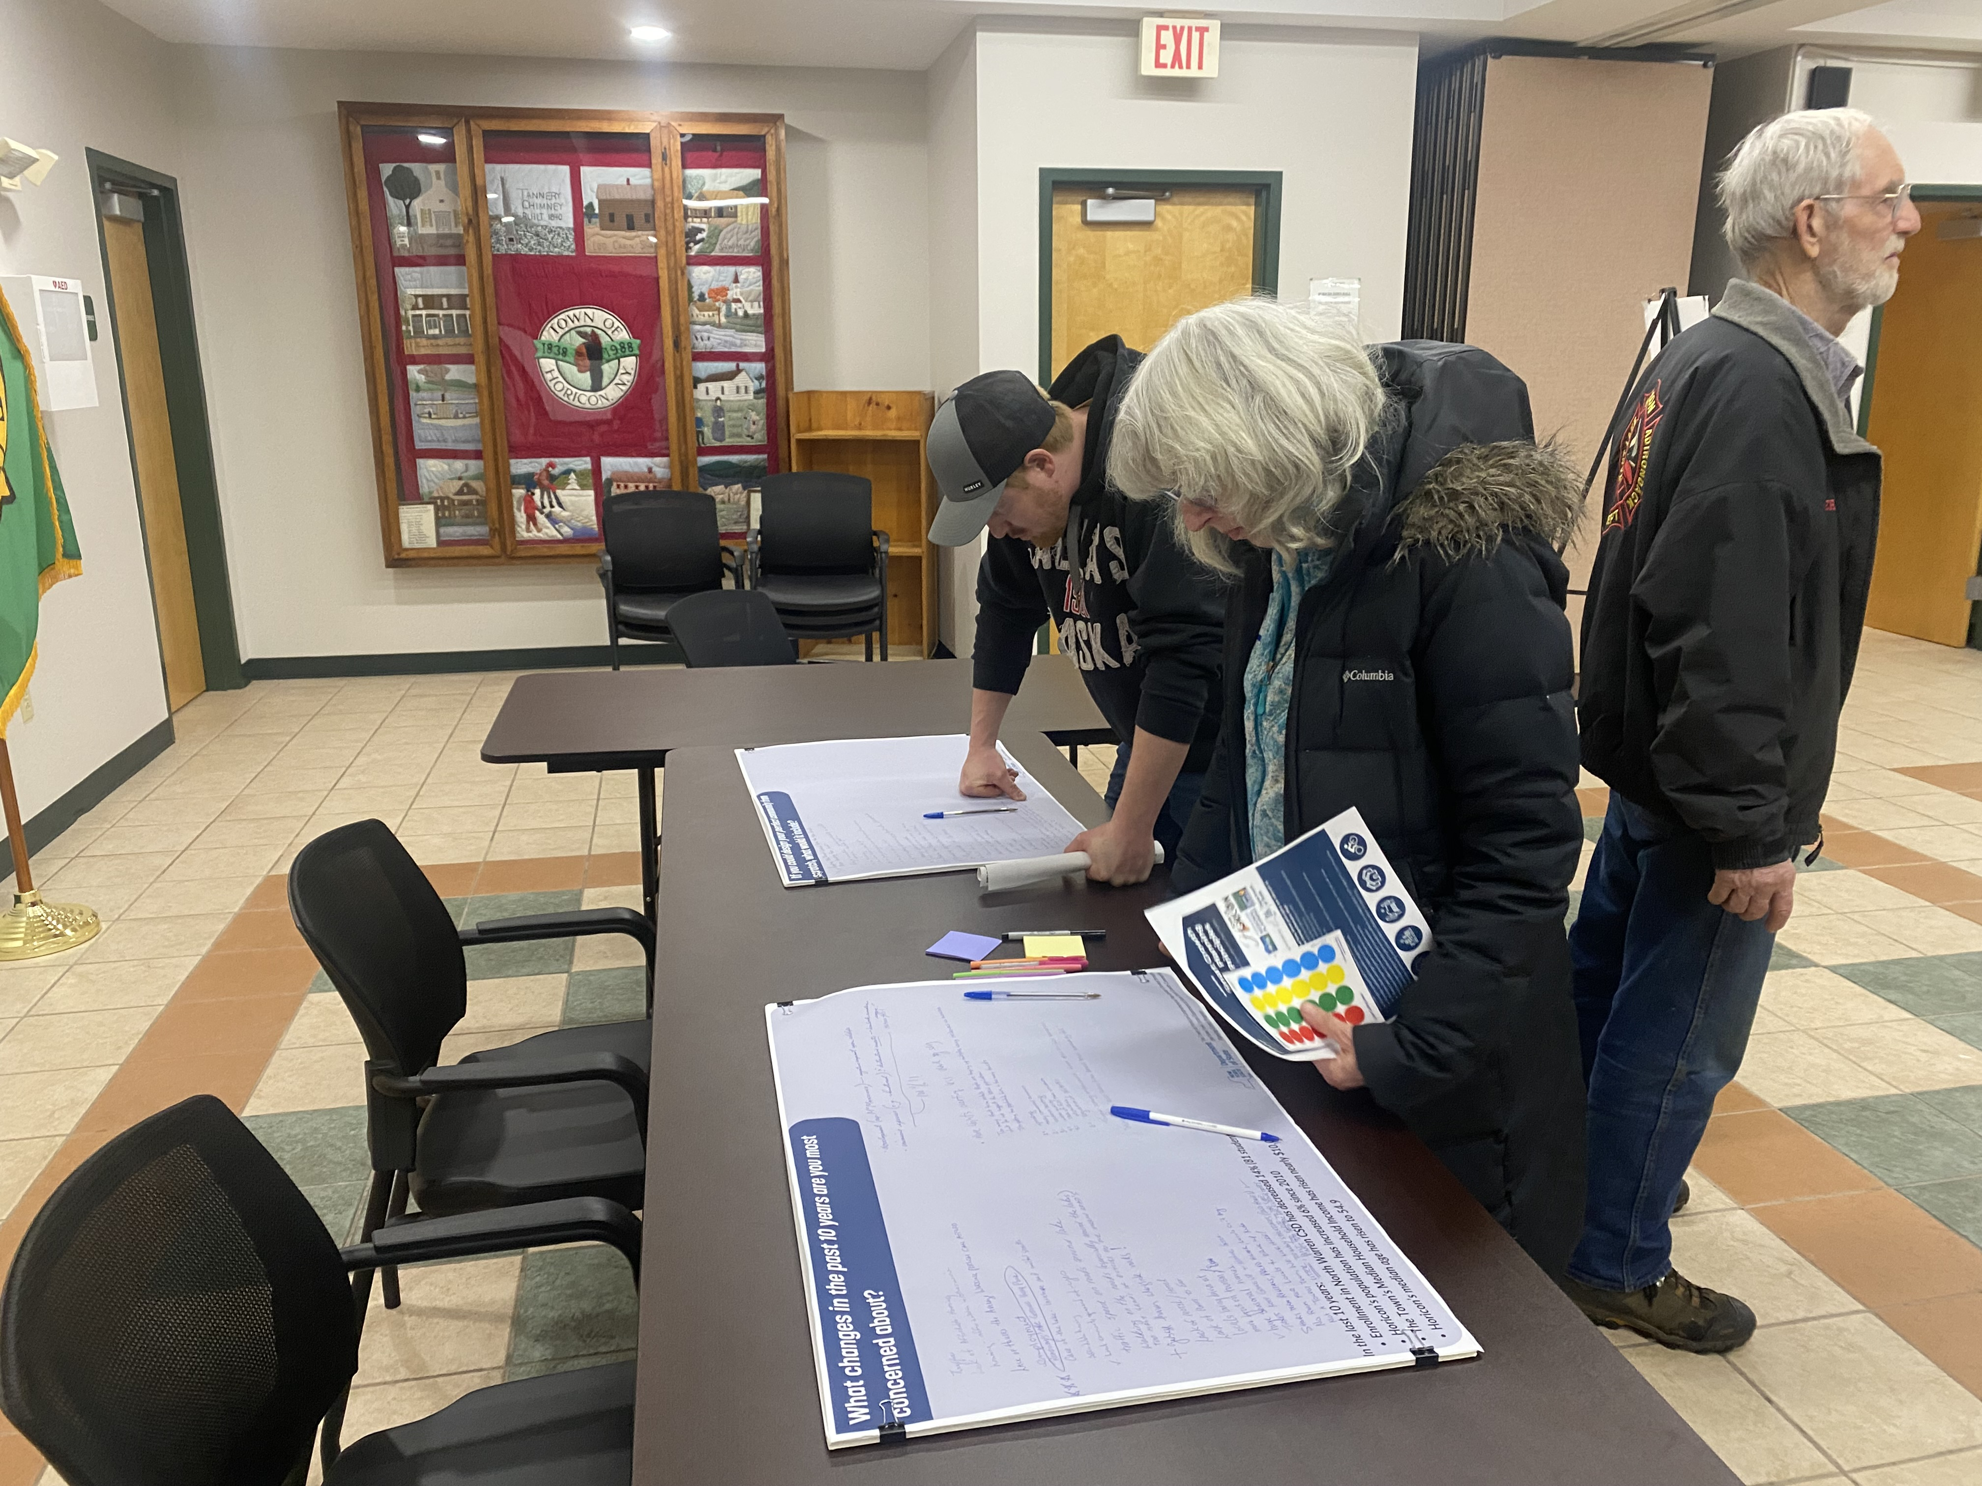
Throughout the process, the CPC met regularly and worked collaboratively with staff from the Lake Champlain Lake George Regional Planning Board (LCLGRPB) and the Warren County Planning Department. From the outset, the CPC prioritized transparency and public involvement, recognizing that the plan’s success depends on broad community participation.
Photo 2: February 2025 public workshop at Horicon Town Hall.
To engage residents and gather meaningful input, the CPC conducted a community survey, hosted three community workshops, and offered virtual engagement opportunities alongside a project website to share updates and resources. Feedback collected through these efforts played a central role in shaping the plan’s vision, goals, and strategies, ensuring that the Comprehensive Plan truly reflects the community’s collective priorities and aspirations.
Photo 3: August 2025 public workshop at Albert E Monroe Park in Adirondack.
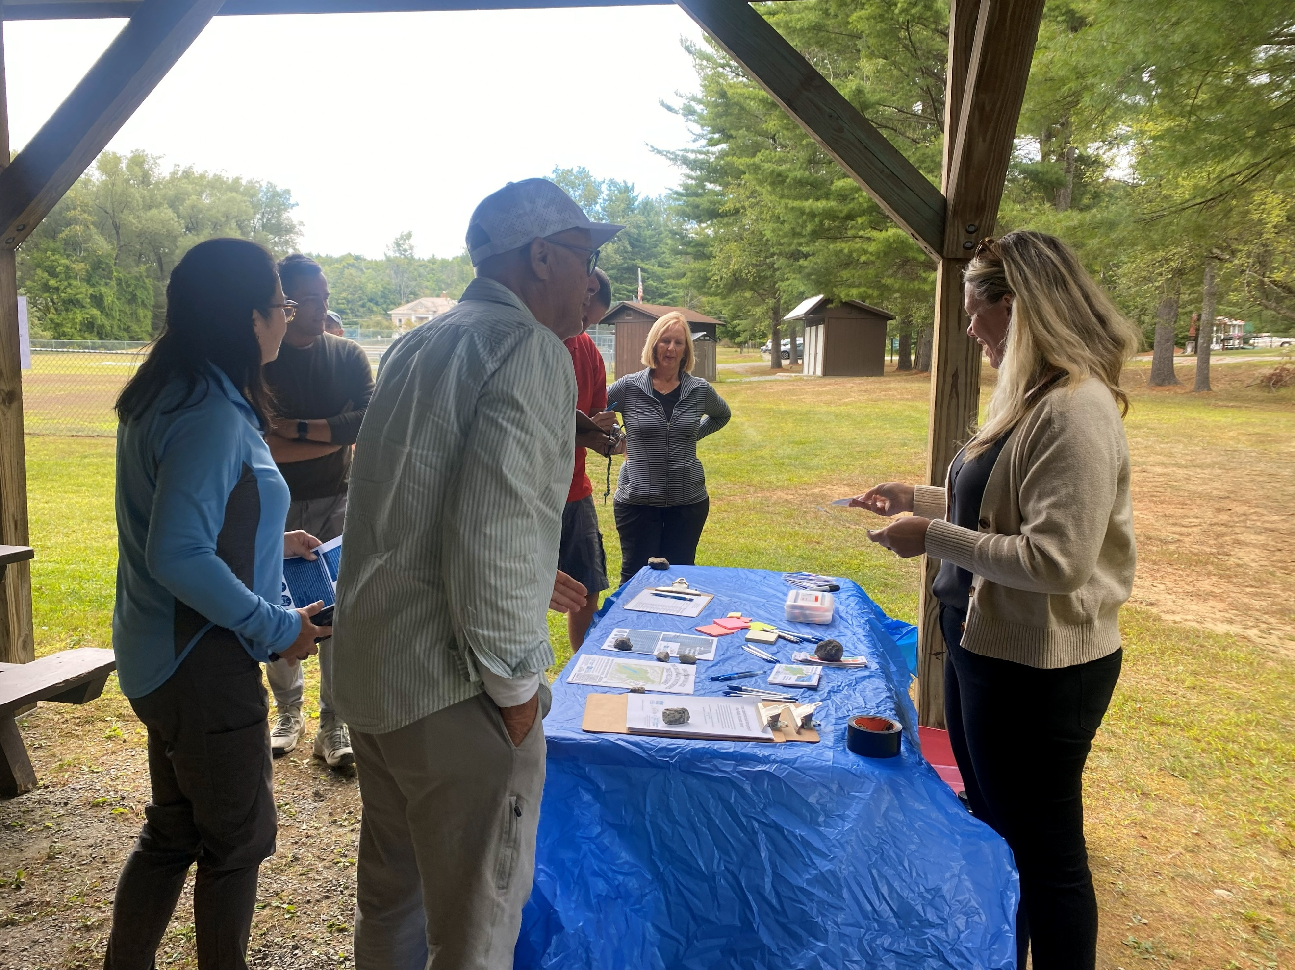

1.3 Local and Regional Plans
An important component of the Comprehensive Plan’s development was a review of existing local and regional plans and studies. The analysis helps ensure that the strategies and recommendations presented in the Comprehensive Plan are consistent with, and build upon, the goals and objectives identified in prior planning efforts. The planning documents reviewed for this process are summarized in Table 1 below in chronological order of publication.
Table 1. Review of Local and Regional Plans
Local Planning Documents |  | Year
1. | Warren County Outdoor Recreation Economy Research Report | 2024
2. | Housing Needs Study and Market Demand Analysis of Warren County | 2023
3. | Mill Pond Feasibility Study | 2023
4. | Warren County Hazard Mitigation Plan | 2023
5. | Town of Horicon First Wilderness Plan | 2019
6. | Schroon Lake Watershed Management Plan Addendum | 2019
7. | Schroon Lake Watershed Management Plan | 2010
8. | Town of Horicon Comprehensive Plan | 2010
9. | Town of Horicon Community Development Strategic Plan | 2008
10. | Brant Lake Watershed Assessment | 2000

The documents reviewed revealed several recurring themes that remain highly relevant to the Town of Horicon today. These include the importance of outdoor recreation and tourism development, housing affordability and diversity, environmental protection and watershed management, community identity and hamlet revitalization, pedestrian improvements and walkability, and strategic planning and interagency coordination. Together, these themes highlight the community’s ongoing commitment to balancing growth, sustainability, and quality of life.

1.4 Community Engagement and Findings
To guide the planning process, the Town of Horicon carried out a broad and ongoing public engagement effort. This included a community survey, three public workshops, a stakeholder roundtable, one-on-one interviews, and a presentation to the Town Board. These activities were designed to identify key issues and opportunities, gather meaningful community input, and build consensus around the priority projects and actions needed to achieve the goals of this plan.
Survey responses showed a nearly even split between seasonal and year-round residents, providing a balanced perspective on community priorities. While each group emphasized different aspects of life in Horicon, there was broad agreement on the Town’s most important issues. Both groups highlighted concerns, including the distance to goods and services, broadband and cellular service, impacts on environmental quality, and rising taxes.
Certain issues, such as the aging population and overall affordability, were more frequently noted by year-round residents, reflecting their ongoing, full-time connection to the community. Similarly, seasonal and year-round residents shared many of the same values regarding what they enjoy about Horicon and what they hope to see in the future. Both groups stressed the importance of access to recreation and open space, improvements to parks, trails, and recreational amenities, enhanced broadband and cell service, more community events, and increased shopping and retail options. Overall, seasonal and year-round residents share similar values and are closely aligned in their vision for Horicon’s future.
In addition to the community engagement activities held throughout the planning process, the CPC and the Town Board each held formal public hearings in accordance with §272-A of New York State Town Law. The CPC public hearing was held on February 26, 2026, followed by the Town Board’s public hearing on March 19, 2026, before adoption of the plan.
The summary of public workshops and the community survey findings can be found in Appendix A of this document. A summary of public comments received through the public hearing and comment period can be found in Appendix D.
Photo 4: The Town of Horicon Town Hall serves as a space for community events such as Food Truck Fridays. Photo Credit: Advokate

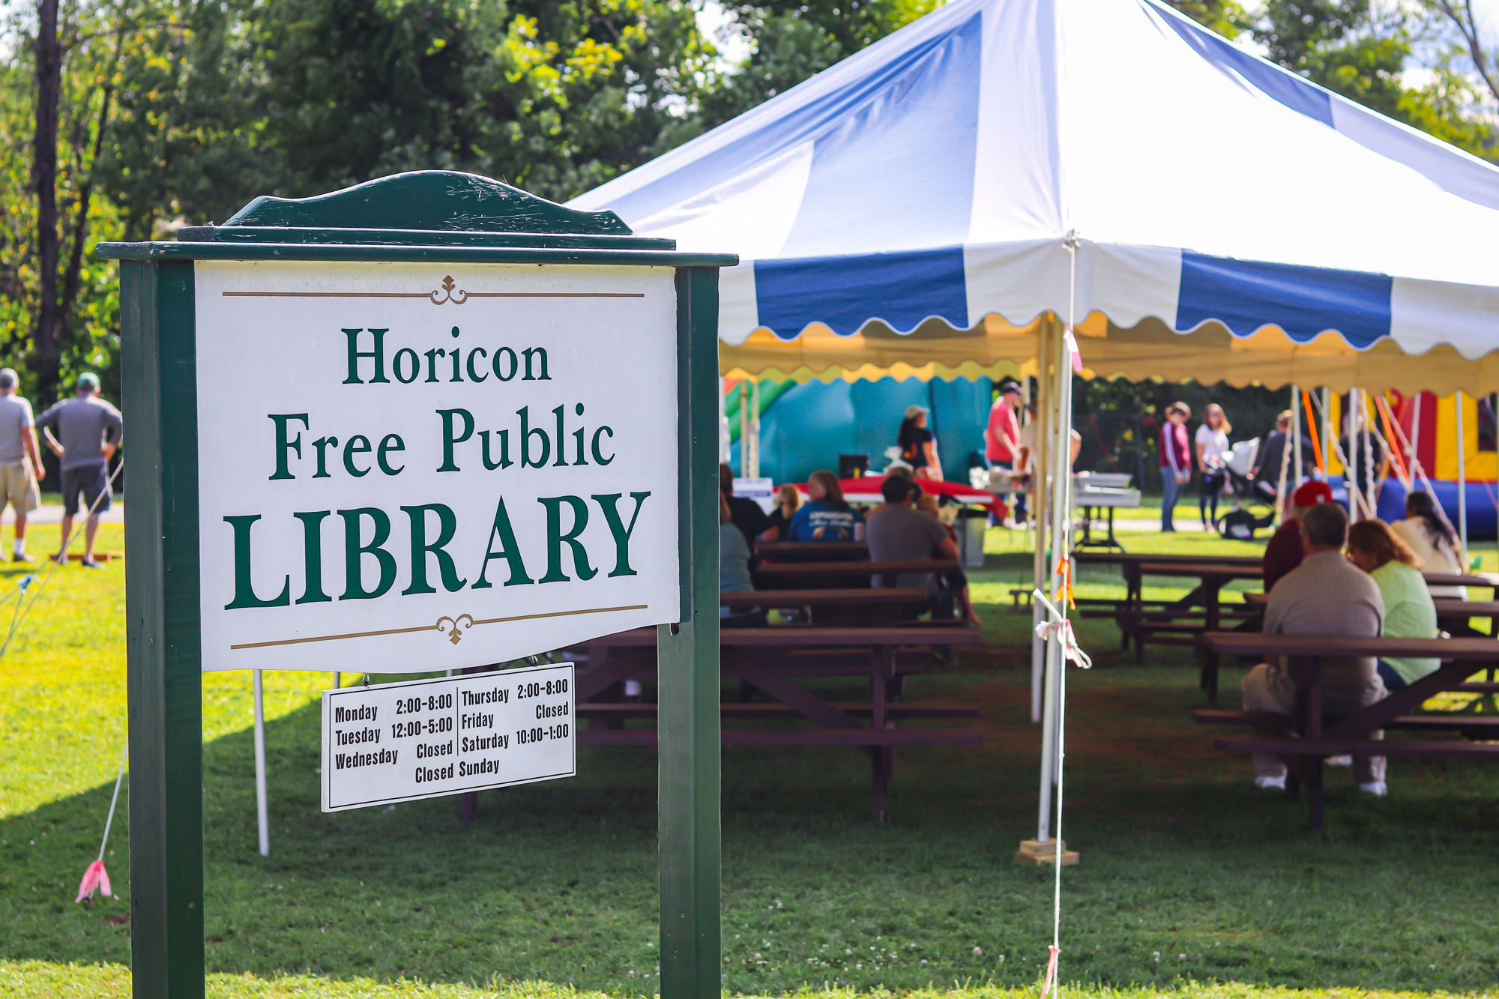

1.5 Highlights from the Town of Horicon Community Profile
A community profile was prepared to provide an updated picture of the Town’s current conditions, including demographics, economic trends, housing, land use and zoning, infrastructure and community facilities, transportation, parks and recreation, cultural and historical resources, natural resources, and climate-related impacts. The full Community Profile is included in Appendix B of this document.

Demographic Challenges and Opportunities
The Town of Horicon is at a pivotal point in its demographic evolution. Although the overall population has remained stable, it is growing older, highlighting the need for thoughtful strategies to sustain community vitality in the years ahead. Ensuring that older residents have the amenities and services they need, while also attracting and retaining younger households, will be essential to maintaining a balanced, thriving population.
The compact hamlets of Brant Lake and Adirondack provide strong opportunities to apply smart growth principles that support age-inclusive, environmentally responsible, and community-oriented development. Looking forward, the Town can strengthen its future by meeting the needs of its aging population while enhancing amenities and creating conditions that make these hamlets appealing places for younger residents to live, work, and stay.
Expanding housing options that are affordable at a range of income levels, improving local services and amenities, and supporting small businesses can help meet the needs of residents of all ages. At the same time, investing in pedestrian infrastructure will improve mobility and safety for older adults while making Horicon more attractive to younger families seeking an active, connected lifestyle.
Although the Town’s demographic shifts present challenges, they also open the door to new possibilities. By supporting aging in place, welcoming new residents, and strengthening its sense of community, Horicon can position itself for a more inclusive, resilient, and prosperous future. The goals and recommendations in this plan are designed to build on these opportunities and guide the Town toward that vision.
U.S. Census data provide an important baseline for understanding demographic trends in the Town of Horicon; however, it does not fully capture the community’s significant seasonal population. Because census counts are based on year-round residency, many part-time property owners and seasonal residents who contribute to the Town’s economy, character, and tax base are not reflected in official population figures. As a result, census data represents only one piece of a broader planning framework. While these statistics help identify long-term trends, the Town recognizes that planning decisions must also consider seasonal population fluctuations, local knowledge, service demands, and community input to present a more complete picture of Horicon’s present conditions and future needs.

Population and People
According to the 2020 U.S. Census, the Town of Horicon had a population of 1,471, making it the fourth smallest town in Warren County, larger than only Hague, Stony Creek, and Thurman. Between 2000 and 2023, Horicon’s population remained stable, increasing by just 2% overall. Notably, between the 2010 and 2020 Censuses, Horicon was the only municipality in Warren County outside the urban center to experience population growth, increasing by 6%, while the nearby communities of Chester and Hague saw declines of 8% or more, and the neighboring Town of Schroon in Essex County experienced a 6.8% increase during the same period (Figure 1). Overall, Warren County’s population grew by 4% between 2000 and 2020.
Horicon’s steady population trends, in contrast to regional declines, suggest a strong sense of community stability and local appeal. This modest growth may reflect the town’s quality of life, natural amenities, and potential as a desirable location for both year-round and seasonal residents, factors that will continue to influence future housing, infrastructure, and economic development planning.

Figure 1: Regional Population Changes 1970-2020. Source: US Census Bureau.

Aging population
In 2020, Warren County ranked as the fifth-oldest county in New York State, with a median age of 47.5. Within the county, the Town of Horicon had one of the oldest populations, with a median age of 56.9, making it the third-oldest municipality in Warren County. Neighboring towns such as Chester (52.4) and Johnsburg (52.0) were slightly younger by comparison.
By 2023, approximately 32.8% of Horicon’s population was age 65 or older, representing a 7.2% increase since 2010. While population aging is a national trend, it is especially pronounced in Warren County and the Town of Horicon. In 2023, Horicon’s median age of 54.9 was nearly15 years higher than the national median (39.2) and significantly above the state median (40.2) (Figure 2).
This demographic pattern underscores the town’s growing population of older adults and highlights a growing challenge to balance the needs of an aging population while creating opportunities that attract and retain young families.




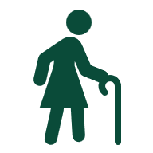
Population Change
Figure 2: Town of Horicon population changes 2010 – 2020—source: U.S. Census and 2023 American Community Survey.
Town of Horicon
1,480
1,389
1,512
-6.1%
8.9%
2000
2010
2023
Population
by Age
Age Under 18
13%
54%
Age 18-64
33%
Age 65+
2010: 16%
MEDIAN AGE
54.9
2010: 50.3
2010: 59%
2010: 26%

Table 2: Population Change by Age 2000-2020, Source: US Census Bureau
 | Population by cohort per year
Age Range | 2000 | 2010 | 2020 | Change 2000-2020 | Change in Number
Under 5 years | 32 | 58 | 46 | 43.8% | 14
5 to 14 years | 219 | 107 | 136 | -37.9% | -83
15 to 24 years | 138 | 144 | 103 | -25.4% | -35
25 to 34 years | 110 | 124 | 125 | 13.6% | 15
35 to 44 years | 224 | 150 | 126 | -43.8% | -98
45 to 54 years | 247 | 213 | 16 | -35.2% | -87
55 to 64 years | 227 | 238 | 280 | 23.3% | 53
65 to 74 years | 164 | 216 | 266 | 62.2% | 102
75 to 84 years | 98 | 109 | 176 | 79.6% | 78
85 years and over | 21 | 30 | 53 | 152.4% | 32

Table 2 illustrates the changes in Horicon’s population by age group between 2000 and 2020. Horicon’s largest age cohort is between 55 and 64 years old, followed by those ages 65 to 74, reflecting the Town’s aging population. Between 2010 and 2020, Horicon gained approximately 92 residents aged 55 to 74, while the number of younger residents aged 15 to 34 declined by about 40 people. This loss of younger residents is the reverse of the previous decade, in which the population in that age group gained a total of 20 people. However, according to the 2023 American Community Survey (ACS), this age group has again gained population, with a net increase of about 85 residents ages 15 to 34 between 2020 and 2023. This recent growth among younger adults could signal renewed interest in Horicon as a place to live and work, which may have positive implications for the local labor force, schools, and housing market.

School Enrollment and Educational Attainment
Approximately 91% of Horicon residents have completed high school, a figure that is comparable to Warren County's rate of 91.9%, and nearly a quarter of Horicon residents hold a bachelor's degree or higher (24.8%).
Public education for residents of Horicon is provided by the North Warren Central School District, which was established in 1973 through the consolidation of the Horicon, Chester, and Pottersville schools. The district faces challenges resulting from demographic indicators like an aging population and declining numbers of young families, which have led to a 24% decrease in enrollment from 2000 to 2024 (Figure 3).
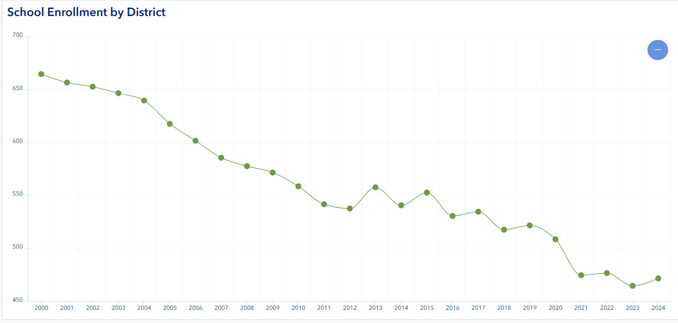
Figure 3: North Warren Central School District Enrollment 2000-2024. Source: New York State Department of Education.

Economic Indicators

Median Household Income
The median household income (MHI) represents the midpoint at which half of all households earn more and half earn less. It is a key indicator of a community’s economic health, often correlating with factors such as home values, educational attainment, and employment stability. Lower median incomes may signal a greater need for affordable housing and expanded job opportunities.
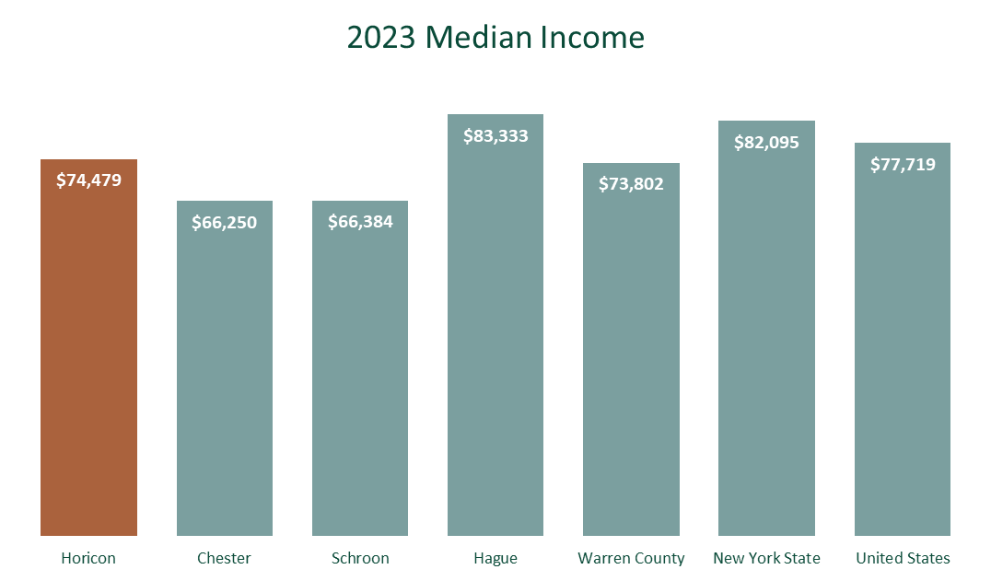
In 2023, the Town of Horicon had an MHI of $74,479 (ACS 5-year Estimates 2023), slightly above the Warren County MHI of $73,802. According to the Warren County Housing Needs Assessment, the MHI for seniors in Horicon is higher than the countywide figure. While Horicon’s MHI is below the New York State and U.S. medians, it remains higher than the neighboring communities of Chester and Schroon (Figure 4).
Figure SEQ Figure \* ARABIC 3: Town of Horicon Median Household Income, 2023. Source: American Communities Survey.
Figure 4: Median Household Income Source: ACS 5 Year Estimates 2023
Poverty
Horicon has a relatively low overall poverty rate of 5.3%, significantly below Warren County’s rate of 9.1%. Poverty rates help illustrate a community’s economic stability, access to jobs and housing opportunities, and need for services. Horicon’s low poverty rate is likely influenced by the high number of retirees in the community and also suggests a generally stable economic environment. However, the picture is more nuanced for younger residents. Among those under age 18, poverty levels are more comparable to the County, with 8% in Horicon and 10% countywide. This indicates that some families with children may face greater financial strain, highlighting the importance of affordable housing, access to childcare, and opportunities for economic mobility, all of which are challenges that have been identified by the community.

Housing Characteristics
Inventory. The Town of Horicon has approximately 1,900 housing units, of which 760 (40%) are occupied year-round and 1,011 (53%) are classified as vacant or seasonal residences. Seasonal housing accounts for a much larger share of Horicon’s housing stock than the Warren County average of 15%, though it falls between neighboring towns, Chester at 37% and Hague at 67%. The share of year-round homes has increased modestly over the past decade, rising from about 37% in 2010 to 40% in 2023. Of these year-round units, approximately 86% are owner-occupied, and 14% are renter occupied.
Housing Type. The predominant housing type in Horicon is single-family detached houses (1,702), followed by mobile homes (198). Nearly one-fifth (19%) of the Town’s housing stock was built before 1940, with the largest periods of housing growth occurring in the 1960s and 1980s, when roughly 300 new homes were constructed in each decade. More recently, new construction has slowed, with only 103 units built between 2010 and 2023. Local building permit data indicates that from 2019 to 2024, 66 permits were issued for single-family homes and 10 for manufactured homes.

According to the Warren County Housing Needs Assessment, home sale prices in Warren County increased by 33% between 2019 and 2022. During that same period, the Town of Horicon experienced one of the highest growth rates in Warren County, a 55% rise in home sale prices, the second largest overall.
Affordability. According to the American Community Survey (ACS) 2017–2021, the median household income in the Town of Horicon was approximately $62,000. The U.S. Department of Housing and Urban Development considers housing affordable when it costs no more than 30 percent of a household’s gross income. In Horicon, the average monthly mortgage payment is approximately $1,292, meaning a household would need to earn about $51,680 annually for this cost to be considered affordable. Rental housing is somewhat less expensive. Between 2017 and 2021, the median gross rent was approximately $930 per month, or about $11,160 annually. To afford this level of rent without being cost-burdened, a household would need to earn at least $37,200 per year.
Recent market trends indicate increasing pressure on housing availability and affordability. According to Warren County Real Property data, the median home value rose from $186,484 in 2016 to $325,000 in 2024. Over the same period, homes have been selling much more quickly, with the average time on the market declining from roughly 10 months in 2019 to just over one month in 2023.
Housing affordability challenges vary by tenure. Approximately 18 percent of homeowners are mortgage-burdened, spending more than 30 percent of their income on housing costs, while 58 percent of renters are rent-burdened. Housing tenure also reflects a mix of long-term residents and more recent arrivals, with about 8 percent of year-round households moving into their homes since 2021 and approximately 18 percent residing in Horicon since before 1990. Together, these trends highlight the importance of maintaining and expanding a range of housing options in the Town of Horicon to support residents at different income levels and stages of life.
Short-Term Rentals. Short-term rentals (STRs) support tourism and the local economy in Horicon, while also reducing the availability of homes for year-round residents, placing additional pressure on the local housing market and influencing housing affordability and opportunities for full-time community members. In 2024, the Town of Horicon had 79 registered short-term rental (STR) properties, representing about 5% of the Town’s housing stock. Most of these rentals are concentrated near Brant Lake and Schroon Lake, reflecting the strong demand for lake-oriented recreation and seasonal visitation. About 30% of STRs are locally owned, while the majority are owned by out-of-county owners, indicating that the lakes attract property owners from beyond the immediate community. Most STRs operate within single-family homes (48 units), along with 11 seasonal residences, and 9 multifamily units, illustrating the range of housing used for short-term rental activity.
The Town of Horicon adopted its Short-Term Rental (STR) law in 2025 to balance tourism, recreation, and neighborhood stability. Under the law, any dwelling rented for fewer than 30 days must obtain a Town-issued permit. To manage impacts on housing availability and community character, the total number of STR permits is capped at 135 townwide, with a waiting list maintained once the cap is reached.

Local and Regional Economic Characteristics

Unemployment Rates and Trends
The unemployment rate in Warren County has been low in recent years, reflecting a tight and resilient labor market. In 2024-2025, unemployment hovered between 3.2 and 3.4% (not seasonally adjusted), well below the County’s long-term average of roughly 6% and lower than typical U.S. rates. Federal Reserve Economic Data (FRED) reveals a sharp decline from a peak of about 8% in 2020 to approximately 3.5% by 2023-2024, indicating that Warren County has largely recovered from pandemic-related job losses and continues to demonstrate strong economic stability.
Small communities such as Horicon, however, experience additional dynamics that aren’t always reflected in countywide averages. Seasonal employment patterns and a mix of full-time and part-time work, especially in the tourism, hospitality, and recreation sectors, can create fluctuations in workforce stability and household income. These conditions shape local planning needs related to workforce development, housing affordability, and economic diversification.

Major Employers and Industries
The top industries for workers in the Town of Horicon are educational services and health care and social assistance (16.8%), followed by retail (14.9%), and public administration (14.8%). Major regional employers include the Town of Horicon and North Warren Central School District. Approximately 65% of workers in Horicon are employed in the private sector, and 27% are in the public sector. Communities with tourism-driven economies tend to have higher rates of private sector employment. The ratio of private to public sector employment in a community helps identify economic strengths, potential vulnerabilities, and opportunities for targeted development. A balance between private and public sector employment can make an economy more resilient. The public sector can act as a stabilizer during economic downturns, while the private sector can drive growth and innovation.
Horicon’s largest employers are primarily concentrated on tourism, outdoor recreation, and local services. Summer camps, hospitality and lodging businesses, marinas, and recreation-oriented enterprises make up a significant share of local employment, reflecting the town’s strong seasonal economy. The Town of Horicon, along with small
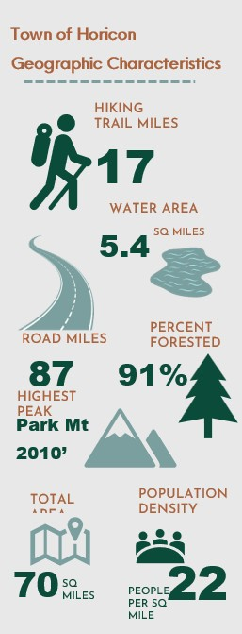
businesses, retail and service establishments, and local construction trades, also provide key year-round employment opportunities. Many residents commute to nearby population centers for work, linking Horicon closely to the broader Warren County labor market.

Land Use and Land Cover
Land use in the Town of Horicon is shaped by multiple layers of regulation, including local ordinances, Adirondack Park Agency (APA) standards, and New York State Department of Environmental Conservation (NYSDEC) Unit Management Plans (UMP). These frameworks overlap across different parts of the town, influencing how land can be developed, conserved, and used for recreation.
Public recreation lands account for more than one-third (37.7%) of Horicon’s total land area, including portions of the Lake George Wild Forest and the Pharaoh Lake Wilderness. Publicly owned forests, open spaces, and parklands make up the town’s largest land-use category. Within the hamlet areas, local parks, ballfields, and other recreation areas contribute an additional 3.9% of land area and are classified as Recreation & Entertainment.
Vacant land is also a major land-use category, representing 29.2% of the town. These areas included forested lots without primary structures, hunting lands, underwater parcels, rural properties, and lands used for public utilities. Residential uses make up nearly 27% of the Town’s land area (Map 2. Town of Horicon Land Use Map).
Within the Brant Lake Hamlet, land use is a mix of residential, commercial, and community services with large tracts of vacant land on the perimeter that could provide opportunities for future compatible uses. The Hamlet of Adirondack is primarily residential with pockets of commercial use in the southern portion of the hamlet (Map 3. Hamlets of Adirondack and Brant Lake Land Use Maps).
Horicon’s land cover is overwhelmingly forested at 91%, far higher than the statewide average of 53%. While there are no large-scale or industrial farming operations, the Town does include several small subsistence farms. State-owned forest lands are managed by NYSDEC under a Unit Management Plan (UMP), which evaluates natural and physical resources, guides public recreation, and ensures that activities are consistent with land classifications and environmental stewardship goals. Horicon contains portions of three NYSDEC land units: the Pharaoh Lake Wilderness Area, the Lake George Wild Forest Area, and the First Brother Primitive Area, each governed by its respective UMP.

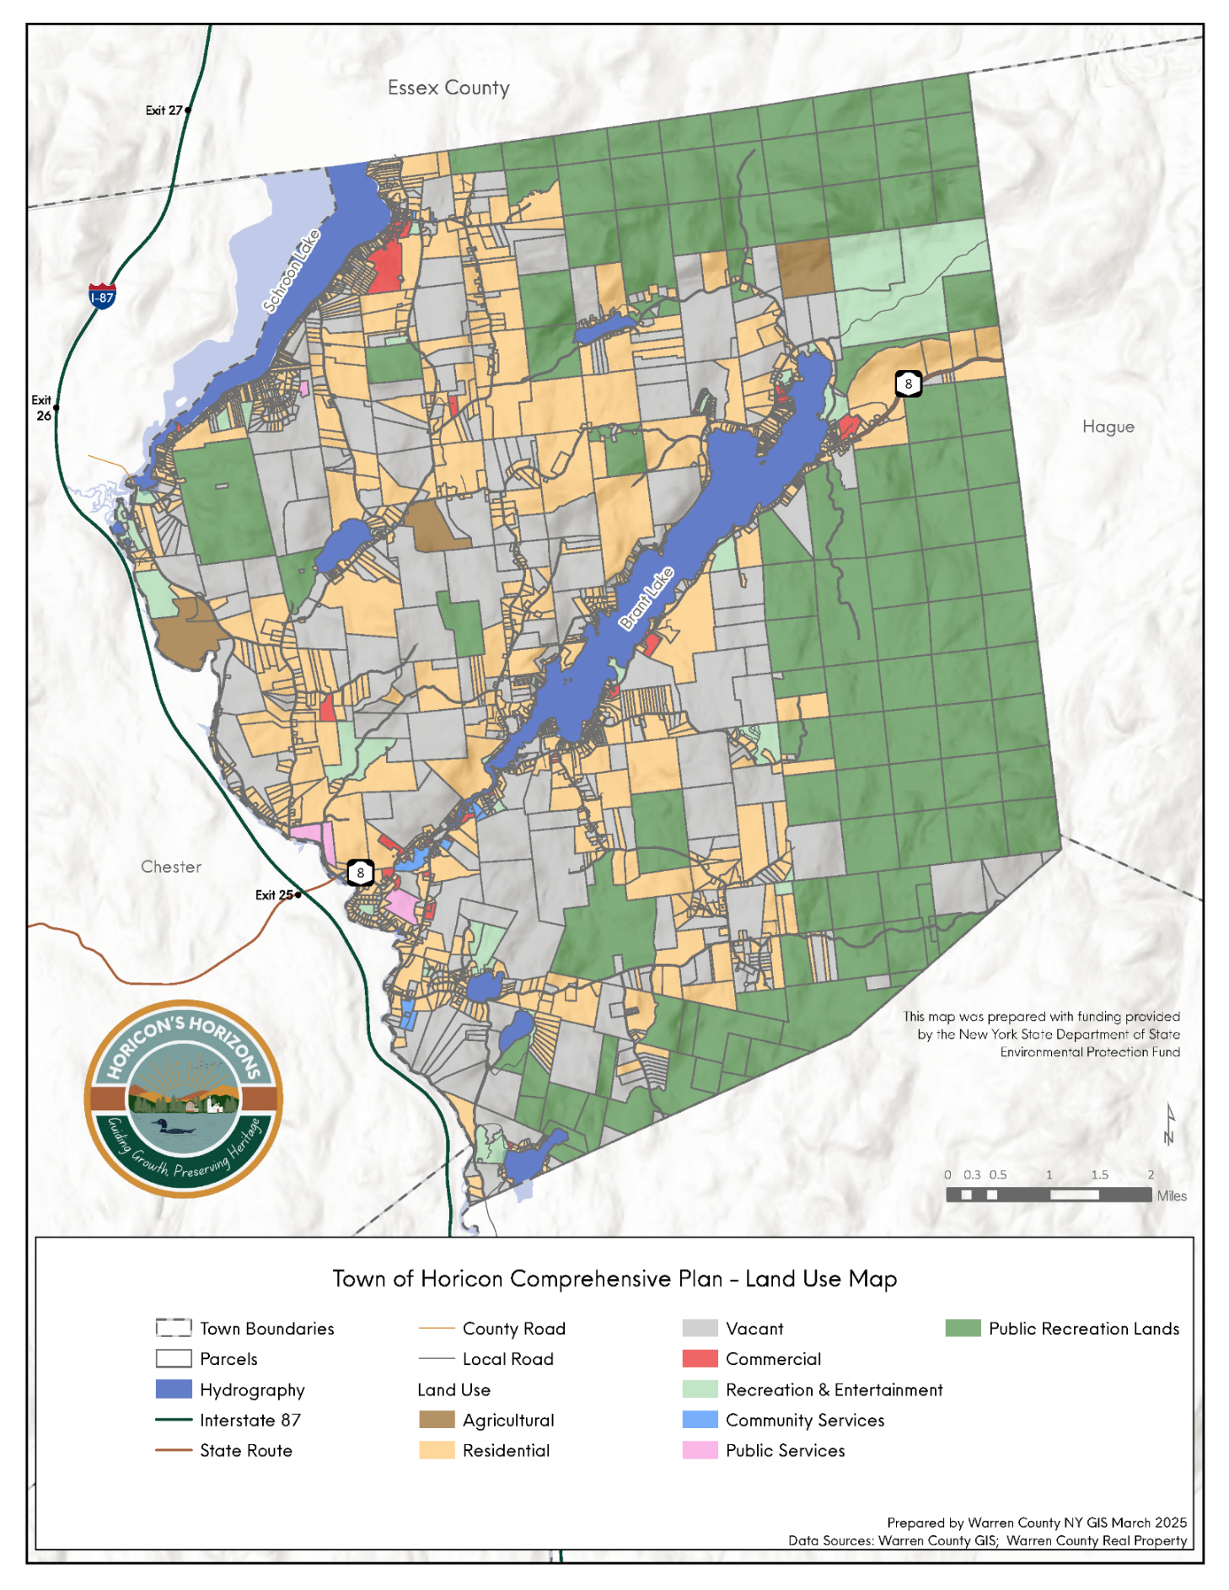
Map 2. Land Use Map
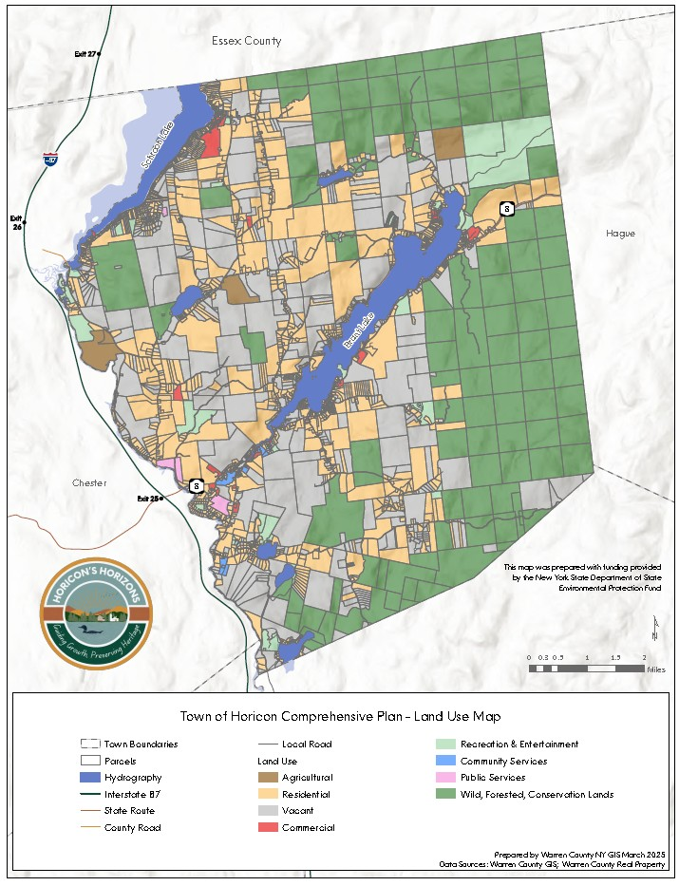

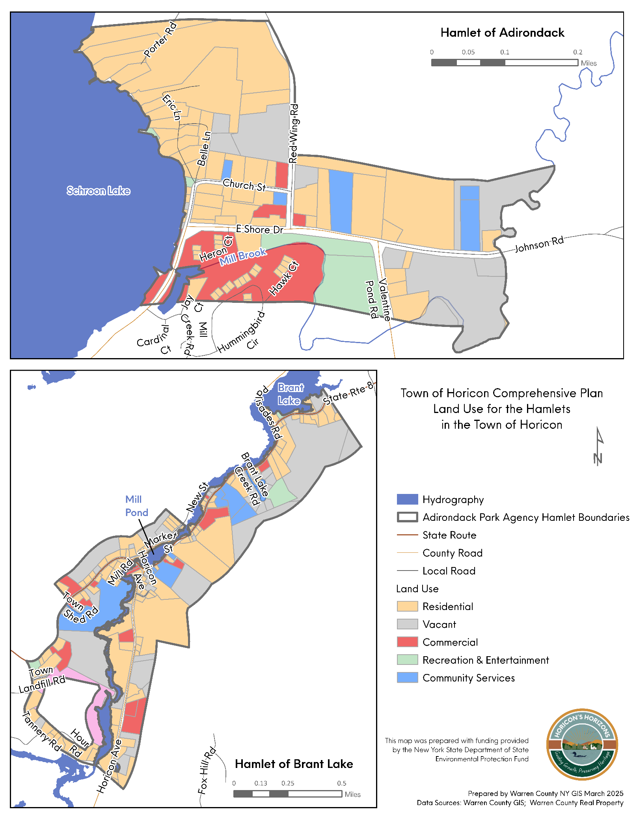
Map 3. Hamlets of Adirondack and Brant Lake Land Use Maps

Zoning and Other Local Development Controls
The Town of Horicon is subject to the Adirondack Park Agency (APA) land controls and any locally adopted land-use ordinances. The APA is an independent, executive state agency responsible for developing long-range Park policy in a forum that balances statewide concerns and interests of local governments in the Adirondack Park. It was created by New York State law in 1971. The APA regulates development on private land within the Adirondack Park.

An ALLUP is a locally developed land use law that aligns with or exceeds the standards set forth by the APA Act. Once approved, an ALLUP enables the municipality to take certain land use responsibility for administering land use and development regulations within its boundaries. This approach allows for more localized decision-making while ensuring alignment with the overarching goals of the APA, balancing local autonomy with regional environmental stewardship.
Within the Adirondack Park, the APA administers the Adirondack Park Agency Act, the Adirondack Park Agency Rules and Regulations, the Freshwater Wetlands Act, and the Wild, Scenic, and Recreational Rivers System Act.
The APA Act §810 defines different land uses and development as class A or class B regional projects based on their location, use, intensity, and other characteristics.
Local governments within the Adirondack Park may develop their local land use program, known as an Agency-approved Local Land Use Program (ALLUP), which, if approved by the APA, may transfer some permitting authority from the APA to the local government’s jurisdiction. If a municipality has an APA ALLUP, review jurisdiction over Class B regional projects, and variances from shoreline restrictions are transferred to the local governments. Class A regional projects require the APA to apply certain considerations of the standards and requirements of the local land use program in its review.
The Town of Horicon has adopted an ALLUP and has two APA-Designated Hamlet Areas, Brant Lake and Adirondack (Map 4. APA Land Use Designations Map). Within the Adirondack Park, designated Hamlet Areas are the growth and service centers where development is encouraged. There are very few development restrictions from the APA within the Hamlet areas.

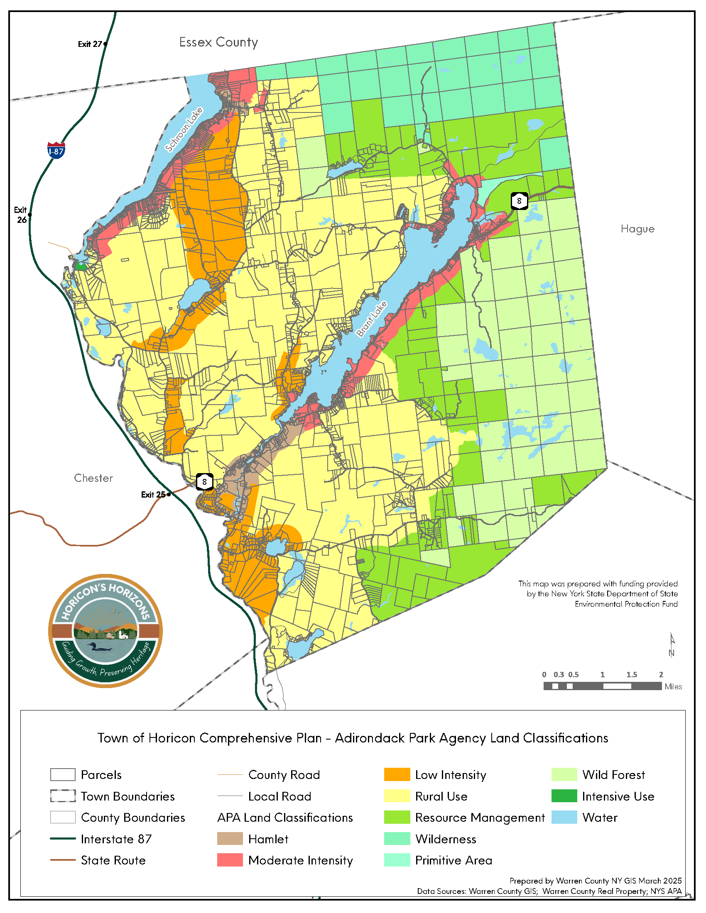
Map 4. APA Land Use Map

The Horicon Zoning ordinance consists of seven zoning districts and two overlay districts (Table 3). Most of the town’s land area is zoned Land Conservation. Residential districts are located on many of the lakeshores and along roadways throughout the town, and each Hamlet area has an established Commercial Residential District, promoting mixed-use opportunities in these community hubs (Map 5. Town of Horicon Zoning Map, Map 6. Town of Horicon Zoning within the Hamlets of Adirondack and Brant Lake).
Table 3: Town of Horicon Zoning Districts and District Intent
Zoning District | Purpose and Intent/Vision
Residential 1 | The vision for this district is to maintain the scenic residential environment, and promote and protect the residential character and physical environment of lakeshore areas, while providing for tourism and resort-oriented businesses consistent with traditional land uses found along the town’s lakeshores
Residential 1A | This district is envisioned as lower-density residential neighborhoods that provide affordable rural building lots
Residential 2 | The district includes the purposes and intent of Residential 1 and Residential 1A, but with rural residential and home-based commercial developments
Commercial/Residential | Serve as focal points and growth centers for neighborhoods
Land Conservation | There are three main intentions:  (a) Promote and protect the open space character of the environment, (b) Allow for recreation, agriculture, forestry and other open space uses of land, and (c) Allow for low density rural residential development and home-based businesses
Recreational River District | This district is envisioned as mixed use rural residential areas that prioritize maintaining open lands, public use of the river, and riverfront
Industrial | Opportunity for development of forest and ag lands, commercial sand and gravel extraction, mineral extraction, public utility expansion, and hunting and fishing specific structures
Adirondack Hamlet Design Review Overlay | Continue to build on community public amenities, such as the Town Park and Recreation Facilities
Millpond Overlay | Preservation of scenic qualities of selected travel corridors
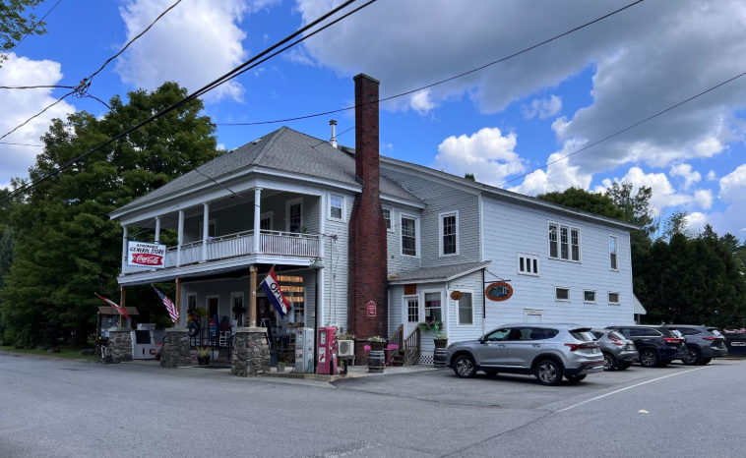
Smart Growth Focus Areas: Hamlets of Adirondack and Brant Lake
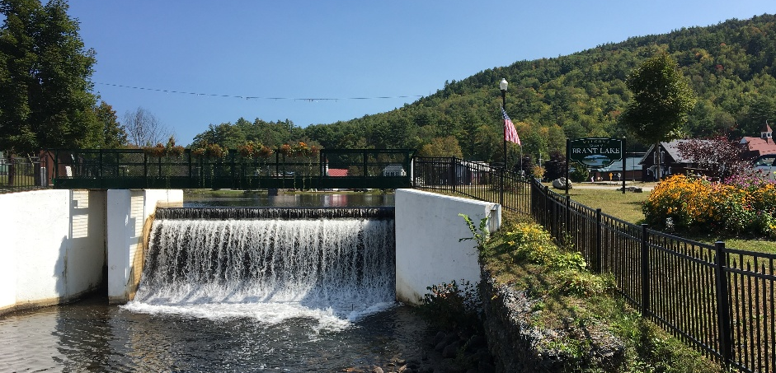
The Town of Horicon contains two APA-designated Hamlet Areas, Adirondack and Brant Lake. The Hamlet of Adirondack is in the northern portion of the Town, and the Hamlet of Brant Lake lies near the geographical center of Horicon at the southern end of Brant Lake. Under Adirondack Park land use policies, these hamlet areas are the primary locations targeted for growth and development, based on environmental and infrastructure screening factors unique to the Adirondack Park.
Photo 6: The Mill Pond in the Hamlet of Brant Lake. Photo Credit: Warren County Planning Department.
Photo 5: The Adirondack General Store in the Hamlet of Adirondack. Photo Credit: Warren County Planning Department.
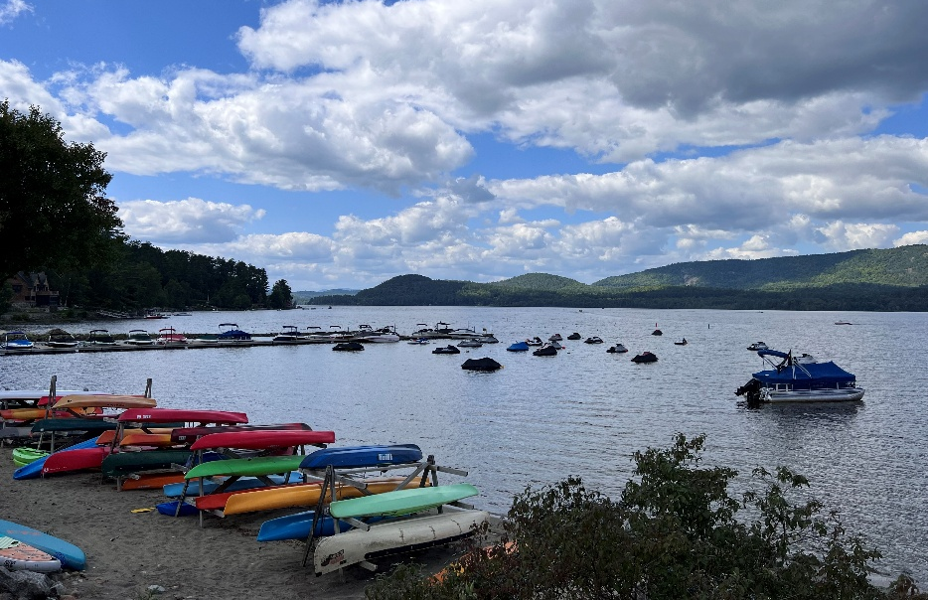
Both hamlets are well-suited to serve as focus areas for Smart Growth strategies. While predominantly residential in character, each has a level of development density that can support enhanced pedestrian and bicycle infrastructure, targeted beautification efforts, and investments that strengthen community life. Currently, sidewalks are limited or absent throughout both hamlets, and designated bicycle facilities are lacking, which can create safety concerns for
Photo 7: Beach in the Hamlet of Adirondack. Photo Credit: Warren County Planning Department.
pedestrians and cyclists.
The Hamlet of Brant Lake was first settled in the early nineteenth century and initially developed around agriculture and logging. As the Adirondacks gained popularity in the late 1800s, Brant Lake evolved into a resort destination, with the lake itself serving as the community’s defining feature. Historically, the lake supported early commercial activity and continues to attract visitors seeking recreation and scenic beauty. Today, Brant Lake remains a small but active community anchored by a community center, library, post office, parks, and several local businesses that contribute to the local economy while preserving its dual identity as both a place to live and a destination to visit.
The Hamlet of Adirondack, located along the eastern shore of Schroon Lake near Warren County’s northern boundary, has its origins in logging, farming, and the nineteenth-century tanning industry. Once home to a hotel, school, and a range of local businesses, the hamlet experienced a gradual decline in population and commercial activity over time. Today, Adirondack is a quiet residential community centered around a post office, town beach, general store, and museum. Land uses are primarily residential, with limited commercial activity and several vacant parcels, presenting both challenges and opportunities for future community-focused investment.

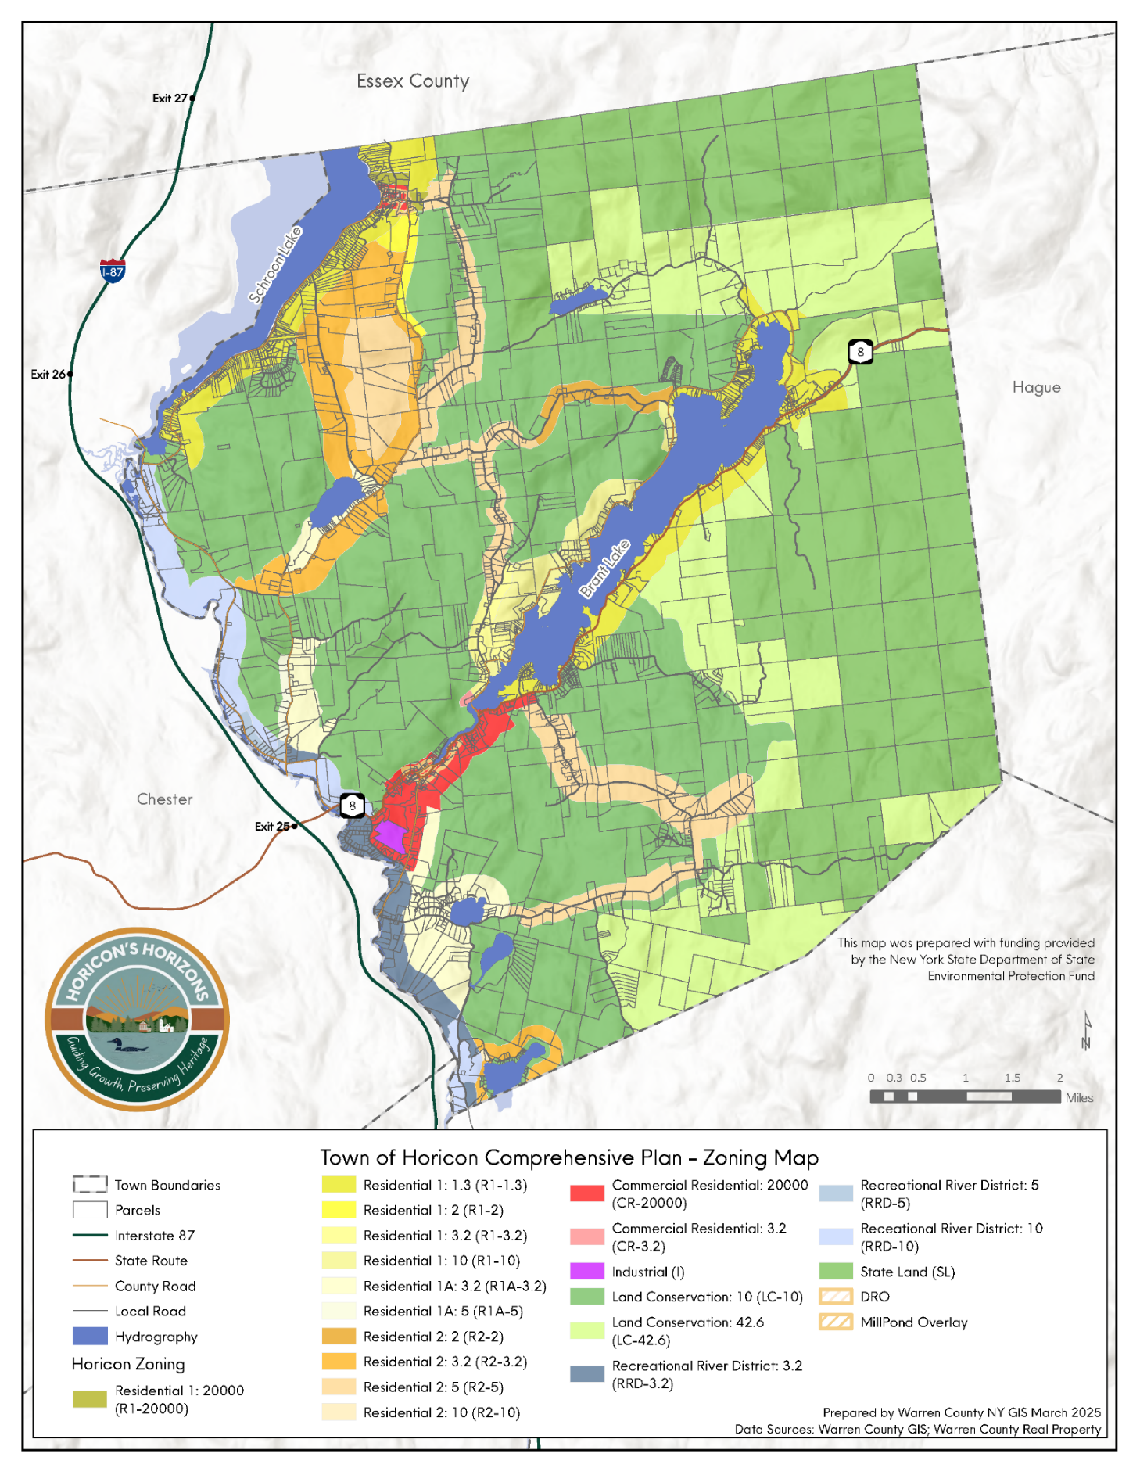
Map 5. Town of Horicon Zoning Map

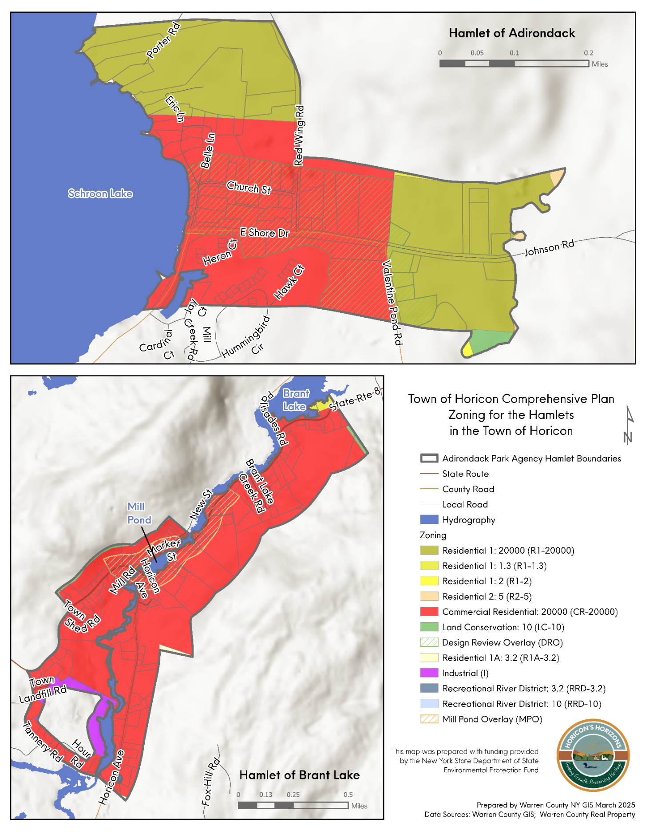
Map 6. Hamlets of Adirondack and Brant Lake Zoning Map

Historic and Cultural Resources
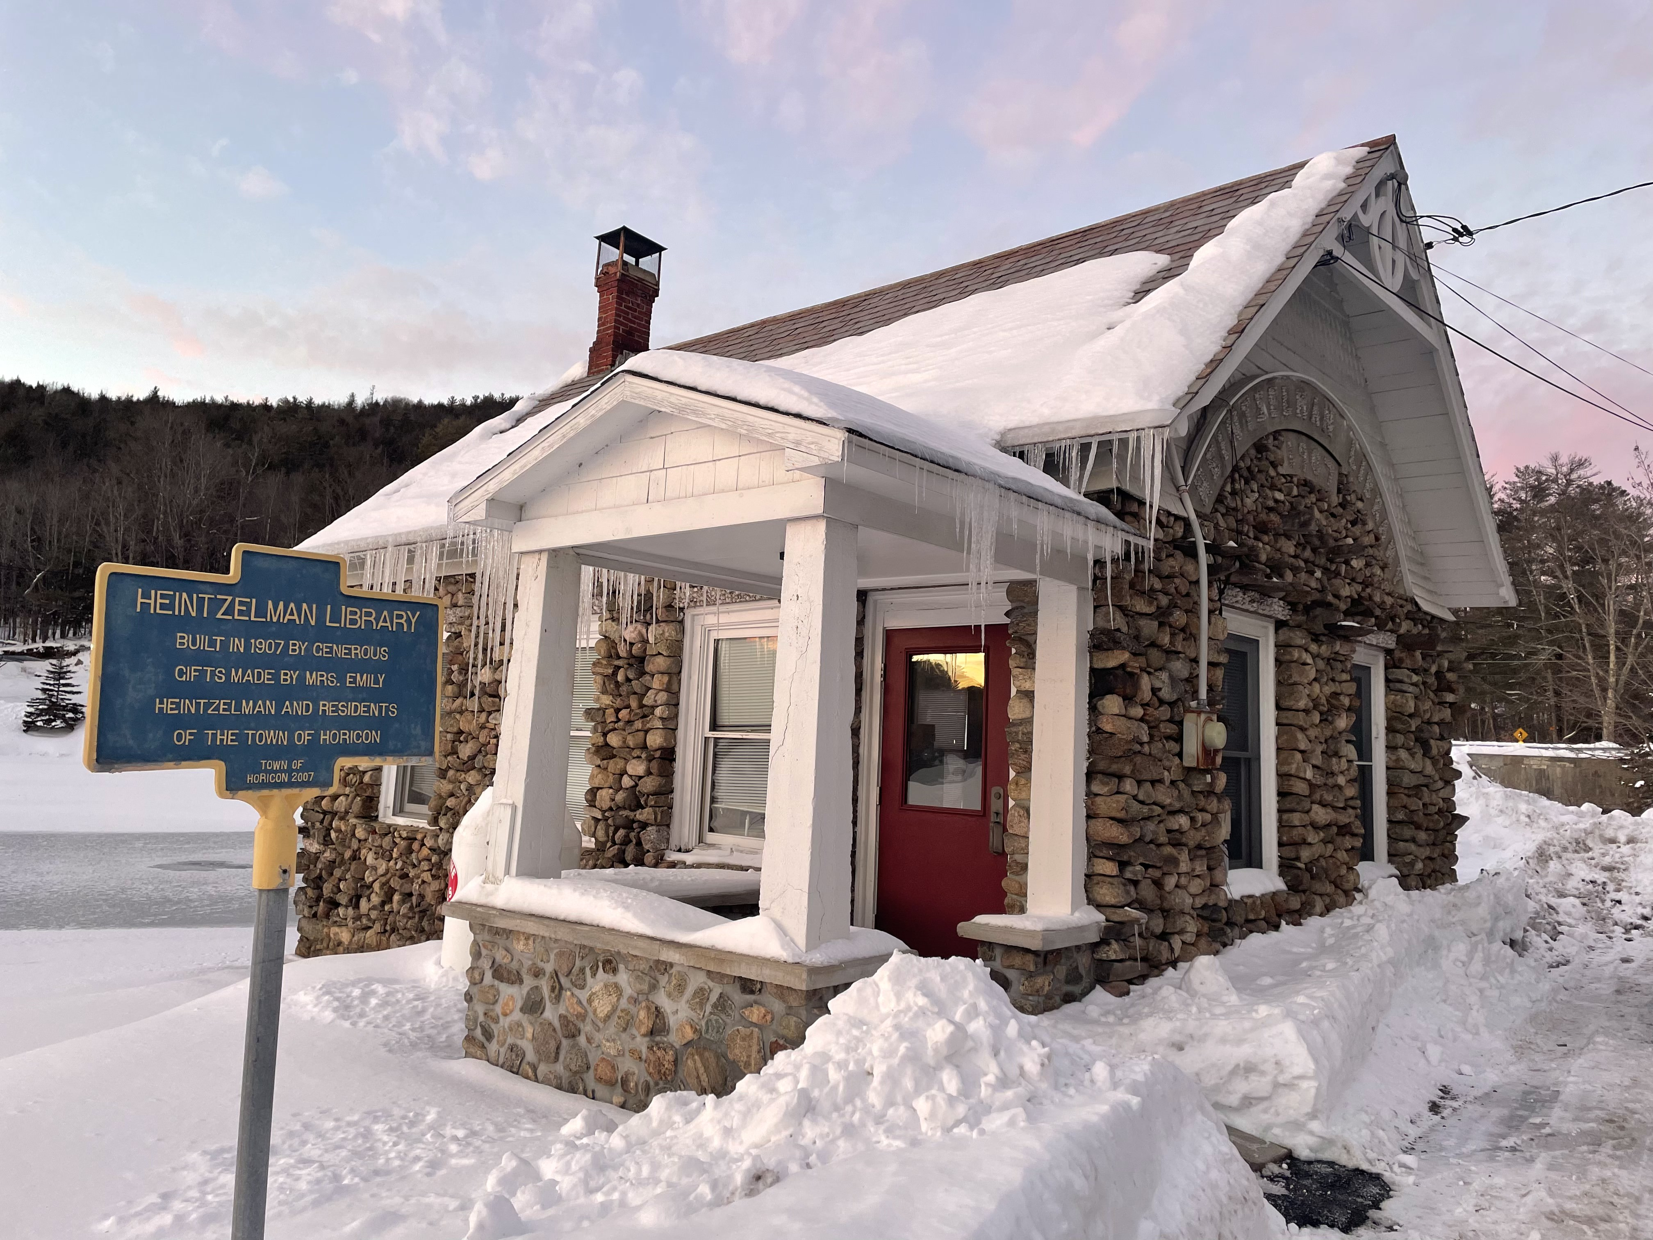

Horicon holds a deeply rooted and well-preserved history that residents value. It's only the National Register property, the Heintzelman Library, which stands as a landmark on the shores of Mill Pond. Built in 1907 through the philanthropy of Mrs. Emily Heintzelman, who donated books and funding to establish a public library, the building served the community until 2001. It now houses the Town Historian’s office and the Adirondack Book Collection.
Photo 8: Heintzelman Library, that stands as a landmark on the shores of Mill Pond. Photo Credit: Warren County Planning Department.
The Horicon Historical Society operates two museums, the Town of Horicon Museum (Brant Lake Museum) and the Adirondack 1881 Annex, which together showcase the community’s cultural heritage and local stories.
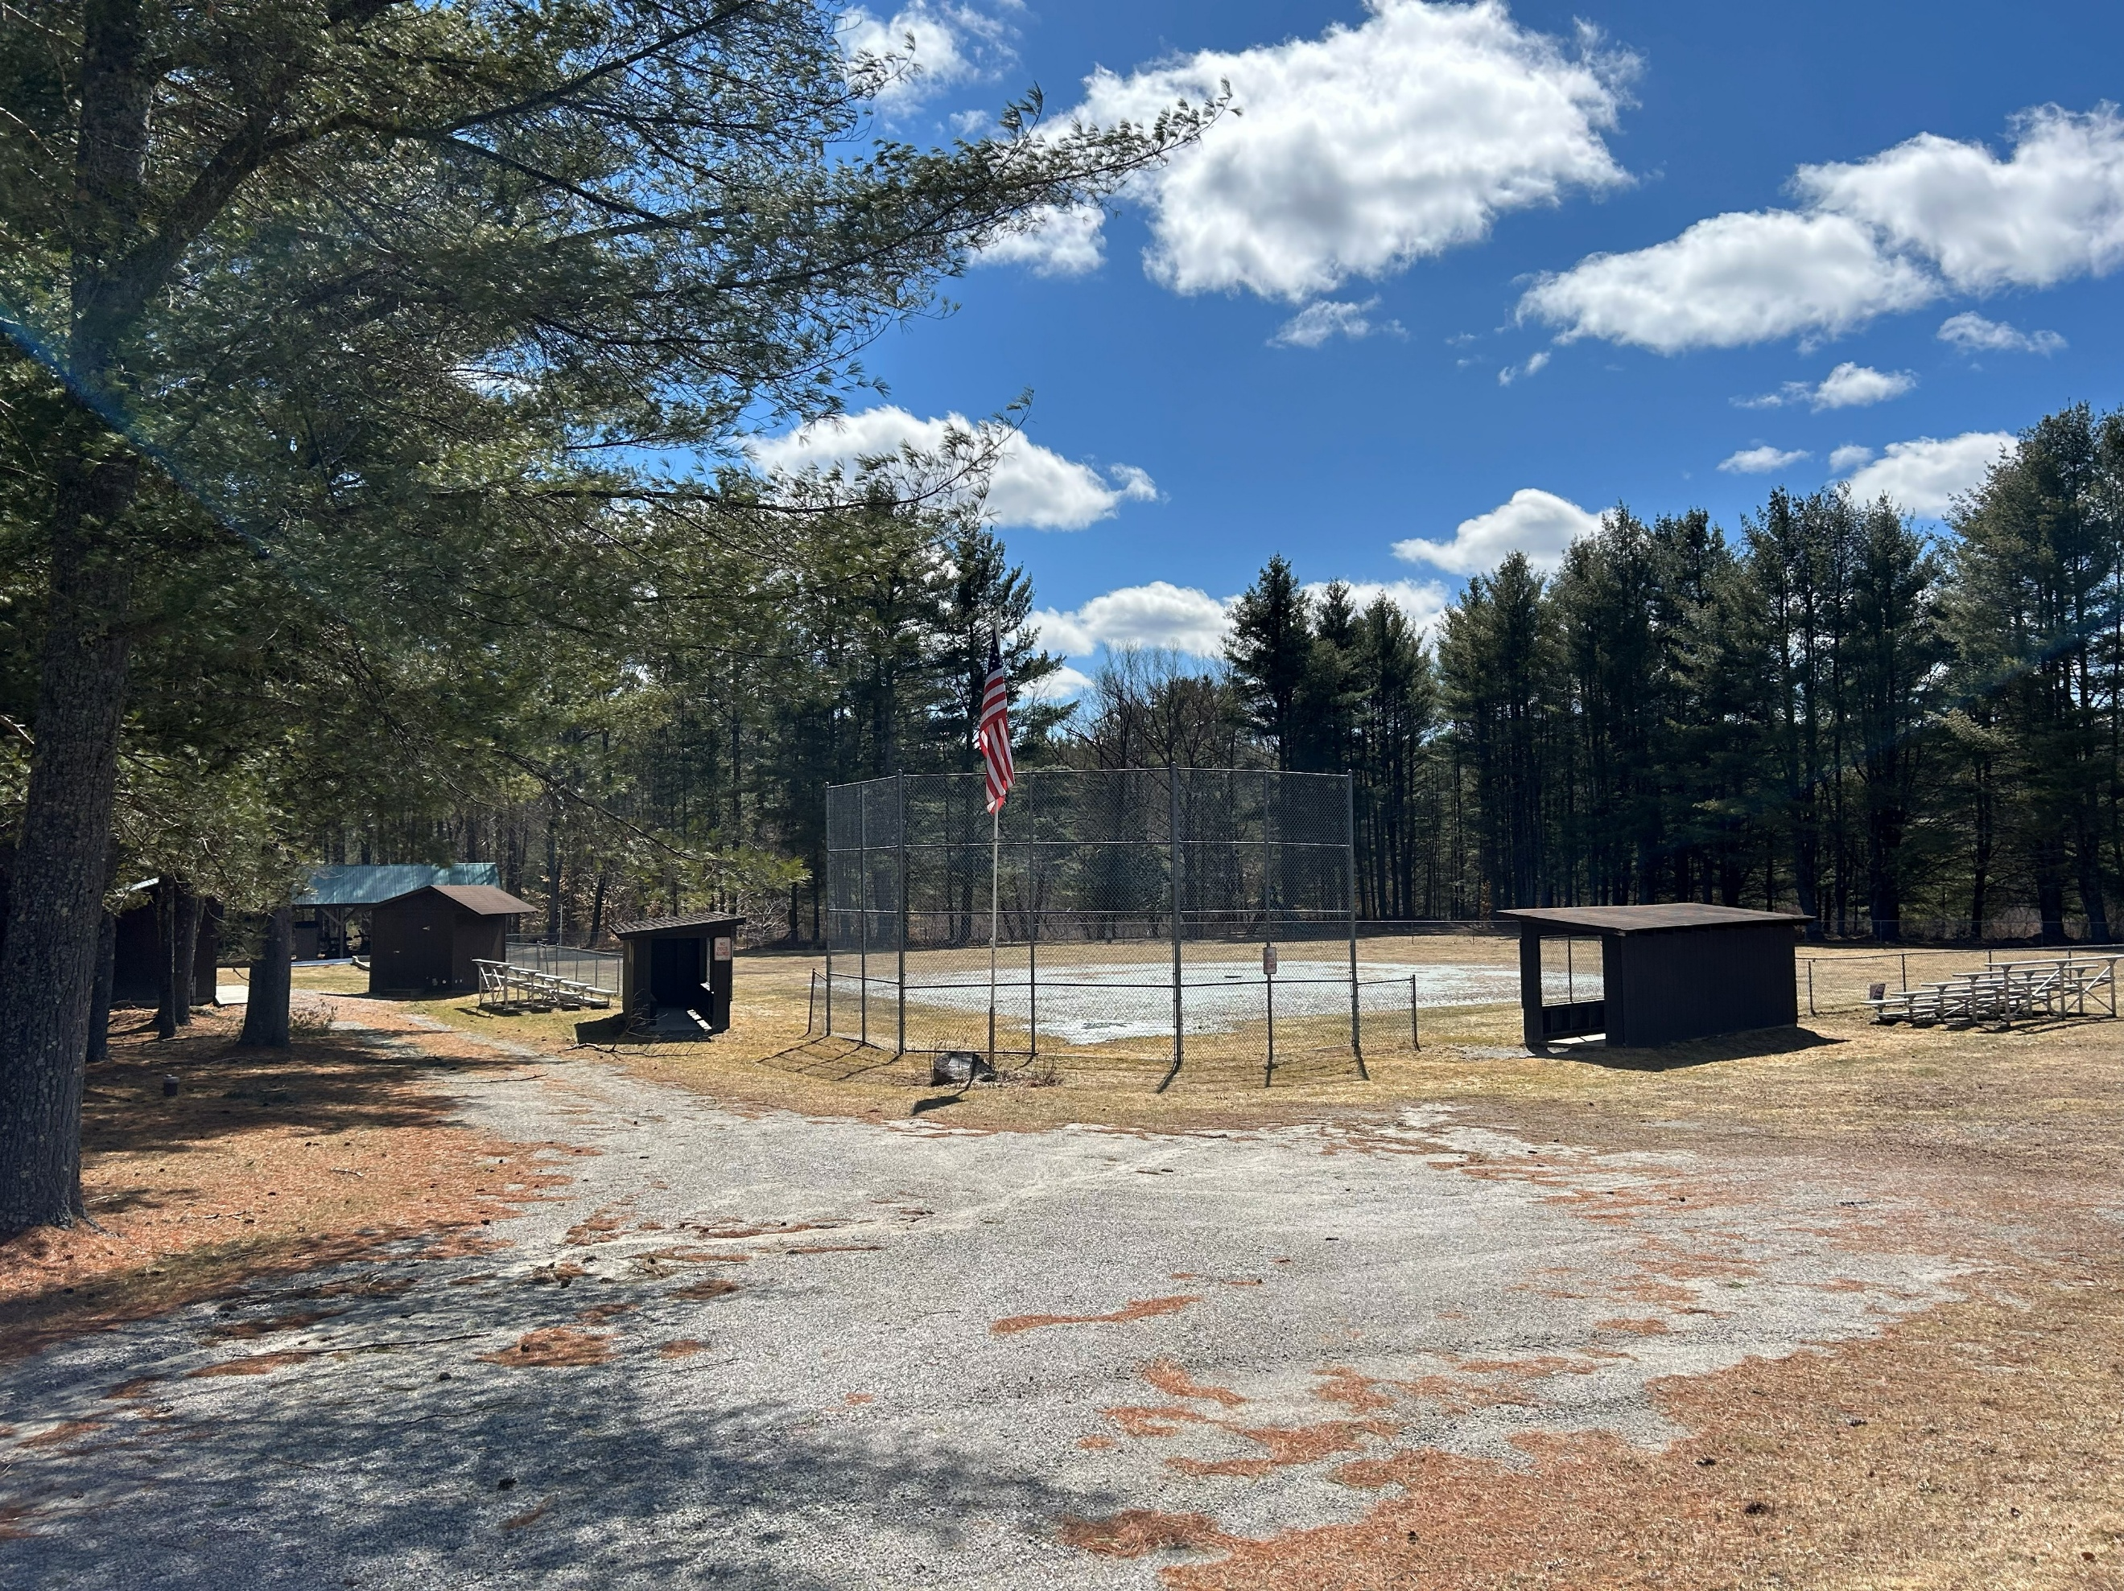

Historic and cultural resources are largely concentrated in the hamlets of Brant Lake and Adirondack, where most community services are located. These areas contain a rich collection of scenic and historic sites within close proximity, yet they lack adequate pedestrian infrastructure and designated bicycle routes. Improving walkability through connected walking loops, enhanced signage, and accessibility upgrades would better link these assets and enrich both resident and visitor experiences (Map 7. Historic and Cultural Resources Map).
Scenic resources such as Mill Pond, Brant Lake, Schroon Lake, and the surrounding wilderness lands are central to Horicon’s identity and economy. Preserving these landscapes while maintaining the town’s small-scale character is a key priority for the community. Horicon’s sense of place is also shaped by its history, museums, and lakeside heritage. Establishing design guidelines for the hamlet areas could help protect and enhance this distinct character, supporting attractive and vibrant centers that reflect Horicon’s historic and visual identity.
Photo 9: Albert E Monroe Park in the hamlet of Adirondack.

Public Spaces, Parks, and Recreational Facilities
The Town of Horicon is defined by its abundant water resources, anchored by its two major lakes, Schroon Lake and Brant Lake, and complemented by several smaller ponds and lakes, including Sherman Lake, Mill Pond, Lily Pond, Island Pond, Valentine Pond, Beaver Pond, and Round Pond. Together, these waters form the backbone of the Town’s scenic character and offer a wide range of recreational opportunities.
The Schroon Lake Park District (SLPD) is a multi-municipal entity established to protect water quality, manage aquatic invasive species, and support responsible recreation use of Schroon Lake. SLPD is responsible for the maintenance and operation of the Starbuckville Dam, which regulates the lake level of Schroon Lake. The Park District provides a coordinated framework for lake management that extends beyond municipal boundaries and reflects the shared ecological and economic importance of Schroon Lake to the region.
Schroon Lake and Brant Lake are central to the Town of Horicon’s economy, supporting property values, tourism, recreation, and municipal revenues. Studies of comparable regional waterbodies, including Lake Champlain, estimate that clean lake ecosystems generate hundreds of millions of dollars annually through tourism spending, waterfront property premiums, and ecosystem services. Research also shows that declining water quality can significantly reduce property values and visitor activity, directly affecting local economies.
Horicon maintains numerous public access points that invite residents and visitors to its lakes and rivers. These include the Town of Horicon Public Beach in Adirondack on Schroon Lake, the Brant Lake Public Beach on the Mill Pond, the Horicon Schroon Lake Boat Launch, Brant Lake Canoe/Kayak Access, and the Brant Lake Public Boat Launch (Map 8. Parks and Open Space Map).
The Schroon River, which forms Horicon’s western boundary, is another cornerstone of the Town’s natural and recreational landscape. Known for its healthy populations of rainbow, brown, and brook trout, the river supports fishing, paddling, and wildlife observation. Public access points provide convenient entry, and regular fish stocking by Warren County in partnership with NYSDEC enhances its appeal to anglers and outdoor enthusiasts.
At the center of the community is the Horicon Community Center, a gathering place for events, programs, and civic activities. The building houses the Town offices, Horicon Free Library, and the local food pantry. Located in the heart of Brant Lake, the community center plays a vital role in supporting community life and delivering essential services to residents.

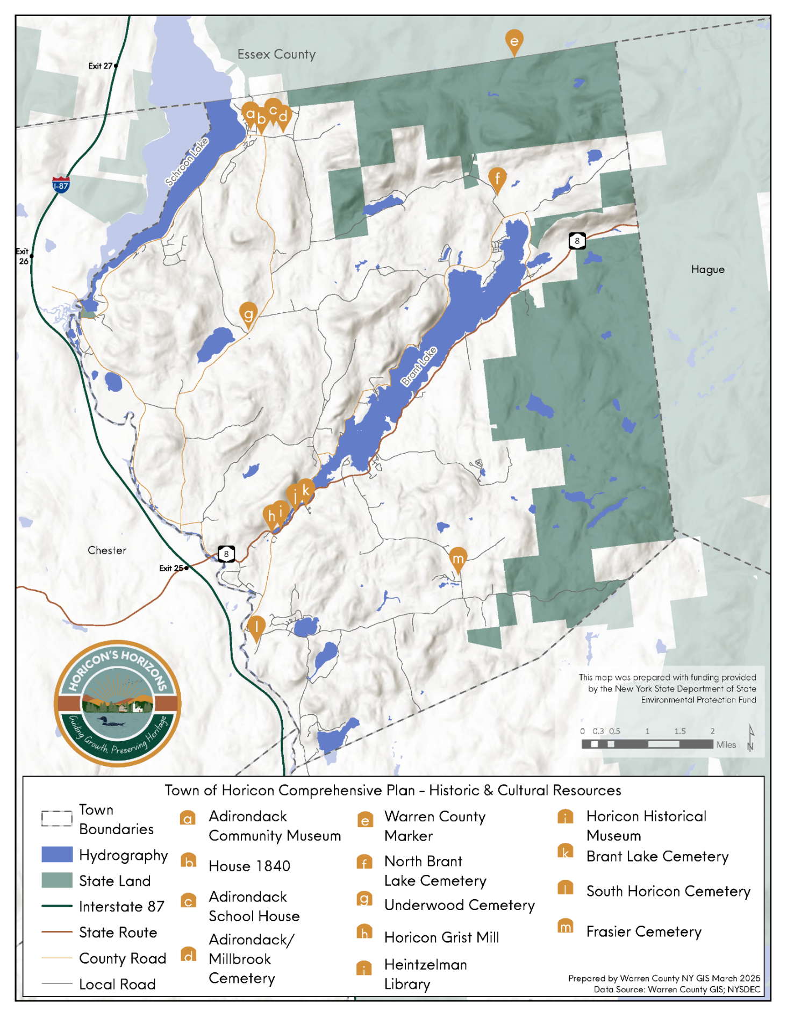
Map 7. Historic and Cultural Resources Map

Infrastructure and Community Facilities

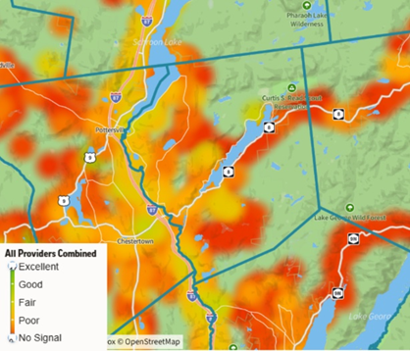

The Town does not have a municipal water supply or sewer system; instead, properties rely on individual wells and on-site septic systems or privately operated community systems. While the absence of public water and sewer infrastructure has not hindered development to date, aging or poorly maintained on-site septic systems can pose risks to nearby waterbodies and overall environmental health.
Figure 5: Signal Strength in the Town of Horicon Source: Ookla Speed test Data
The Town of Horicon has identified broadband and cellular connectivity as a critical issue affecting public safety, workforce development, and economic growth. Gaps in reliable internet and cell service pose challenges for emergency response, remote work, business operations, and access to essential services. There are opportunities for the Town to participate in regional and statewide initiatives working towards broadband improvements and enhancing cellular coverage in rural communities.
Figure 6: Broadband coverage in the Town of Horicon. Source: NYS Broadband Mapper
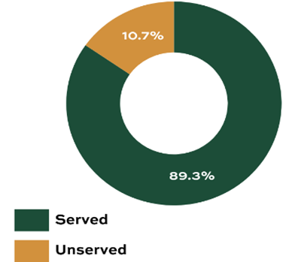

Much of the Town of Horicon experiences weak or nonexistent wireless coverage (Figure 5). Sizable portions of the Town have been found to have poor or no signal, shown in red, particularly in more rural and forested areas. Areas with fair to good coverage are shown in yellow and green, however, these zones are limited and often concentrated near hamlet centers and major road corridors. This limited connectivity can present challenges for residents, businesses, and visitors, especially in terms of accessing essential communication services, emergency response, and modern digital infrastructure needs.

The New York State Broadband Map evaluates the availability, reliability, and affordability of high-speed internet across communities statewide. In Horicon, approximately 89% of homes have internet access, while 11% are classified as unserved (Figure 6), meaning they lack a fixed wireless or wired connection or have connection speeds below 25 Mbps. Connection and service fees can be a hurdle to future broadband connection. High broadband costs are leaving residents classified as served but not choosing to connect due to unaffordable prices.
Schroon Lake and Brant Lake are influenced by small but critical water-control dams that help regulate lake levels, support recreation, maintain shoreline stability, and contribute to regional water management. The Starbuckville Dam regulates water levels for Schroon Lake and is owned and operated by the Schroon Lake Park District (SLPD), a multi-town special district. The dam is designed to maintain a lake elevation of approximately 806 feet above sea level and helps sustain docks, beaches, and shoreline protection while moderating downstream flooding through controlled water releases and supporting recreational and fisheries resources.
Brant Lake is regulated by smaller control structures that stabilize water levels rather than providing large-scale regulation like on Schroon Lake. The Brant Lake Lower Dam, located at the lake’s outlet on a tributary of the Schroon River, is owned by the Town and is intended to maintain consistent lake elevation, support recreational use and shoreline conditions, and manage downstream flows within the Schroon River system.
The economic and ecological stability of Schroon Lake and Brant Lake depends not only on water quality but also on the continued maintenance and coordinated management of this dam infrastructure, which directly influences lake levels, shoreline conditions, and recreational usability.

Transportation Systems
The Town of Horicon relies almost entirely on personal vehicles, as no public transportation is available. The community is served by three main corridors, County Route 15, State Route 8, and County Route 26, which connect to Interstate 87 (Adirondack Northway). State Route 8 is the busiest, with an average daily traffic count of 2,030 in 2023. Although electric vehicle use is increasing, Horicon has no public EV charging stations and only one fast charger that is privately owned. Adding a charger in high-traffic areas would support future demand and enhance tourism initiatives in the region.
Horicon residents commute an average of 23 minutes to work, similar to the county average, which is between 22 to 24 minutes. Approximately 81% of people commute alone, 5% carpool, and 10% work from home. Bicycle and pedestrian mobility are limited due to the lack of sidewalks and the absence of bicycle infrastructure on key routes in the community. The National Walkability Index rates Horicon as “Least Walkable,” largely because most errands require driving, and essential services such as grocery stores, pharmacies, and medical offices are not located nearby.

Map 8. Parks and Open Space Map
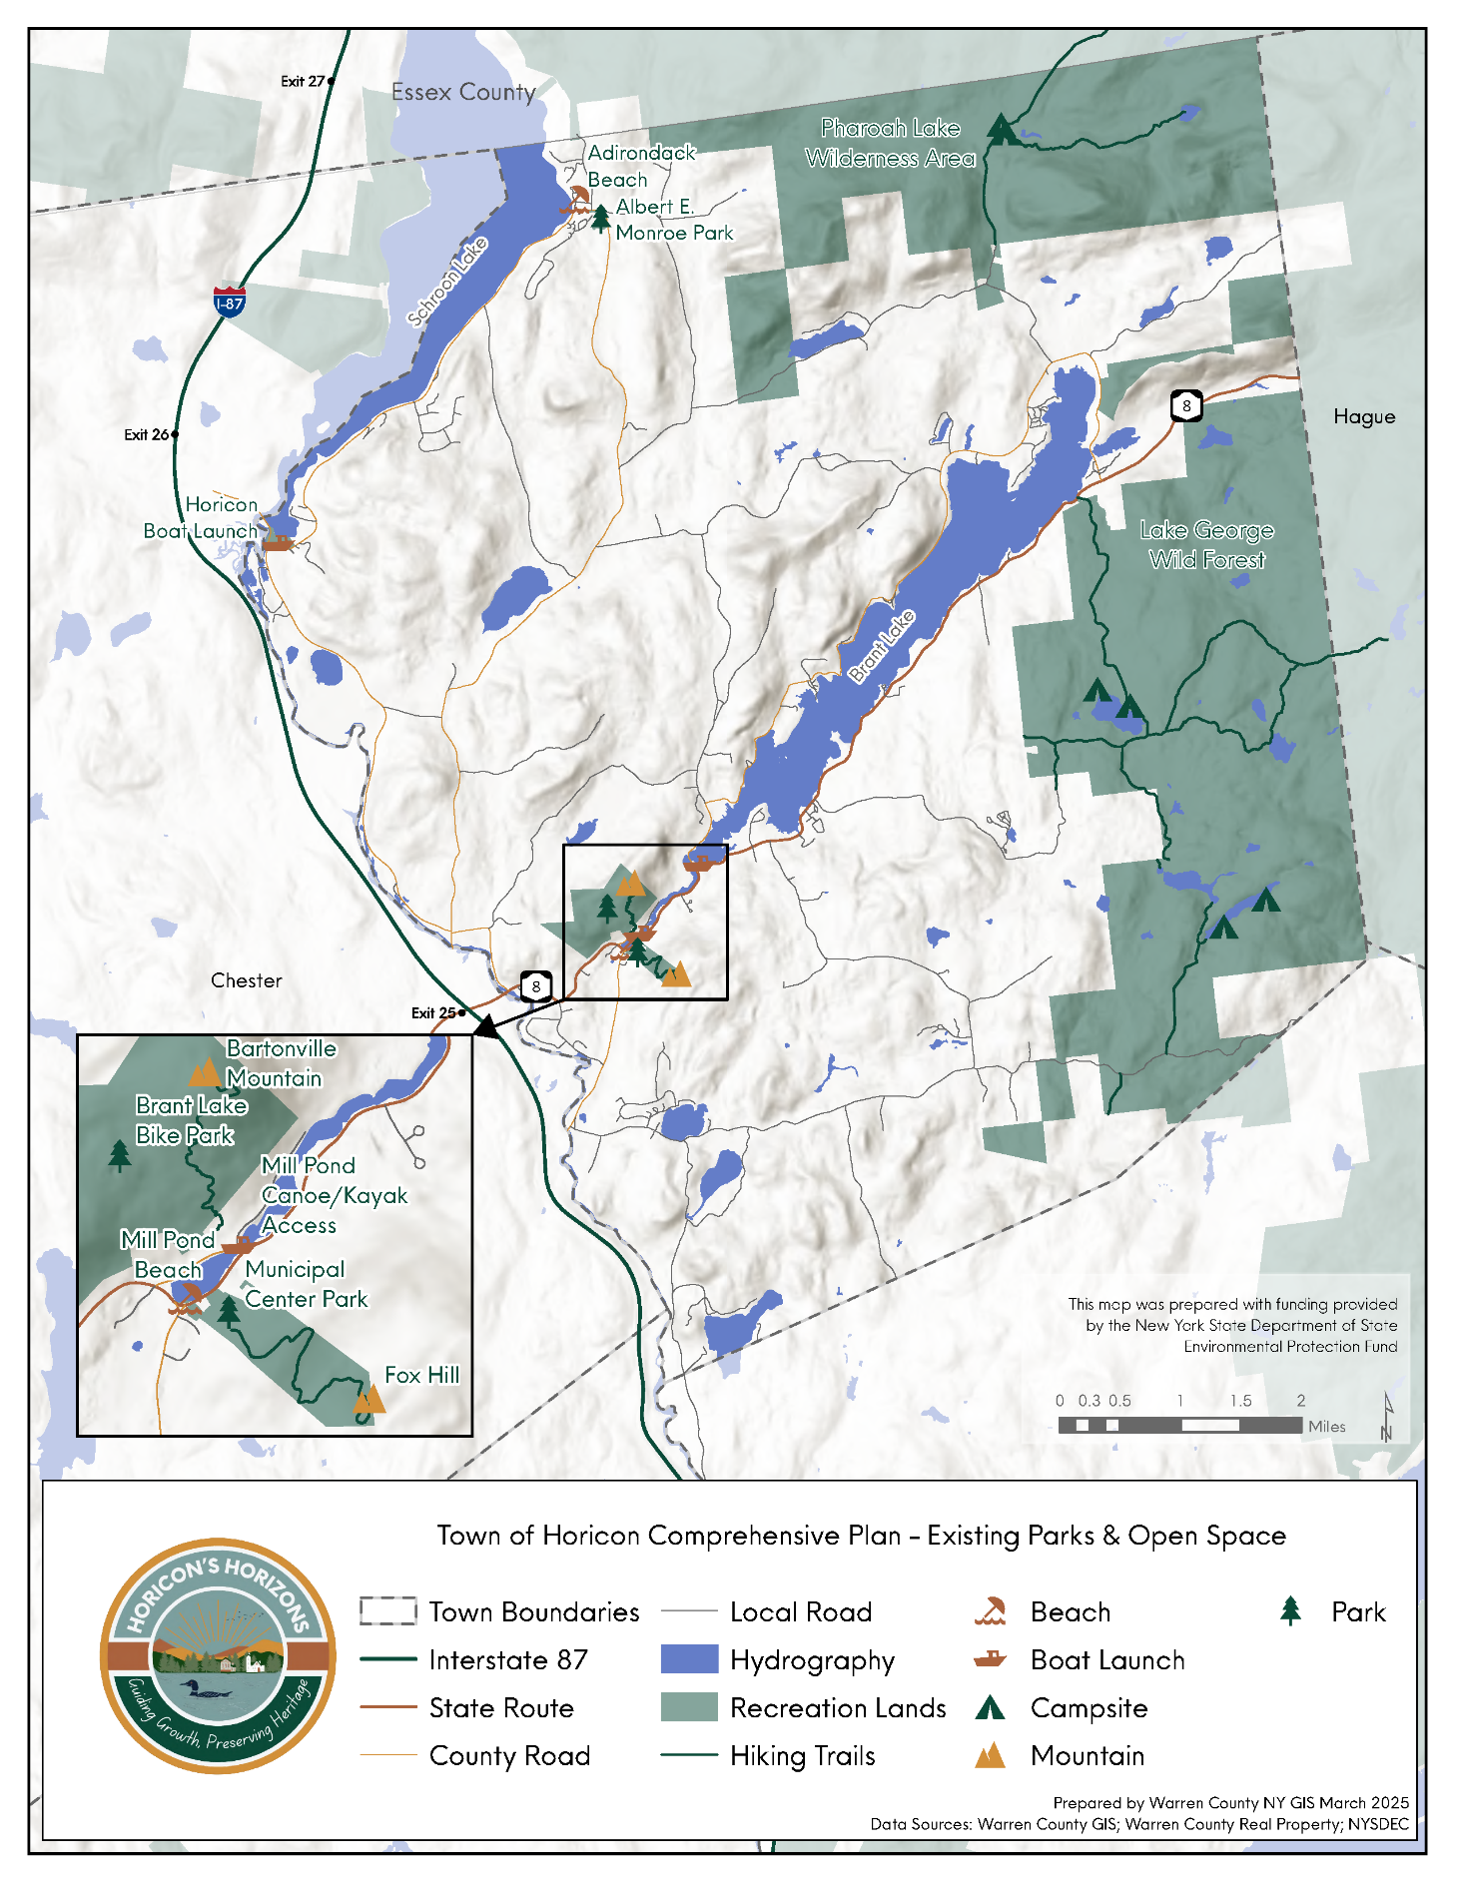

Section 2. Vision, Goals, and Objectives
A vision statement is an aspirational, forward-looking description of what the community hopes to achieve in the next five to ten years. The vision statement for the Town of Horicon was developed in collaboration with the CPC and shaped by extensive public input gathered through the community survey, public workshops, and stakeholder interviews. This statement provides the foundation for the plan’s goals and recommendations, guiding future decisions and investments toward the community’s desired future.

Town of Horicon Vision Statement: The Town of Horicon is a vibrant and welcoming four-season community where all residents contribute to a place where people thrive, and future generations are inspired to put down roots and build their lives. Guided by a shared commitment to our heritage, community ties, opportunities, and sustainability, our town continues to grow while retaining its unique qualities. Our community is dedicated to:
- Engaging Residents: Ensure that all residents have a strong voice in decisions shaping the Town’s future, while fostering an inclusive community where all members feel valued, supported, and connected.
- Quality, Affordable Housing: Expand diverse, attainable housing options for families, individuals, and seniors of all income levels and abilities.
- Supporting Local Businesses: Promote entrepreneurship, skilled trades, and local economic growth that sustain year-round employment and strengthen Horicon’s unique character.
- Environmental Stewardship: Protect natural resources while nurturing a safe, welcoming, and interconnected community.
- Preserving our Heritage: Celebrate the Town’s history while actively shaping a prosperous future driven by innovation, small business, and resident participation.
- Attracting Young Families and Retaining Residents: Enhance quality of life through housing, excellent amenities and supportive services, recreational opportunities, and a strong sense of community.
- Reliable Infrastructure and Accessible Transportation: Maintain safe, dependable roads, telecommunications, and transportation networks that link residents to opportunities, services, and one another.

Community Goals:
- Expand and Diversity Housing Options
- Revitalize and Protect Hamlets as Community Hubs
- Strengthen and Grow the Local Economy
- Support Local Businesses and Entrepreneurs
- Protect Natural Resources and Enhance Outdoor Recreational Assets
- Promote A Sustainable, Year-Round Recreational Economy
- Modernize and Align Zoning and Land Use Regulations

2.1 Smart Growth Principles
Smart Growth promotes key land use planning principles that foster livable, sustainable, and equitable communities. This plan is funded through the New York State Department of State (NYSDOS) Smart Growth Comprehensive Planning Grant Program, which helps municipalities statewide implement Smart Growth principles within their comprehensive planning efforts.
According to Hamlets 3, a report prepared for the Adirondack Community Housing Trust in partnership with Essex County, smart growth in the Adirondack is the opposite of auto-dependent growth and can provide opportunities to stimulate a local economy:
A smart-growth Adirondack hamlet remains compact, walkable, well-defined, and connected to neighboring hamlets. Smart hamlets provide job opportunities and year-round affordable workforce housing for Adirondackers. Smart growth in the Adirondacks steers new development toward existing hamlet infrastructure or facilitates new infrastructure investments.
Smart Growth Principles are woven throughout this plan in ways that are compatible with the community’s shared vision and goals and include:

 | Develop plans and land use regulations that allow for and encourage mixed-use neighborhoods
 | Enable a diverse mix of housing types, providing opportunity and choice for all
 | Prioritize infill and redevelopment of existing buildings to revitalize neighborhoods and downtown areas, including areas around public transportation
 | Provide well-planned, equitable, and accessible public spaces
 | Encourage compact neighborhood design and concentrated development around existing infrastructure
 | Preserve open space, agricultural resources, and natural resources
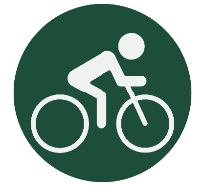 | Prioritize transportation options such as walking, cycling, and public transportation
 | Promote climate resiliency and adaptation, preferably through nature-based solutions, and reduce greenhouse gas emissions
 | Build on unique traits to create an attractive and welcoming community with a strong sense of place
 | Engage in an inclusive, collaborative public planning process that considers the needs and character of the community

2.2 Goals, Objectives, and Strategies
The goals and objectives established through the Comprehensive Plan serve as a roadmap to guide the community toward achieving its shared vision for the future. Each goal is supported by specific, measurable, and attainable objectives that outline actionable steps the Town can monitor and evaluate over the life of the plan. The Implementation Matrix in Section 4.1 provides additional guidance, tools, and resources to assist in tracking progress and ensuring the successful completion of the goals and objectives outlined in this report.
Horicon’s goals and objectives are organized around the key community issues identified through public outreach and stakeholder engagement and include housing, hamlet centers and community hubs, economic stability, natural resources and recreation, and land use and development. Each area represents a priority for the Town and reflects the values and needs expressed by residents throughout the planning process.
Indicates a priority strategy.
Priority projects were identified through a combination of established Town priorities, alignment with regional planning initiatives, and feedback received through the public engagement process. This approach ensures that recommended actions reflect ongoing local goals and broader regional efforts, while incorporating the perspectives and needs expressed by community members throughout the planning process.

Housing

Relevant Smart Growth Principles:
 |  |  | 
Mix of Housing Types | Infill and Redevelopment | Develop Around Existing Infrastructure | Collaborative Planning
With nearly two-thirds of homes used seasonally, Horicon is facing increasing pressure on the availability of affordable, year-round housing for residents and workers.
Over the past decade, Horicon has seen notable changes in its housing market. A recent Warren County Housing Study identifies key trends, especially a high vacancy rate. The 2020 Census reports that nearly 64% of the town’s housing units are categorized as vacant, with about 93% of those units used as seasonal residences. Like many Adirondack communities, Horicon faces ongoing issues with housing affordability, limited long-term rentals, and a shortage of year-round and workforce housing. Much of the housing stock consists of second homes and short-term rentals, which drive up prices and reduce full-time housing availability. Consequently, young families and local workers find it increasingly difficult to afford suitable housing.
Goal 1 aims to expand and diversify Horicon’s housing by encouraging renovations and new developments that serve various income levels and household types, including accessory dwelling units (ADUs), duplexes, triplexes, and tiny homes. The focus is on balancing growth with preserving the community’s character through infill development and sensitive projects, while managing the impact of short-term rentals to support a stable year-round housing market. Priority should be given to infill development in Brant Lake and Adirondack hamlets.
According to the Adirondack Park Agency (APA), hamlets are meant to serve as the growth and service hubs of the Park, accommodating expansion of housing and commercial activities. Warren County’s Thriving Hamlets initiative highlights the potential for infill development on vacant parcels. In Brant Lake, about 94 acres of land, around 19% of the total land area in the hamlet, are available for development. In Adirondack, roughly nine acres, or 11% of the hamlet area, remain developable. Collaborations with local employers, regional agencies, and nonprofits will be vital to achieving these goals. Horicon aims to cultivate a vibrant year-round community and attract new residents and families.

Goal 1: Expand and Diversify Housing Options

Objectives and Strategies:
1.1 | Preserve and enhance existing residential neighborhoods by promoting the rehabilitation and maintenance of existing residential structures
S1.1 Partner with county and regional housing programs to support the rehabilitation of existing homes for workforce housing and year-round residential uses
S1.2 Establish a town-wide vacant and blighted building inventory to prioritize areas for investment
1.2 | Create opportunities for lower-cost, affordable housing
S1.3 Promote a mix of quality housing options at price ranges that are accessible to all ages, abilities, and incomes

S1.4 Ensure local zoning and initiatives support the development of senior and accessible housing in centrally located areas with access to services and community activities

S1.4a Pursue funding for senior housing opportunities in hamlet areas

S1.5 Identify and map parcels best suited for new and infill development for housing

S1.6 Review and update Town fees, codes, and procedures to streamline the review and permitting process for residential development.
1.3 | Continue to work collaboratively to balance short-term rental housing stock and the need for affordable year-round housing opportunities
 | S1.7 Implement a program to mitigate the conversion of year-round housing to short-term rentals
1.4 | Improve retention of area employees by promoting affordable long-term rentals for the local workforce
 | S1.8 Promote employee-assisted housing partnerships to help local workers live within the community.

Hamlet Centers and Community Hubs

Relevant Smart Growth Principles:
  Welcoming Community and Strong Sense of Place |   Enhance Opportunities for Walking and Cycling
The Mill Pond area and the Hamlet of Adirondack are Horicon’s community hubs, and targeted investments can make these areas more vibrant, walkable, and welcoming while maintaining small-town character.
The Mill Pond area of Brant Lake and the Hamlet of Adirondack serve as the cultural and social heart of Horicon. Strengthening these centers of activity will reinforce the Town’s community identity, enhance quality of life, and expand local economic opportunities. Goal 2 focuses on preserving Horicon’s rural, small-town charm while making thoughtful investments in streetscapes, transportation, and community facilities.
By improving walkability, enhancing visual appeal, and adding recreational amenities, the Town can create more vibrant, welcoming hamlet centers that better serve both residents and visitors. These efforts will allow Horicon to evolve and grow while preserving the character and sense of place that define the community.

Goal 2: Revitalize and Protect Hamlets as Community Hubs

Objectives and Strategies:
2.1 | Retain our rural small-town character
S2.1 Codify design standards that reflect Horicon’s community character while balancing functionality, accessibility, and affordability

S2.2 Develop a Hamlet Masterplan for Adirondack to ensure that any future development aligns with the community’s vision
2.2 | Preserve and enhance the distinctive identities of the Hamlets of Adirondack and Brant Lake through a combination of building and streetscape improvements that maintain the rural community character
S2.3 Encourage reinvestment in underused or vacant buildings for housing or small businesses, reducing the need for new infrastructure

S2.4 Ensure local land use codes allow for mixed-use and small-scale business development
2.3 | Improve and enhance community facilities and services
S2.5 Support community spaces and facilities that enhance civic life and serve all residents

S2.6 Plan and implement improvements to the Brant Lake Fire House

S2.7 Conduct a feasibility study for the acquisition of property for a town beach on Brant Lake

S2.8 Develop a plan for the upgrade of facilities at the public beaches in Adirondack and the Mill Pond, including evaluating ADA accessibility
2.4 | Improve transportation infrastructure to enhance the safety, convenience, and efficiency of drivers, cyclists, and pedestrians
S2.9 Implement findings of the Brant Lake Trail Feasibility Study
S2.10 Conduct pedestrian and bicycle safety connectivity studies for the Hamlets of Brant Lake and Adirondack
The Brant Lake Trail Feasibility Study examines potential routes, technical and environmental constraints, property ownership issues, and opportunities to create safe, accessible non-motorized connections between key recreational and community destinations. By identifying challenges, partnerships, and funding strategies, the project lays the groundwork for expanding recreational infrastructure, improving safety, and strengthening Horicon’s appeal as an active, nature-based destination.

2.5 | Improve the visual appeal, safety, and walkability of main streets and thoroughfares throughout Horicon
S2.11 Develop a Gateway Masterplan for the Hamlets of Brant Lake and Adirondack that includes traffic calming measures that reduce vehicle speed

S2.12 Collaborate with NYSDOT and AGFTC to redesign and configure the intersection of Route 30 and Horicon Ave at the Mill Pond in Brant Lake

S2.13 Implement the Adirondack Hamlet Walkway initiative

S2.14 Identify and inventory vacant or underutilized community spaces

S2.15 Evaluate and implement opportunities to improve pedestrian and bicycle safety and connectivity on main roadways throughout Horicon
The Adirondack Hamlet Walkway Initiative calls for the construction of a pedestrian path between the public parking lot, the town beach, and other key points in the hamlet. This project will improve pedestrian safety and circulation in Adirondack.

Economic Stability

Relevant Smart Growth Principles:
 | 
Welcoming Community and Strong Sense of Place | Preserve Open Space and Natural Resources | Mix of Housing Types
Through investments in local businesses, outdoor tourism, and better broadband and cellular connectivity, Horicon can grow a more resilient year-round economy and attract new residents, workers, and visitors.
A strong and resilient economy is essential to sustain Horicon’s year-round population and enhance the quality of life for residents. Building on the Town’s recreational, cultural, and environmental assets, Horicon can strengthen and diversify its economic base by supporting existing local businesses, attracting new employers, and expanding its tourism infrastructure, such as trails, support services, and lodging accommodations, to capture a broader visitor market.
Horicon’s strong entrepreneurial spirit and network of home-based businesses represent important economic assets that can be further supported through targeted technical assistance, small-business resources, and improved connectivity. Addressing gaps in broadband and cellular service will not only bolster existing home-based enterprises but also create opportunities for remote work and digital entrepreneurship, attracting new residents and diversifying the local workforce.

Goal 3: Strengthen and Grow the Local Economy

Objectives and Strategies:
3.1 | Strengthen and diversify the economic base of the Hamlets of Adirondack and Brant Lake by encouraging a mix of commercial, civic, and residential uses  S3.1 Implement zoning regulations that encourage commercial uses in designated Hamlet areas
3.2 | Retain existing employment opportunities and attract new businesses
S3.2 Promote the expansion of essential trades, service providers, and small manufacturers that support residents and regional employers
S.3.3 Partner with North Warren CSD and local businesses to develop a local jobs portal and a local career fair to connect employers with young residents

S3.4 Ensure local regulations support business development while maintaining standards that are appropriate to the project scope
3.3 | Promote the Town’s recreational, cultural, and environmental resources to foster the local economy
S3.5 Formalize signage and parking for the Brant Lake Challenge
S3.6 Connect recreational assets to Town Centers through signage, trails, sidewalks, and other amenities

Goal 4. Support local businesses and entrepreneurs

Objectives and Strategies:
4.1 | Support the Town’s local and home-based businesses with technical assistance
S4.1 Connect local businesses with the U.S Small Business Administration’s Small Business Development Centers (SBDC)

S4.2 Collaborate with the Lake Champlain Lake George Regional Planning Board and Warren and Washington Counties IDA to connect businesses with low-interest loan opportunities
4.2 Promote the establishment of cottage industries that highlight the area’s culture, history, and natural resources

S4.3 Promote local products through a “Made in Horicon” initiative

S4.4 Partner with schools and nonprofits to introduce young residents to local arts, trades, and entrepreneurship pathways

S4.5 Promote the establishment of a makers’ space that provides tools, equipment, and workspace for local artisans and small producers
S4.6 Establish a centralized market hub or marketplace where local products can be showcased and sold
4.3 | Encourage remote working opportunities and digital business growth by closing gaps in broadband and cellular services
 | S4.7 Identify underserved areas and work with service providers to expand service

Natural Resources and Recreation

Relevant Smart Growth Principles:
Accessible Public Spaces | Preserve Open Space and Natural Resources | Climate Resilience and Adaptation
By protecting its lakes and landscapes while expanding recreation and access, Horicon can fuel its outdoor recreation economy, support local businesses, and keep its natural beauty thriving for everyone year-round.

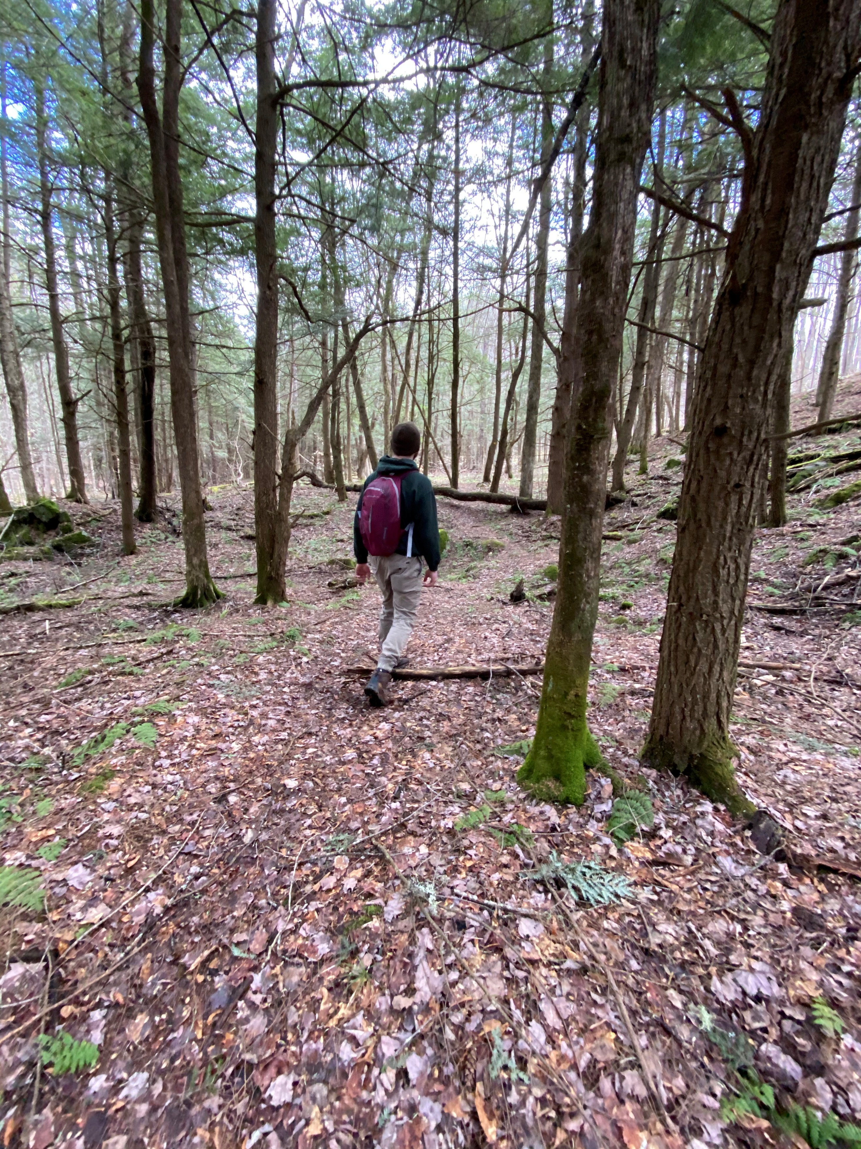
Photo 10: Hiking the Fox Hill trail in the Town of Horicon. Photo Credit: Advokate
Horicon’s natural environment and recreational resources are among its greatest strengths and a top reason many residents choose to call the Town home. Protecting these assets while expanding recreational opportunities is essential to Horicon’s identity
and long-term economic success. The following goals promote water quality protection, invasive species and stormwater management, and continued investment in recreation facilities. By balancing conservation with accessibility, Horicon can ensure its natural resources remain welcoming and enjoyable for residents and visitors of all ages and abilities. Environmental regulations should support shared community goals while remaining practical for property owners and businesses, with voluntary programs, education, and incentives playing an important role in advancing stewardship.
Tourism and recreation are central to Horicon’s economy, supporting local businesses, year-round employment, and essential community services built around the Town’s natural assets. Eleven private businesses cater directly to outdoor recreation, including marinas, a bike shop, sleepaway camps, and campgrounds. Nearly three-quarters of local jobs are in tourism-oriented economic sectors, with about half in the Accommodation/Food Service sector (Warren County Outdoor Recreation Economy Research Report, April 2024).
The 2025 Warren County Outdoor Recreation Economy Strategic Plan highlights exceptionally high levels of outdoor recreation participation countywide. Survey results show that 93% of resident respondents participate in outdoor recreation activities during the summer, including 96 % of residents age 45 and older. Winter participation also remains strong, with approximately 75 % of residents engaging in outdoor recreation. Respondents further emphasized the importance of outdoor recreation to their daily lives, with more than three-quarters indicating that it is “very important” to their overall quality of life in Warren County.

Sustaining this success depends on balancing growth with environmental stewardship community well-being, and recreation infrastructure that supports local businesses and residents. Expanding recreational and community offerings across all seasons, improving signage and branding, and strengthening regional collaboration will help attract visitors while supporting local businesses and preserving the character valued by residents.

Horicon’s waterways, including Brant Lake, Schroon Lake, and the Schroon River, are especially important natural and recreational assets for both the Town and the region. Thoughtful management of public access, including access planning, consideration of a registration system, and targeted improvements to access points, will help ensure these resources remain sustainable, safe, and inviting for generations to come.

Goal 5. Protect Natural Resources and Enhance Outdoor Recreational Assets

Objectives and Strategies:
5.1 | Coordinate with NYSDEC land managers to better align state management and maintenance practices with local needs
 | S5.1 Work with NYSDEC to implement improvements to the Pharaoh Lake trail and access road
5.2 | Improve and maintain access to recreational areas, including the Pharaoh Lake Wilderness Area and Lily Pond
 | S5.2 Conduct and implement the Mill Pond to Starbuckville Dam Feasibility Study
Mill Pond to Starbuckville Dam Trail Feasibility Study. This plan will evaluate the feasibility of a non-motorized hike-bike trail connecting the Brant Lake Bike Park near The Hub to Koch Park at the Starbuckville Dam. The study will assess potential routes, property ownership and access, environmental constraints, and preliminary costs. If feasible, the trail would improve safety, enhance access to scenic and historic sites, strengthen Horicon’s recreational network, and support active transportation for residents and visitors while advancing broader community goals related to health, connectivity, and outdoor recreation.

5.3333 | Continue to support water quality improvement efforts, including monitoring and prevention of aquatic invasive species and emerging water quality threats
S5.3 Work with Warren County Department of Public Works to reduce salt road usage around lakes and waterways

S5.4 Continue to work with lake associations to support the AWI Boat Launch Stewards program
S5.5 Partner with Warren County SWCD to participate in the Countywide Lake Monitoring Program
5.4 | Enhance stormwater and erosion management practices
S5.6 Conduct a Green Infrastructure Feasibility Study on Palisades Road, Brant Lake

S5.7 Work with Warren County and lake associations to distribute educational materials to property owners

S5.8 Implement enhanced stormwater education and outreach to property owners and developers based on the LCLGRPB’s MS4 Lite Campaign
5.5 | Improve facilities at town parks to better incorporate ADA/Universal Accessibility and provide inclusive, family-friendly amenities that serve all residents and visitors
S5.9 Conduct an inventory and assessment of all town parks to identify ADA/UA gaps and plan for upgrades

S5.10 Plan and develop community playgrounds in the Hamlets of Brant Lake and Adirondack

S5.11 Design new recreational infrastructure with accessibility in mind

5.6 | Develop a septic inspection program that combines incentives and educational initiatives to safeguard community health and safety and protect the Town’s waterways
S5.12 Develop a septic inspection program for sensitive environmental and prioritized areas
S5.13 Work with Warren County Planning Department to promote the available funding for homeowners for septic system replacement
5.7 | Collaborate with the Lake George Hemlock Coalition and Warren County Soil and Water Conservation District to share information and resources about emerging terrestrial invasive species
S5.14 Participate in a “Forest Pest Hunters” program to identify potential areas of hemlock woolly adelgid (HWA) infestations
S5.15 Develop and distribute educational materials about the identification and spread of HWA

Goal 6: Promote A Sustainable, Year-Round Recreation Economy

Objectives and Strategies:
 | Develop tourism strategies that balance economic growth with quality of life and natural resource stewardship
S6.1 Develop a Tourism Strategy and Destination Management Plan that supports the priorities of the community
S6.2 Identify and support opportunities for local business growth and expansion that support the recreation and tourism economies in Horicon
6.2 | Manage and enhance public access to waterways, including Brant Lake, Schroon Lake, and the Schroon River, by developing access management plans and improving physical access points to improve safety, address congestion, and improve user experience.
S6.3 Prepare an access management plan for the Brant Lake Boat Launch upon the return of ownership and operational responsibility to the Town
Recreational Carrying Capacity (RCC) is the maximum level of visitor use a natural or developed area can sustain without causing unacceptable damage to the environment, facilities, or the quality of visitor experience, balancing resource protection with user satisfaction through indicators like crowding, impacts, and wait times.
For a lake, RCC considers not just the number of boats but also their type (speed, size), the intensity of shoreline development, and the number of boats that can be on the water before water quality declines or boaters feel too crowded.

S6.4 Work with NYSDEC to update the Horicon Boat Launch UMP to include parking and traffic access controls

S6.5 Evaluate the feasibility of establishing a permit-based system for Town boat launches

S6.6 Improve physical access points to reduce erosion and disperse usage
S6.7 Evaluate the recreational and social carrying capacities of Schroon Lake and Brant Lake
6.3 | Enhance the visitor and resident experience by improving signage, strengthening town identity, collaborating regionally, and connecting hamlets and neighborhoods to recreation areas with trails and paths.
S6.8 Develop a uniform wayfinding, informational, and interpretive signage plan for the Town
S6.9 Collaborate with the Towns of Johnsburg, Chester, Hague, and Bolton to promote the region with coordinated marketing, tourism initiatives, and consistent signage
6.4 | Promote Horicon’s diverse recreational opportunities across all seasons
S6.10 Invest in infrastructure that supports off-season recreation and full-time employment, like multi-season trail networks, trailhead amenities and parking, and broadband and digital infrastructure
S6.11 Work with Warren County Planning Department to implement recommendations from the Warren County Outdoor Recreation Economy Strategic Plan (2025)
6.5 | Expand the Town’s online, year-round calendar of events and programs to foster community engagement and attract off-peak tourism.
 | S6.12 Work with the North Warren Chamber of Commerce to ensure the community calendar is up to date and promoted to residents and visitors

Land Use and Development

Relevant Smart Growth Principles:
Enable  Mixed-use Neighborhoods | Mix of Housing Types | Infill and Redevelopment | Preserve Open Space and Natural Resources | Welcoming Community and Strong Sense of Place | Collaborative Planning
Modern land use regulations will enable Horicon to guide growth, protect its rural character, support housing affordability, and balance development with environmental and community priorities.
Horicon’s land use regulations are a primary instrument for guiding future growth while protecting the Town’s rural character and scenic setting. Updating these regulations will help expand housing affordability, support well-planned and sustainable development, and safeguard the natural resources residents value most. Clear, consistent, and enforceable zoning, subdivision, and site plan standards also provide the Town Board, Planning Board, and Zoning Board of Appeals with a dependable framework for evaluating proposals, ensuring that new development aligns with the community’s long-term vision.

Modernized regulations can also advance best practices such as dark-sky–friendly lighting, which balances public safety with the preservation of natural nighttime conditions. Fully shielded fixtures that direct light downward, paired with warm, low-intensity bulbs and limited use through timers or motion sensors, reduce glare and light trespass while improving visibility. By reinforcing consistent enforcement and incorporating contemporary standards like dark-sky lighting, Horicon can more effectively guide growth, reinforce community character, and maintain a healthy balance between economic opportunity, environmental protection, and overall quality of life.

The Land Use goals, objectives, and strategies address identified gaps in Town processes and are intended to guide decision-making and strengthen the Town’s planning and development review processes. Implementation of these recommendations will occur through the adoption and revision of local land use laws, ordinances, and regulations. The adoption, administration, and enforcement of such measures rest with the Town Board in accordance with its authority under New York State law.

Goal 7. Modernize and Align Zoning and Land Use Regulations

Objectives and Strategies:
7.1 | Update zoning and land use policies to reflect Horicon’s evolving community needs while preserving its small-town character
S7.1 Update the Town of Horicon Zoning Code

S7.2 Ensure land use and building regulations support a range of housing options to serve all ages, incomes, and abilities

S7.3 Foster community participation in land use planning to ensure regulations align with the vision for the future

S7.4 Identify areas in the APA Moderate Intensity and Low Intensity Land Use Areas that are eligible for the APA Community Housing Density Bonus Program for up to 120% AMI income-restricted housing to increase the stock of workforce housing in Horicon
The Adirondack Park Agency (APA) Community Housing Density Relief Program (APA Act §802 (17-a) helps create more affordable housing opportunities within the Adirondack Park. The program allows more homes to be built on certain properties than would normally be permitted when those homes are set aside for local residents with moderate incomes. To qualify, the housing must be used only as year-round residences, remain affordable over time, and be no larger than 1,500 square feet (not including garages). Eligible projects must be located near existing communities, either within three miles of a hamlet or within one mile of a post office. Households living in these homes must earn no more than 120% of the county’s median income (approximately $94,000 in Warren County, based on ACS 2019-2023 data).
The program allows units classified as “community housing” to receive up to a four times density bonus on land classified as Low Intensity or Moderate Intensity.
7.2 | Encourage appropriate and sustainable growth through clear, predictable, and streamlined regulations
S7.5 Establish a code compliance strategy that is enforceable, efficient, and equitable
S7.6 Simplify local permitting for residential construction that is allowed “by right” in the Town zoning code
7.3 | Promote mixed-use and infill development within the Hamlets of Adirondack and Brant Lake to strengthen their role as vibrant community centers
S7.7 Identify and inventory buildings and locations suitable for mixed-use development
S7.8 Conduct a build-out analysis for Brant Lake and Adirondack to identify where new development could occur
7.4 | Protect natural resources and scenic beauty by integrating conservation practices into land use decisions
S7.9 Promote ridgeline development standards that safeguard environmentally sensitive areas while minimizing visual and broader community impacts

S7.10 Strengthen tree preservation standards to minimize unnecessary tree removal and protect natural and scenic resources

S7.11 Develop guidance for, and encourage dark sky-compliant lighting on new construction

S7.12 Develop site plan review guidance for alternative energy facilities, like small-scale solar arrays and battery storage
Regulations may include promoting shielded fixtures that direct light downward, encouraging the use of motion-sensitive or timed lights that reduce unnecessary lighting during off-peak hours, and replacing traditional streetlights with energy-efficient LEDs that are dimmable and have less scatter. lighting during off-peak hours, and replacing traditional streetlights with energy-efficient LEDs that are dimmable and have less scatter.
Dark sky-compliant lighting reduces glare, light trespass, and unnecessary sky glow by directing light downward and using appropriate intensity and color temperature. These practices improve nighttime visibility for pedestrians and drivers, enhance rural character, protect wildlife habitats, and conserve energy. Encouraging shielded fixtures and thoughtful lighting design allows the Town to balance safety needs with the preservation of Horicon’s natural nighttime environment.

For municipalities, implementing Dark Sky Strategies involves adopting measures to reduce light pollution, protect the natural night environment, and promote sustainability while ensuring safety and security.
Figure 6: Dark Sky Compliant Lighting. Source: Summit County Sheriff.
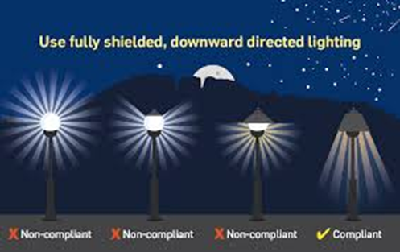

Section 3. Future Land Use
The Comprehensive Plan provides guidance for future land use and development and can inform updates to the zoning code, land use ordinances, or even APA land use classifications. On December 4, 2025, the CPC hosted a public workshop to review existing land uses in and around the hamlet areas, with the findings illustrated in the maps that follow. These Future Land Use maps serve as a tool for the Town when evaluating new development proposals and updating zoning or land use ordinances, helping ensure that allowed uses align with the community’s vision. Where discrepancies arise, the maps highlight opportunities to review and refine the zoning ordinance to better reflect the desired land uses.
The following sections include brief descriptions of the areas reviewed during the workshop, along with the recorded notes from the workshop.

Brant Lake
In the Hamlet of Brant Lake, participants of the workshop focused on the need for additional housing options to support residents, seasonal workers, and year-round activity. Attendees identified the Mill Pond area and parcels along Route 8 as priority locations for new residential and multifamily housing. Conversations also included the former landfill site, with participants expressing interest in exploring reuse or redevelopment options for the large, underutilized space within the hamlet.

Adirondack
In the hamlet of Adirondack, workshop participants emphasized strengthening the existing hamlet center. Attendees identified the area surrounding the Adirondack General Store as a location for future investment of small-scale, mixed-use development that could include ground-floor commercial or community uses with residential units above.

Section 4. Implementation Strategy
To successfully implement the strategies in this plan, the Town Board should establish a standing Comprehensive Plan Implementation Committee to review the recommendations, collaborate with local partners to secure funding, and take concrete steps toward action. The committee, in coordination with the Town Board, should also conduct annual plan reviews to adjust strategies in response to evolving opportunities and priorities. While the actions outlined in this plan address the Town’s identified issues and goals, additional planning will be needed to define next steps and identify appropriate funding sources.
A standing Comprehensive
Plan Implementation Committee (CPIC) should be established following the adoption of the Comprehensive Plan to facilitate its recommendations.

Securing funding is a critical component of implementation. Federal, state, and local grants are regularly available, most programs require a local match, which can be provided by the applicant in cash or through in-kind contributions such as staff time, volunteer labor, or donated materials and equipment. Because many grants are reimbursable, upfront funding is often necessary. The implementation committee can work with the Town Board to ensure the town budget includes dedicated resources for matching grants, helping to advance the community’s goals efficiently and sustainably.
The following implementation matrix outlines the strategies the Town of Horicon will pursue to achieve the visions and goals developed in this plan. In addition to the recommended action, the matrix identifies partners for implementation and sources for funding or technical assistance. Funding and technical assistance sources are described in Section 4.2 of this document.
Funding conditions are not static. They shift in response to policy priorities, economic cycles, and emerging needs, and what is unavailable today may be well within reach tomorrow. With time, new funding programs may be created, existing programs may expand, and eligibility criteria may change. Staying attentive and adaptable allows the community to respond to these shifts, pursue newly available resources, and align projects with evolving funding opportunities over time.

A Living Document. A comprehensive plan is a living document that evolves to reflect the changing needs, priorities, and goals of a community. While it provides a long-term vision for growth and development, the plan must be reviewed annually to ensure its policies and recommendations remain relevant and effective. Regular reviews allow for adjustments based on new data, emerging trends, and unforeseen challenges. Additionally, a more thorough plan update should be conducted by the Town every 5 to 10 years to incorporate significant changes in demographics, infrastructure, economic conditions, and community aspirations. This iterative process ensures that the comprehensive plan remains a useful and adaptable tool for guiding sustainable development and decision making.

4.1 Implementation Matrix
The Implementation Matrix serves as a critical tool for the Town of Horicon to realize the community’s vision and goals established during this planning process. While certain strategies will require direct leadership from the Town Board, other actions can be initiated by various agencies, non-profit organizations, or community groups, with the Town Board providing support and coordination.
The following chart outlines potential implementation partners, funding sources, and technical resources, along with the anticipated timeline for implementation. Strategies are categorized under their corresponding goal and priority strategies are noted throughout the implementation matrix. Priority strategies represent key initiatives identified through the planning process, community input, and prior efforts as critical projects that address pressing needs and enhance overall community well-being.

Implementation Matrix
The implementation matrix is a tool that can be used by the Town of Horicon to achieve the goals and strategies identified in this planning process.

Housing
Recommended Action |  |  |  | Partners for implementation |  | Potential Funding Sources/Technical Resources |  | Timeframe to Initiate
Goal 1: Expand and Diversify Housing Options
1.1 |  | Preserve and enhance existing rural neighborhoods by promoting the rehabilitation and maintenance of existing residential structures
 | S1.1 | PRIORITY: Partner with county and regional housing programs to support the rehabilitation of existing homes for workforce housing and year-round residential uses |  | Warren County, Adirondack Roots, NCRDC |  | NYSHCR |  | Short Term (1-3 years), ongoing
 | S1.2 | Establish a town-wide vacant and blighted building inventory to prioritize areas for investment |  | Warren County Planning, LCLGRPB, Town Building and Codes Dept. |  | NYSHCR |  | Short Term (1-3 years)
1.2 |  | Create opportunities for lower-cost, affordable housing
 | S1.3 | Promote a mix of quality housing options at price ranges that are accessible to all ages, abilities, and incomes |  | Horicon Planning Dept., LCLGRPB, ACHT, Warren County Office for the Aging |  | NYSHCR, CDBG, NYSDOS, Adirondack Roots |  | Short Term (1-3 years), ongoing
 | S1.4 | Ensure local zoning and initiatives support the development of senior and accessible housing in centrally located areas with access to services and community activities |  | Warren County, LCLGRPB, NYSDOS |  | NYSDOS, AARP |  | Short Term (1-3 years)
 | S1.4a | Pursue funding for senior housing opportunities in hamlet areas |  | Warren County Office for the Aging, Adirondack Roots, NRDC |  | NYSHCR, AARP |  | Medium Term (3-5 years)
 | S1.5 | Identify and map parcels best suited for new and infill development for housing |  | Warren County Planning Dept, LCLGRPB |  | NYSDOS, ACF |  | Short Term (1-3 years)
 | S1.6 | PRIORITY: Review and update Town fees, codes, and procedures to streamline the review and permitting process for residential development |  | Warren County, LCLGRPB, NYSDOS |  | NYSDOS, Center for Community Progress |  | Short Term (1-3 years)
1.3 |  | Continue to work collaboratively to balance short-term rental housing stock and the need for affordable year-round housing opportunities
 | S1.7 |  | PRIORITY: Implement a program to mitigate the conversion of housing to short-term rentals |  | Adirondack Action, Adirondack Roots, HHHN |  | NYSDOS |  | Medium Term (3-5 years), ongoing
1.4 |  |  | Improve retention of area employees by promoting affordable rentals for the local workforce
 | S1.8 |  | Promote employee-assisted housing partnerships to help local workers live within the community |  | Area employers, Warren County |  | NBRC, HHHN, Area employers |  | Long Term (5+ years)

Hamlet Centers and Community Hubs
Recommended Action |  |  |  | Partners for implementation | Potential Funding Sources/Technical Resources | Timeframe to Initiate
Goal 2: Revitalize and Protect Hamlets as Community Hubs
2.1 |  |  | Retain our rural small-town character
 | S2.1 |  | Codify design standards that reflect Horicon’s community character while balancing functionality, accessibility, and affordability | LCLGRPB, Warren County Planning Dept. | NYSDOS, NYSDEC ACSG | Short Term (1-3 years)
 | S2.2 |  | Develop a Hamlet Masterplan for Adirondack to ensure that any future development aligns with the community’s vision | LCLGRPB, Warren County Planning Dept. | NYSDOS, NYSDEC ACSG, P4PS | Medium Term (3-5 years)
2.2 |  |  | Preserve and enhance the distinctive identities of the Hamlets of Adirondack and Brant Lake through a combination of building and streetscape improvements that maintain the rural community character
 |  | S2.3 | Encourage reinvestment in underused or vacant buildings for housing or small businesses, reducing the need for new infrastructure | Warren County Planning, LCLGRPB, Town Building and Codes Dept. | NCRDC, NYSESD, NBRC, NYSHCR | Long Term (5+ years)
 |  | S2.4 | Ensure local land use codes allow for mixed-use and small-scale business development | Warren County Planning Dept., APA, LCLGRPB | NYSDOS, NYSDEC ACSG | Short Term (1-3 years)
2.3 |  |  | Improve and enhance community facilities and services
 |  | S2.5 | Support community spaces and facilities that enhance civic life and serve all residents | Warren County, Community Organizations | CDBG, USDA RD | Medium Term (3-5 years)
 |  | S2.6 | Plan and implement improvements to the Brant Lake Fire House | Warren County Emergency Services, Horicon Fire Department | NYSHCR, CDBG, USDA RD, NYSDHSES, FEMA | Long Term (5+ years)

 | S2.7 |  |  |  | Conduct a feasibility study for the acquisition of property for a town beach on Brant Lake | Town, APA, NYSDEC, Warren County Planning |  |  |  | DASNY NYSWIMS, OPRHP, NYSDOS LWRP | Long Term (5+ years)
 | S2.8 |  |  |  | Develop a plan for the upgrade of facilities at the public beaches in Adirondack and the Mill Pond, including evaluating ADA Accessibility | Town DPW, Lake Association |  |  |  | NYSDEC ACSG, NYSDOS, DASNY NYSWIMS, OPRHP | Medium Term (3-5 years)
2.4 |  |  |  |  | Improve transportation infrastructure to enhance the safety, convenience, and efficiency of drivers, cyclists, and pedestrians
 | S2.9 |  |  |  | PRIORITY: Implement the findings of the Brant Lake Trail Feasibility Study | AGFTC, LCLGRPB, Warren County Planning Dept., Town DPW |  |  |  | FHWA TAP, NYSDOS, OPRHP, T-Mobile, P4PS | Long Term (5+ years)
 | S2.10 |  |  |  | PRIORITY: Conduct pedestrian and bicycle safety and connectivity studies for the Hamlets of Brant Lake and Adirondack | AGFTC, LCLGRPB, Warren County Planning Dept., ACA |  |  |  | FHWA TAP, NYSDEC ACSG, NYSDOT | Medium Term (3-5 years)
2.5 |  |  |  |  | Improve the visual appeal, safety, and walkability of main streets and throughfares in and around the hamlets
 | S2.11 |  |  |  | Develop a Gateway Masterplan for the Hamlets of Brant Lake and Adirondack that includes traffic calming measures that reduce vehicle speed | LCLGRPB, Warren County Planning Dept., AGFTC |  |  |  | FHWA TAP, NYSDOS, NYSDEC ACSG | Medium Term (3-5 years)
 | S2.12 |  |  |  | Collaborate with NYSDOT and AGFTC to redesign and reconfigure the intersection of NYS Route 8 and Horicon Ave at the Mill Pond | NYSDOT, AGFTC, Warren County DPW |  |  |  | FHWA TAP, FHWA TIP, NYSDOT | Long Term (5+ years)
 | S2.13 |  |  |  | Implement the Adirondack Hamlet Walkway initiative | Warren County Planning Dept, Town DPW, AGFTC |  |  |  | NYSDEC ACSG, FHWA TAP, T-Mobile, ACF | Long Term (5+ years)
 | S2.14 |  |  |  | Identify and inventory vacant or underutilized community spaces | Warren County Planning Dept, LCLGRPB, Town Building and Codes Dept. |  |  |  | NYSDOS | Short Term (1-3 years)
 | S2.15 |  |  |  | Evaluate and implement opportunities to improve pedestrian and bicycle safety and connectivity on main roadways throughout Horicon | AGFTC, Warren County Planning Dept, LCLGRPB, NYSDOT |  |  |  | NYSDOT, NYSDOS, FHWA TAP | Medium Term (3-5 years)

Economic Stability
Recommended Action |  |  |  |  |  |  | Partners for implementation |  |  | Potential Funding Sources/Technical Resources | Timeframe to Initiate
Goal 3: Strengthen and Grow the Local Economy
3.1 |  |  | Strengthen and diversify the economic base of the Hamlets of Adirondack and Brant Lake by encouraging a mix of commercial, civic, and residential uses
 |  | S3.1 | Implement zoning regulations that encourage commercial uses in designated Hamlet areas |  |  |  | WC Planning Dept., LCLGRPB |  |  | NYSDEC ACSG, ACF | Short Term (1-3 years)
3.2 |  |  | Retain existing employment opportunities and attract new businesses
 |  | S3.2 | PRIORITY: Promote the expansion of essential trades, service providers, and small manufacturers that support residents and regional employers |  |  |  | BOCES, North Warren CSD, NWCC, WC Workforce Development |  |  | WWIDA, USDA RBDG, SBA, WC Workforce Development | Long Term (5+ years)
 |  | S3.3 | PRIORITY: Partner with North Warren CSD and local businesses to develop a local jobs portal and a local career fair to connect employers with young residents |  |  |  | NWCC, Warren County Workforce Development, North Warren CSD |  |  | NBRC, WC Workforce Development | Medium Term (3-5 years)
 |  | S3.4 | Ensure local regulations support business development while maintaining standards that are appropriate to the project scope |  |  |  | WC Planning Dept., NYSDOS |  |  | NYSDOS | Short Term (1-3 years)
3.3 |  |  | Promote the Town’s recreational, cultural, and environmental resources to foster the local economy
 |  | S3.5 | PRIORITY: Formalize signage and parking for the Brant Lake Challenge |  |  |  | WC Planning Dept., NWCC |  |  | NBRC, NYSDEC ACSG, NYSDOT TAP, OPRHP, ACF | Short Term (1-3 years)
 |  | S3.6 | PRIORITY: Connect recreational assets to Town Centers through signage, trails, sidewalks, and other amenities |  |  |  | WCDPW, Town DPW, NYSDOT, AGFTC |  |  | FHWA Recreational Trails Program, NYSDEC ACSG, OPRHP | Medium Term (3-5 years)
Goal 4: Support local businesses and entrepreneurs
4.1 |  |  |  | Support the Town’s local and home-based businesses with technical assistance
 |  | S4.1 |  | Connect local businesses with the U.S. Small Business Administration’s Small Business Development Centers (SBDC) |  |  |  | NWCC, WCEDC, ARCC |  | ARCC, SBA, LCLGRPB, NWCC, ANCA | Short Term (1-3 years), ongoing
 |  | S4.2 |  | Collaborate with LCLGRPB and WWIDA to connect businesses with low-interest loan opportunities |  |  |  | LCLGRPB, WWIDA, NWCC |  | ARCC, LCLGRPB Small Business RLF | Short Term (1-3 years)
4.2 |  |  |  | Promote the establishment of cottage industries that highlight the area’s culture, history, and natural resources
 |  | S4.3 |  | Promote local products through a “Made in Horicon” initiative |  |  |  | NWCC, ARCC |  | NYSESD, NYSAGM, ANCA | Short Term (1-3 years)
 |  | S4.4 |  | PRIORITY: Partner with schools and nonprofits to introduce young residents to local arts, trades, and entrepreneurship pathways |  |  |  | WC Workforce Development, North Warren CSD, SUNY ADK |  | ACF, NYSDOS, LARAC, NBRC, ESD | Medium Term (3-5 years)
 |  | S4.5 |  | PRIORITY: Promote the establishment of a makers’ space that provides tools, equipment, and workspace for local artisans and small producers |  |  |  | Horicon Library, NWCC, ANCA |  | NYSAGM, ACF, LARAC, ESD | Long Term (5+ years)
 |  | S4.6 |  | PRIORITY: Establish a centralized hub or marketplace where locally made products can be showcased and sold |  |  |  | Horicon Library, NWCC, ANCA | NYSAGM, ACF, LARAC, ESD |  | Long Term (5+ years)
4.3 |  |  |  | Encourage remote working opportunities and digital business growth by closing gaps in broadband and cellular service
 |  | S4.7 |  | Identify underserved areas and work with service providers to expand service |  |  |  | LCLGRPB, WCEDC |  | NYSConnectALL, NBRC | Medium Term (3-5 years)

Natural Resources and Recreation
Recommended Action |  |  |  |  |  |  |  |  | Partners for implementation | Potential Funding Sources/Technical Resources | Timeframe to Initiate
Goal 5: Protect Natural Resources and Enhance Outdoor Recreational Assets
5.1 |  |  |  |  |  |  |  | Coordinate with NYSDEC land managers to better align state management and maintenance practices with local needs
 |  |  | S5.1 |  |  |  |  | PRIORITY: Work with NYSDEC to implement improvements to the Pharaoh Lake trail and access road | NYSDEC Region 5, APA | NYSDEC | Short Term (1-3 years)
5.2 |  |  |  |  |  |  |  | Improve and maintain access to recreational areas, including the Pharaoh Lake Wilderness Area and Lily Pond
 |  |  | S5.2 |  |  |  |  | Conduct and implement the Mill Pond to Starbuckville Dam Feasibility Study | NYSDEC, APA | NYSDOS LWRP, OPRHP | Long Term (5+ years)
5.3 |  |  |  |  |  |  |  | Continue to support water quality improvement efforts, including monitoring and prevention of aquatic invasive species and emerging water quality threats
 | S5.3 |  |  |  |  |  |  | PRIORITY: Work with Warren County DPW to reduce road salt usage around lakes and waterways | Town DPW, WCDPW | NYSDEC WQIP, ADK Action | Medium Term (3-5 years)
 | S5.4 |  |  |  |  |  |  | PRIORITY: Continue to work with lake associations to support the AWI Boat Launch Stewards program | Town, Lake Associations, AWI | AWI, NYSDEC | Short Term (1-3 years)
 | S5.5 |  |  |  |  |  |  | PRIORITY: Partner with Warren County SWCD to participate in the Countywide Lake Monitoring Program | WCSWCD, Lake Association | WCSWCD, Lake Associations | Medium Term (3-5 years)
5.4 |  |  |  |  |  |  |  | Enhance stormwater and erosion management practices
 |  | S5.6 |  |  |  |  |  | Conduct a Green Infrastructure Feasibility Study on Palisades Road, Brant Lake | WCDPW, LCLGRPB, NYSDOT | NYSDEC WQIP | Short Term (1-3 years)
 |  | S5.7 |  |  |  |  |  | Collaborate with Warren County and lake associations to distribute educational materials to property owners | WCSWCD, Lake Associations, LCLGRPB | No funding needed | Short Term (1-3 years)
 |  | S5.8 |  |  |  |  |  | Implement and enhance stormwater education and outreach to property owners and developers based on LCLGRPB’s MS4 Lite Campaign | LCLGRPB, Town Building and Codes Dept. | No funding needed | Short Term (1-3 years)
5.5 |  |  |  |  |  |  |  | Improve facilities at town parks to better incorporate ADA/Universal Accessibility and provide inclusive, family-friendly amenities that serve all residents and visitors
 |  |  | S5.9 |  |  |  |  | Conduct an inventory and assessment of all town parks to identify ADA/UA gaps and plan for upgrades | LCLGRPB, WC Planning Dept. | NYSDOS, AARP | Short Term (1-3 years)
 |  |  | S5.10 |  |  |  |  | Plan and develop community playgrounds in Hamlets of Brant Lake and Adirondack | WC Planning Dept., AARP | CDBG, NYSDOS, NYPLAYS | Short Term (1-3 years)
 |  |  | S5.11 |  |  |  |  | Design new recreational infrastructure with accessibility in mind | WC Planning Dept., LCLGRPB | NYSDOS,  OPRHP | Ongoing
5.6 |  |  |  |  |  |  |  | Develop a septic inspection program that combines incentives and educational initiatives to safeguard community health and safety and protect the Town’s waterways
 |  |  |  | S5.12 |  |  |  | PRIORITY: Develop septic inspection program for sensitive environmental and prioritized areas | WC Planning Dept., LGPC, NYSDOS | NYSDOS | Short Term (1-3 years)
 |  |  |  | S5.13 |  |  |  | Work with Warren County Planning Department to promote the available funding for homeowners for septic system replacement | WC Planning Dept., LCLGRPB, Lake Association | No funding needed | Short Term (1-3 years)
5.7 |  |  |  |  |  |  |  | Collaborate with the Lake George Hemlock Coalition and Warren County Soil and Water Conservation District to share information and resources about emerging terrestrial invasive species
 |  |  |  |  | S5.14 |  |  | PRIORITY: Participate in a “Forest Pest Hunters” program to identify potential areas of HWA | APPIP, LGA, LGLC, WCSWCD, Lake Association | NYSDEC, APPIP | Short Term (1-3 years)
 |  |  |  |  | S5.15 |  |  | Develop and distribute educational materials to landowners about the identification and spread of HWA | APPIP, LGA, LGHC, Lake Associations | NYSDEC, NYSP2I | Short Term (1-3 years)
Goal 6: Promote a Sustainable, Year-Round Recreation Economy
6.1 |  |  |  |  |  |  |  | Develop tourism strategies that balance economic growth with quality of life and natural resource stewardship
 |  |  |  |  |  | S6.1 |  | PRIORITY: Develop a Tourism Strategy and Destination Management Plan that supports the priorities of the community | Warren County Tourism Dept, NWCC, LCLGRPB | ESD, ANCA, WC Occupancy Tax | Medium Term (3-5 years)
 |  |  |  |  |  | S6.2 |  | Identify and support opportunities for local business growth and expansion that support the recreation and tourism economies of Horicon | LCLGRPB, WC Tourism Dept, NWCC | ESD, CDBG Microenterprise, NBRC | Medium Term (3-5 years), ongoing
6.2 |  |  |  |  |  |  |  | Manage and enhance public access to waterways, including Brant Lake, Schroon Lake, and Schroon River, by developing access management plans and improving physical access points
 |  |  |  |  |  | S6.3 |  | Prepare an access management plan for the Brant Lake Boat Launch upon the return of ownership and operational responsibility to the Town | BLA, Town DPW, WC Planning, APA, NYSDEC, Community | NYSDOS LWRP, OPRHP | Long Term (5+ years)
 |  |  |  |  |  | S6.4 |  | PRIORITY: Work with the NYSDEC to update the Horicon Boat Launch UMP to include parking and traffic access controls | NYSDEC, APA | NYSDEC | Medium Term (3-5 years)
 |  |  |  |  |  | S6.5 |  | Evaluate the feasibility of establishing a permit-based system for Town boat launches | NYSDEC, APA, Lake Association | Town Budget | Long Term (5+ years)
 |  |  |  |  |  | S6.6 |  | Improve physical access points to reduce erosion and disperse usage | WCDPW, Town DPW, WCSWCD | NYSDEC WQIP, WCSWCD | Medium Term (3-5 years)
 |  |  |  |  |  | S6.7 |  | PRIORITY: Evaluate the recreational and social carrying capacities of Schroon Lake and Brant Lake | NYSDEC, AWI, Lake Association, APA, NYSWRI | NYSDEC, Lake Associations, NYSWRI | Medium Term (3-5 years)
6.3 |  |  |  |  |  |  |  | Enhance the visitor and resident experience through improving signage, a strong town identity, and regional collaboration, and connecting hamlets and residential areas to recreational facilities with trails and paths
 |  |  |  |  |  | S6.8 |  | Develop a uniform wayfinding, informational, and interpretive signage plan for the Town | Town DPW, NWCC | Adirondack Foundation, T-Mobile, NYSDEC, NYSDOS | Short Term (1-3 years)
 |  |  |  |  |  | S6.9 |  | PRIORITY: Collaborate with the Towns of Johnsburg, Chester, Hague, and Bolton to promote the region with coordinated marketing, tourism initiatives, and consistent signage | NWCC, Towns, WC Tourism Dept. | WC Occupancy Tax, NYSESD, ACF | Short Term (1-3 years), ongoing
6.4 |  |  |  |  |  |  |  | Promote Horicon’s diverse recreational opportunities across all seasons
 |  |  |  |  |  |  | S6.10 | PRIORITY: Invest in infrastructure that supports off-season recreation and full-time employment, like multi-season trail networks, trailhead amenities and parking, and broadband and digital infrastructure | Town DPW, LCLGRPB, WWIDA, ECEDC, ANCA | NBRC, NYSESD | Long Term (5+ years), ongoing
 |  |  |  |  |  |  | S6.11 | Work with Warren County Planning Department to implement recommendations from the Warren County Outdoor Recreation Economy Strategic Plan (2025) | WC Planning Dept. |  | Long Term (5+ years)
6.5 |  |  |  |  |  |  |  | Expand the Town’s online, year-round calendar of events and programs to foster community engagement and attract off-peak tourism
 |  |  |  |  |  | S6.11 |  | Work with the North Warren Chamber of Commerce to ensure the community calendar is up to date and promoted to residents and visitors | NWCC | No funding needed | Short Term (1-3 years), ongoing

Land Use and Development
Recommended Action |  |  | Partners for implementation | Potential Funding Sources/Technical Resources | Timeframe to Initiate
Goal 7. Modernize and Align Zoning and Land Use Regulations
7.1 |  | Update zoning and land use policies to reflect Horicon’s evolving community needs while preserving its small-town character
 | S7.1 | PRIORITY: Update the town zoning code | LCLGRPB, WC Planning Dept., APA | NYSDOS, NYSDEC ACSG | Short Term (1-3 years)
 | S7.2 | Ensure land use and building regulations support a range of housing options to serve all ages, incomes, and abilities | WC Planning Dept., LCLGRPB, APA | NYSDOS, NYSDEC ACSG | Short Term (1-3 years), ongoing
 | S7.3 | Foster community participation in land use planning to ensure regulations align with the vision for the future | WC Planning Dept., LCLGRPB, APA | NYSDEC ACSG, NYSDOS | Short Term (1-3 years), ongoing
 | S7.4 | Identify areas in the APA Moderate Intensity and Low Intensity Land Use Areas that are eligible for the APA Community Housing Density Bonus Program for up to 120% AMI income-restricted housing to increase the stock of workforce housing in Horicon | WC Planning Dept., APA | NYSDEC ACSG, NYSDOS | Medium Term (3-5 years)
7.2 |  | Encourage appropriate and sustainable growth through clear, predictable, and streamlined regulations
 | S7.5 | Establish a code compliance strategy that is enforceable, efficient, and equitable | Center for Community Progress, LCLGRPB, WC Planning Dept. | NYSDOS, NYSDEC ACSG | Medium Term (3-5 years), ongoing
 | S7.6 | PRIORITY: Simplify local permitting for residential construction that is allowed “by right” in the Town zoning code | WC Planning Dept., LCLGRPB, APA | NYSDOS, NYSDEC ACSG | Short Term (1-3 years)
7.3 |  | Promote mixed-use and infill development within the Hamlets of Adirondack and Brant Lake to strengthen their role as vibrant community centers
 | S7.7 | Identify buildings and locations suitable for mixed-use development | WC Planning Dept., LCLGRPB, APA | NYSDOS, NYSDEC ACSG | Medium Term (3-5 years), ongoing
 | S7.8 | Conduct a build-out analysis from Brant Lake and Adirondack to identify where new development could occur | WC Planning Dept., LCLGRPB | NYSDEC ACSG, ACF | Medium Term (3-5 years)
7.4 |  | Protect natural resources and scenic beauty by integrating conservation practices into land use decisions
 | S7.9 | PRIORITY: Promote ridgeline development standards that safeguard environmentally sensitive areas while minimizing visual and broader community impacts | WC Planning Dept., APA | NYSDOS, NYSDEC ACSG | Short Term (1-3 years)
 | S7.10 | Strengthen tree preservation standards to minimize unnecessary tree removal and protect natural and scenic resources | WC Planning Dept., APA | NYSDEC | Short Term (1-3 years)
 | S7.11 | PRIORITY: Develop guidance for, and encourage dark sky-compliant lighting on new construction | WC Planning Dept., APA | NYSDOS, NYSDEC ACSG | Short Term (1-3 years)
 | S7.12 | Develop site plan review guidance for alternative energy facilities, like small-scale solar arrays and battery storage | WC Planning Dept., APA | NYSDOS, NYSDEC ACSG | Short Term (1-3 years)

4.2 Funding and Technical Assistance Resources
The plan identifies a range of funding sources and opportunities available at both the State and Federal levels, along with organizations offering technical assistance and business support. While not exhaustive, this list highlights key resources that can support implementation efforts.
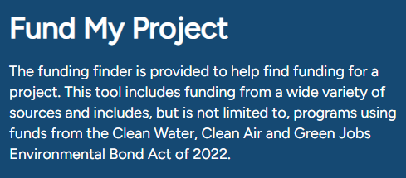
New York State has created a Funding Finder resource that allows grant seekers to filter through grants based on categories specific to a project. The result of the search within the tool will provide a link directly to the funding information that is best suited to the information provided for your project. Visit the Funding Finder tool at https://environmentalbondact.ny.gov/pages/funding-opportunities.

State Funding Opportunities
Dormitory Authority of New York State (DASNY)
- DASNY finances, designs, and builds health and education infrastructure that is the foundation of inclusive, sustainable communities.
- NYSWIMS provides funding for projects that build out municipal pools in high needs areas, connect New Yorkers to the State’s rivers and lakes, deploy pools in urban environments, in enhance parks and pools.
- NY PLAYS supports the design, construction, and renovation of public playgrounds in New York State. NY PLAYS helps communities expand access to safe, welcoming outdoor spaces that promote physical activity, emotional well-being, and in-person social connection for children and families.

Empire State Development (ESD)
- ESD invests strategically in infrastructure, innovation, place-making, revitalization, and workforce development with a focus on sustainability and historically disadvantaged populations across the state.

New York State Homes and Community Renewal (NYSHCR)
- NYSHCR oversees housing and community development programs aimed at creating and preserving affordable housing. It also enhances communities by providing grants and loans to municipalities and non-profits, supporting local infrastructure improvements, economic development, and housing initiatives in underserved areas.
New York State Division of Homeland Security and Emergency Services (DHSES)
- Recruitment and Retention Grant Program: Provides funding to support county and local fire and EMS agencies in their efforts to recruit new and retain existing fire and EMS volunteers.
- Volunteer Fire Infrastructure & Response Equipment (V-FIRE) Grant Program: Provides funding to support volunteer fire departments to upgrade and improve their facilities and response capabilities.
New York State Department of Environmental Conservation (NYSDEC)
- Adirondack Park Community Smart Growth Program: Supports projects that foster sustainable development, environmental protection, and community livability. The program supports the planning and implementation of key projects identified as priorities in plans. The program offers grant funding for counties, towns and villages that need financial or technical assistance to plan and grow successfully in the Adirondack Park.
- Climate Smart Communities Grant Program (CSC): The CSC Grant program was established in 2016 to provide 50/50 matching grants to municipalities for various climate change mitigation, adaptation, and planning and assessment projects.
New York State Department of State (NYSDOS)
- Brownfield Opportunity Area (BOA) Program: Provides communities with grant funding and technical assistance to develop area-wide plans to effectively redevelop brownfields and other vacant and abandoned sites, transforming them into catalytic properties that facilitate community investment and improvement.
- Local Waterfront Revitalization Program (LWRP) implementation: Funding for the implementation of projects identified in an LWRP is available through this program with funding from the NYS Environmental Protection Fund (EPF).
- Smart Growth Community Planning and Zoning Program: The Smart Growth Planning and Zoning Program provides grants to communities to create and update municipal comprehensive plans and zoning ordinances to incorporate smart growth and clean energy elements.
New York State Department of Transportation (NYSDOT)
- Transportation Alternatives Program (TAP): TAP provides funding for on-road and off-road facilities for pedestrians, bicyclists, and other non-motorized forms of transportation; infrastructure projects that will provide safe routes for non-drivers, including children, older adults, and individuals with disabilities.
New York State Department of Education (NYSED)
- State Aid for Library Construction: Covers approved costs for the acquisition, construction, renovation, or rehabilitation of public libraries as well as broadband infrastructure projects.
New York State Energy Research and Development Authority (NYSERDA)
- Clean Energy Communities (CEC): Grants are available for communities for the implementation of high-impact actions related to the CEC program.
New York State Office of Parks, Recreation, and Historic Preservation (OPRHP)
- Recreational Trails Program (RTP): Provides funds to develop and maintain recreational trails and trail-related facilities.
- Parks Grant Program: The Parks program supports acquiring, developing, and planning parks and recreational facilities. It focuses on preserving, rehabilitating, or restoring lands, waters, and structures for recreation or conservation, as well as structural assessments and project planning.

Federal Funding Opportunities
Adirondack/Glens Falls Transportation Council (AGFTC)
- Engineering Assistance Program: Provides access to transportation planning and engineering consultants for eligible municipal transportation projects including safety evaluations and pedestrian infrastructure.
- Make the Connection Program: This program helps municipal project sponsors fund enhancements to the region's bicycle and pedestrian network, such as new sidewalks, multi-use trails, safety upgrades for pedestrians and cyclists, trail improvements, and ADA compliance projects.
Community Development Block Grant (CDBG)
- CDBG provides annual funding to states, cities, and counties to create vibrant communities by offering decent housing, a suitable living environment, and expanded economic opportunities. These grants support various local projects, including infrastructure, public facilities, housing rehabilitation, economic development, and public services. In New York State, HCR administers CDBG programs.

Federal Emergency Management Agency (FEMA)
- Assistance to Firefighters Grants Program: Provides funds for critically needed resources to equip and train emergency personnel, enhance efficiencies, and support community resilience.
Northern Borders Regional Commission (NBRC)
- Catalyst Program: This program makes available funding for infrastructure and non-infrastructure projects that stimulate growth and inspire partnerships for rural economic vitality in the northern border region.
- Workforce Opportunities for Rural Communities (WORC): This program provides grant funds to support workforce development activities that prepare workers for good jobs in high-demand occupations in rural communities.
Small Business Administration (SBA)
- SBA is an independent agency of the federal government created to support small businesses and entrepreneurs. The SBA aims to strengthen the economy by enabling the establishment of small businesses and providing recovery assistance.

United States Department of Agriculture (USDA)
- Community Facilities Direct Loan & Grant Program: Provides affordable funding to develop essential community facilities in rural areas.
- Rural Development Business Programs: Business programs provide financial backing and technical assistance to stimulate business creation and growth. The programs work through partnerships with public and private community-based organizations and financial institutions to provide financial assistance, business development, and technical assistance to rural businesses.
United States Department of Economic Development (USEDA)
- Public Works Program: This program invests in communities to revitalize, expand, and upgrade their physical infrastructure to attract new industry; encourage business expansion, diversify local economies, and generate job growth. The program invests in technology-based infrastructure as well as traditional public works projects such as water and sewer improvements, industrial parks, and brownfield redevelopment.
United States Department of Transportation (USDOT) Federal Highway Administration (FHWA)
- Transportation Alternatives Program (TAP) (administered by NYSDOT) provides funding for active transportation-related projects and programs that support the advancement of healthy lifestyles.
- Transportation Enhancement Activities: Federal Highway Administration monies for smaller–scale transportation projects such as pedestrian and bicycle facilities, overlooks and viewing areas; community improvements such as historic preservation and vegetation management; environmental mitigation related to stormwater and habitat connectivity; recreational trails; safe routes to school projects; and vulnerable road user safety assessments.
- Transportation Improvement Program (TIP) (administered by A/GFTC) is a short-term funding program that identifies which transportation projects will receive federal transportation dollars over the next several years. It shows how available funds are allocated to specific, ready-to-advance projects and serves as the required link between long-range transportation plans and actual project funding and construction.

Private Funding Opportunities
AARP
- The AARP Community Challenge grant program is part of the nationwide AARP Livable Communities initiative that helps communities become great places to live for residents of all ages.
Adirondack Community Foundation (ACF)
- The Adirondack Community Foundation is a 501(c)(3) nonprofit organization dedicated to building strong communities across the Adirondacks. ACF provides a variety of funding opportunities through the Generous Act Fund.
- Community Fund for the Gore Mountain Region (CFGMR): The CFGMR offers grants to nonprofit organizations in the Towns of Chester, Horicon, Johnsburg, Minerva, and Schroon to support community beautification, historic preservation, culture and the arts, education, recreation, and programs for youth, seniors, and veterans.
Institute of Museum and Library Services (IMLS)
- Inspire! Grants for Small Museums are designed to reduce the application burden on small museums and help them address priorities identified in their strategic plans. Recipients focus on lifelong learning experiences, institutional capacity building, and collections stewardship and access.

Lower Adirondack Arts Council (LARAC)
- Community Art Grants provide support for art and cultural projects to non-profit organizations, groups, collectives, and artists through three categories: Project Support, Individual Artist, and Art Education. Community Art Grants are available in Warren and Washington Counties.

Project for Public Spaces (P4PS)
- Community Placemaking Grants provide direct funding, technical assistance, and capacity building facilitated by P4PS. This program funds US-based nonprofits and government agencies to work with local stakeholders to transform public spaces or create new ones.

T-Mobile Hometown Grants
- Hometown Grants support shovel-ready projects that enhance community spaces and foster local connections. Examples include repurposing historic buildings into gathering spaces, upgrading parks or trails, and implementing technology projects for public libraries.

Warren-Washington Counties IDA (WWIDA)
- The WWIDA provides incentive-based assistance programs to encourage and help businesses start, expand, or move into the two-county region.

Sources for Technical Assistance
Adirondack Architectural Heritage (AARCH)
- AARCH is a nonprofit historic preservation organization for the Adirondack Region, with a mission to promote better public understanding, appreciation, and stewardship of the region’s unique and diverse architectural heritage https://aarch.org/.

Adirondack Park Agency (APA)
- The APA offers technical assistance to municipalities and landowners in the Adirondack Park in a variety of areas, including economic development, land use and zoning, and solar development.

Adirondack Roots
- Formally known as the Housing Assistance Program of Essex County (HAPEC), Adirondack Roots is a nonprofit community development and affordable housing organization. Adirondack Roots works in partnership with the Adirondack Community Housing Trust to provide housing across the Adirondack region that will remain affordable in perpetuity https://adirondackroots.org/.

Acronyms Used
A/GFTC | Adirondack Glens Falls Transportation Council
AARP | Formerly the American Association of Retired Persons
ACA | Adirondack Cycling Advocates
ACF | Adirondack Community Foundation
ACS | American Communities Survey
ACSG | Adirondack Communities Smart Growth Grant Program (NYSDEC)
ADA | Americans with Disability Act
ADUs | Accessory Dwelling Unit
ALLUP | Agency-Approved Local Land Use Program
AMI | Area Median Income
ANCA | Adirondack North County Association
APA | Adirondack Park Agency
APIPP | Adirondack Park Invasive Plan Program
ARCC | Adirondack Regional Chamber of Commerce
AWI | Adirondack Watershed Institute
BLA | Brant Lake Association
BOA | Brownfield Opportunity Area
BOCES | Boards of Cooperative Educational Services
CDBG | Community Development Block Grant
CEC | Clean Energy Communities
CPC | Comprehensive Plan Committee
CSC | Climate Smart Communities
CSD | Central School District
DASNY | Dormitory Authority of New York State
DPW | Department of Public Works
ESD | Empire State Development
FEMA | Federal Emergency Management Agency
FRED | Federal Reserve Economic Data
GDP | Gross Domestic Product
HHHN | Hudson Headwaters Health Network
LARAC | Lower Adirondack Arts Council
LCLGRPB | Lake Champlain – Lake George Regional Planning Board
LGA | Lake George Association
LGPC | Lake George Park Commission
LWRP | Local Waterfront Revitalization Program
MHI | Median Household Income
NBRC | Northern Border Regional Commission
NCRDC | North Country Rural Development Corporation
NWCC | North Warren Chamber of Commerce
NYSAGM | New York State Agriculture and Markets
NYSCA | New York State Council on the Arts
NYSDEC | New York State Department of Environmental Conservation
NYSDHSES | New York State Division of Homeland Security and Emergency Services
NYSDOS | New York State Department of State
NYSDOT | New York State Department of Transportation
NYSERDA | New York State Energy Research and Development Authority
NYSHCR | New York State Homes and Community Renewal
NYSOPRHP | New York State Office of Parks, Recreation and Historic Preservation
NYSP2I | New York State Pollution Prevention Institute
NYSWIMS | New York Statewide Investment in More Swimming
NYSWRI | New York State Water Resources Institute at Cornell University
P4PS | Planning for Places
RLF | Rotating Loan Fund
SBA | Small Business Administration
SBDC | Small Business Development Center
SBTA | Small Business Technical Assistance
SLPD | Schroon Lake Park District
STRs | Short Term Rentals
SUNY ADK | State University of New York - Adirondack
UA | Universal Accessibility
UMP | Unit Management Plan
USDA RD | United States Department of Agriculture Rural Development
WC | Warren County
WCDPW | Warren County Department of Public Works
WCEDC | Warren County Economic Development Corporation
WCSWCD | Warren County Soil and Water Conservation District
WWIDA | Warren-Washington Industrial Development Agency
WQIP | Water Quality Improvement Program

Appendices

Appendix A: Public Workshop Summaries and Community Survey Findings
Appendix B: Community Profile
Appendix C: Public Hearing Comment Summary

